
Video Optical Transceiver Series
1/3
1-Channel Video + 1-Channel reverse RS485 data Optical Transceiver
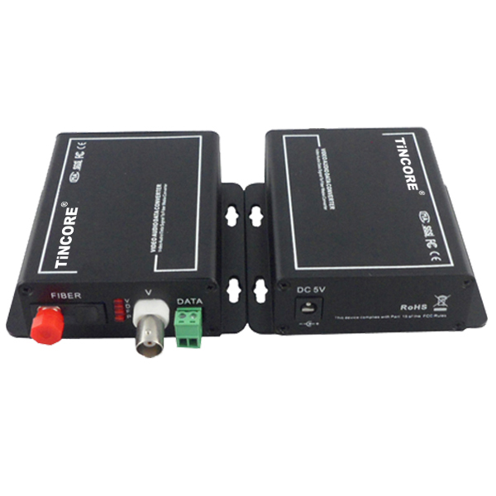
Product Overview
The TCE-SF1V1FD-S20T/R series digital video optical transceiver has a full-featured all-digital video optical transmission equipment that can transmit 1-Channel high-quality (8Bit or 10Bit) uncompressed video information and 1-Channel control signal on one fiber at the same time, optional audio、 data、 switch volume. This product is convenient for field wiring, no need for any photoelectric adjustment; with power, optical and data loop instructions; optional standalone desktop installation and modular rack-mounted two structural forms. This series digital optical products are mainly used for long-distance optical fiber transmission monitoring system, such as security monitoring, highways, electronic police, automation, intelligent community, customs, electricity, water, petroleum, chemical and many other fields.

Optical Characteristics：
fiber type/  parameter | Fiber interface type | Emission wavelength nm | Transmit power dBm | Receiver sensitivity dBm | Light saturation dBm | Optical loss dBm/km | Transmission distance km
Multi Mode | SC/FC | 850 | -18.5~-14 | -35 | -8 | 2 | 0~2
Multi Mode | SC/FC | 1310 | -19.5~-16 | -36 | -9 | 1 | 0~3
Single Mode | SC/FC | 1310 | -15~-10 | -34 | -8 | 0.5 | 0~20
Single Mode | SC/FC | 1310 | -12~-5 | -36 | -3 | 0.5 | 0~40
Single Mode | SC/FC | 1550 | -5~0 | -38 | 2 | 0.25 | 0~60

Product Features：
Video Optical Transceiver Series
2/3
- 8/10-bit digital encoding and uncompressed video transmission; support any high-resolution video signal;
- 5Hz-10MHz video channel; automatically compatible with PAL, NTSC, SECAM video system with APC circuit, the output optical power is constant, the dynamic range is large;
- Without downtime maintenance in the process of using, can be hot-swappable; Gigabit fiber transmission, large capacity, easy to upgrade;
- Power and other parameters status indicator LED can monitor the operation status of the system;
- Support video lossless regenerative relay; advanced adaptive technology, does not require on-site electrical or optical adjustment;industrial modular design makes the equipment reliable and flexible;
- Can automatically restore the overload protection; unique full built-in power supply design.

Application Drawing
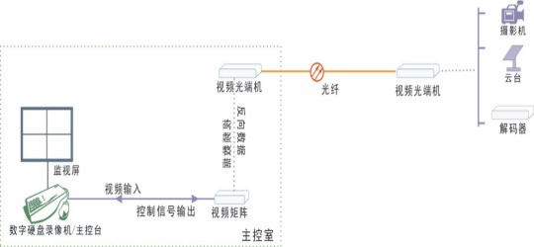

Parameter
Video Optical Transceiver Series

3/3
Application environment: security system, TV medical, high-fidelity video and video conference call, real-time monitoring and control system, intelligent traffic monitoring system (ITS), remote multimedia teaching / campus monitoring, long-distance radio and television transmission system  Optical characteristics:  Optical interface: SC/FC/ST  Wavelength: single mode 1310nm/1550nm ；multimode 850nm/1310nm  Fiber; multimode, single mode;  Transmission power transmission: -9dBm/-5dBm  Transmission length: 0-100km;  Receiving sensitivity: better than -36dBm  Features: Can be customized according to user needs for different interface types.  Video characteristics:  Channel：1-Channel video  Video interface form: BNC  Video input/output impedance: 75（unbalanced)  Video input / output voltage: 1Vp-p  Video bandwidth: 8MHz  Video sampling: 15MHz high speed sampling  Differential gain:(10% -90% APL) DG<1% (typical)  Differential phase:(10% -90% APL) DP<0.7o (typical)  Video signal to noise ratio(weighted):S/N ≥ 70dB (maximum optical link loss) | Data characteristics:  Channel：1-Channel reverse data  Data interface terminal: Standard industrial terminal block or RJ45  Interface signal: RS-232, RS-422, RS-485, Man code / Biphase, switch signal;  Audio characteristics:  Audio channels: 1-Channel Bidirectional audio (optional)  Each channel bandwidth: 20Hz ~ 20KHz;  Sampling frequency: 96KHz  Quantification level: 24bit;  Input impedance (Line-in): 47KΩ / unbalanced  Output impedance (Line-out): 10KΩ unbalanced  Nominal input and output level: 2Vp-p; Total harmonic distortion: 0.1% (typical)  Unbalanced Weighted Signal to Noise Ratio: 75dB (typical)  Switch interface parameters:  Response time: <0.5ms  Switch interface: Optical MOS relay 350V/120mA  Ambient temperature: -30 ℃ ~ 75 ℃;  Storage temperature: -40 ℃ ~ 85 ℃  Relative humidity: 0 ~ 95% (non-Condensing);  Physical interface: RJ45  Size: Standalone (225mm*200mm*40mm)  Size: Card (standard 2U centralized management rack)  Rated supply voltage: AC220V / 50Hz;  Bit error rate: ≤10⁻⁹  Internal power consumption: 1.5 W;  MTBF: ≥10⁵ hours

