
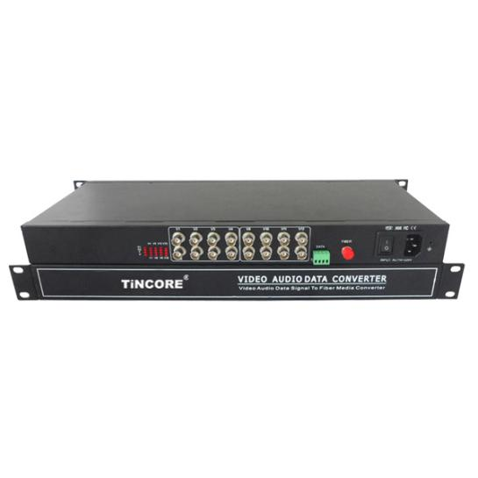
16-Channel Video + 1-Channel reverse RS485 data Optical Transceiver
Video Optical Transceiver Series

1/3

Product Overview
The TCE-SF16V1FD-S20T/R series digital video optical transceiver has a full-featured all-digital video optical transmission equipment that can transmit 16-Channel high-quality (10Bit) uncompressed video information and 1-Channel control signal on one fiber at the same time, It uses all digital video compression transmission technology, high-quality video effects to meet the needs of users, plug and play design makes installation easy, without the need for on-site regulation, the optical modules and core circuits are imported components, High stability, all the optical and electrical interfaces are in line with international standards for different work environments. Optional audio, data, switch, Ethernet signal, E1 and telephone.
This product is based on multi-channel video optical transceiver, through the miniaturization and optimization of the design of the technology crystallization. Products with excellent price / performance, can completely replace the traditional small-capacity PFM analog optical products, and more stable performance, superior technical indicators. On-site support plug and play, does not require any optical adjustments; field wiring convenience; with power, optical and data loop instructions; optional two structural forms :stand-alone desktop installation and modular rack-intensive installation . This series digital optical transceiver products are mainly used for long-distance optical fiber transmission monitoring system, such as security monitoring, highway, electronic police, automation, intelligent community, customs, electricity, water conservancy, petroleum, chemical and many other fields.
Optical Characteristics：
fiber type/  parameter | Fiber interface type | Emission wavelength nm | Transmit power dBm | Receiver sensitivity dBm | Light saturation dBm | Optical loss dBm/km | Transmission distance km
Multi Mode | SC/FC | 850 | -18.5~-14 | -35 | -8 | 2 | 0~2
Multi Mode | SC/FC | 1310 | -19.5~-16 | -36 | -9 | 1 | 0~3
Single Mode | SC/FC | 1310 | -15~-10 | -34 | -8 | 0.5 | 0~20
Single Mode | SC/FC | 1310 | -12~-5 | -36 | -3 | 0.5 | 0~40
Single Mode | SC/FC | 1550 | -5~0 | -38 | 2 | 0.25 | 0~60
Product Features：
Video Optical Transceiver Series
2/3
- 10-bit digital encoding and uncompressed video transmission;
- 5Hz-10MHz video channel; automatically compatible with PAL, NTSC, SECAM video system; with APC circuit, the output optical power is constant, the dynamic range is large;
- Without downtime maintenance in the process of using, can be hot-swappable; Gigabit fiber transmission, large capacity, easy to upgrade;
- Power and other parameters status indicator LED can monitor the operation status of the system;
- Support any high resolution video signal; support video lossless regenerative relay;
- Support RS232/RS485/RS422 or Manchester code;
- Advanced adaptive technology, does not require on-site electrical or optical adjustment;industrial modular design makes the device reliable and flexible;
- Can automatically restore the overload protection; unique full built-in power supply design;
- Desktop, wall mounted, 19 inch 1U rack or 4U card insert; support for user customization.

Application environment:
security system, TV medical, high-fidelity video and video conference call, real-time monitoring and control system, intelligent traffic monitoring system (ITS), remote multimedia teaching / campus monitoring, long-distance radio and television transmission system
Parameter
Optical characteristics:
Wavelength: single mode 1310nm/1550nm ；multimode 850nm/1310nm
Fiber; multimode, single mode; Optical interface: SC/FC/ST
Transmission power : -9dBm/-5dBm Transmission length: 0-100km;
Receiving sensitivity: better than -36dBm
Features: Can be customized according to user needs for different interface types.
Video characteristics:
Channel：16-Channel video Video interface form: BNC
Signal system: PAL/NTSC/SECAM; Nominal input/output level: 1Vp-p
Video input/output impedance: 75Ω（unbalanced)
Video input/output voltage: 1Vp-p Video bandwidth: 8MHz
Video sampling: 15MHz high speed sampling
Video Optical Transceiver Series

3/3
Differential gain:(10% -90% APL) DG<1% (typical)
Differential phase:(10% -90% APL) DP<0.7o (typical)
Video signal to noise ratio(weighted):S/N ≥ 70dB (maximum optical link loss)
Color brightness delay difference of 10ns (typical)
Color brightness gain difference: ± 10% (typical);
Note: support forward, reverse, BIDI video.
Data characteristics:
Data Channel：1-Channel reverse data
Interface type: RS232/RS485/RS422/ Manchester code
Interface signal: RS-232, RS-422, RS-485, Man code / Biphase, switch signal;
Interface features：meet the ITU-T V.24 standard Connection mode:DCE
Code rate:0～256Kbps Bit Error Rate：≤10⁻⁹
Note: support forward, reverse, BIDI data.
Audio characteristics:
Audio channels: 1-Channel Bidirectional audio (optional)
Each channel bandwidth: 20Hz ~ 20KHz; Sampling frequency: 96KHz
Quantification level: 24bit; Input impedance (Line-in): 47KΩ / unbalanced
Output impedance (Line-out): 10KΩ unbalanced
Nominal input and output level: 2Vp-p; Total harmonic distortion: 0.1% (typical)
Unbalanced Weighted Signal to Noise Ratio: 75dB (typical)
Ambient temperature: -30 ℃ ~ 75 ℃; Storage temperature: -40 ℃ ~ 85 ℃
Relative humidity: 0 ~ 95% (non-Condensing); Internal power consumption: 1.5 W;
Size: Rack mount (485mm*255mm*50mm) Desktop (235mm*175mm*40mm)
Rated supply voltage: AC220V / 50Hz; Bit error rate: ≤10⁻⁹ MTBF: ≥10⁵ hours
Application Drawing
