
24-Channel Video + 1-Channel reverse RS485 data Optical Transceiver
Video Optical Transceiver Series

1/3
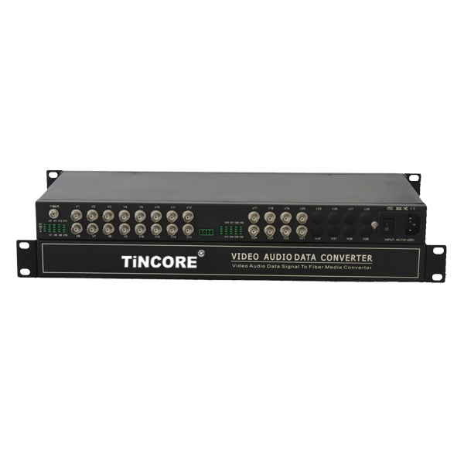
Product Overview
The TCE-SFU24V1FD-S20T/R series digital video optical transceiver has a full-featured all-digital video optical transmission equipment that can transmit 24-Channel high-quality (8 Bit/10 Bit) uncompressed video information and 1-Channel reverse data on one fiber at the same time, optional audio、 data、 switch volume . This product is convenient for field wiring, no need for any photoelectric adjustment; with power, optical and data loop instructions; optional two structural forms:standalone desktop installation and modular rack-mounted . This series digital optical products are mainly used for long-distance optical fiber transmission monitoring system, such as security monitoring, highways, electronic police, automation, intelligent community, customs, electricity, water, petroleum, chemical and many other fields.
Product Features：
- 8/10-bit digital encoding and uncompressed video transmission;
- support any high-resolution video signal;
- 5Hz-10MHz video channel; automatically compatible with PAL, NTSC, SECAM video system with APC circuit, the output optical power is constant, the dynamic range is large;
- Without downtime maintenance in the process of using, can be hot-swappable; Gigabit fiber transmission, large capacity, easy to upgrade;
- Power and other parameters status indicator LED can monitor the operation status of the system;
- Support video lossless regenerative relay;
- Advanced adaptive technology, does not require on-site electrical or optical adjustment;industrial modular design makes the device reliable and flexible;
- Can automatically restore the overload protection; unique full built-in power supply design;

Application environment:
Video Optical Transceiver Series

2/3
security system, TV medical, high-fidelity video and video conference call, real-time monitoring and control system, intelligent traffic monitoring system (ITS), remote multimedia teaching / campus monitoring, long-distance radio and television transmission system.
Parameter
Optical characteristics
Optical interface |  | Conventional FC (optional SC, ST)
Wavelength |  | single mode 1310nm/1550nm ；multimode 850nm/1310nm
Fiber |  | multimode, single mode
Transmission power |  | -9dBm/-5dBm
Transmission length |  | 0-100km
Receiving sensitivity |  | better than -36dBm
Video characteristics(V)
Number of Video interface |  | 24 video (optional 2-Channel , 4-Channel , 8-Channel , 16~128-Channel forward audio or BIDI audio)
Video interface form |  | BNC
Video input/output impedance |  | 75Ω（unbalanced)
Video input/output voltage |  | 1Vp-p
Video bandwidth |  | 8MHz
Video sampling |  | 15MHz high speed sampling
Differential gain |  | (10% -90% APL) DG<1% (typical)
Differential phase |  | (10% -90% APL) DP<0.7o (typical)
Video signal to noise ratio (weighted) |  | S/N ≥ 70dB (maximum optical link loss)
Data characteristics(D):(Optional)
Number of Data Channel |  | 1-Channel reverse data(Optional forward data, bidirectional data)
Data Interface Terminals |  | Standard Industrial Terminals or RJ45
Interface signal |  | RS-232, RS-422, RS-485, Man code / Biphase, switch signal;
Interface features |  | meet the ITU-T V.24 standard
Connection mode |  | DCE
Code rate |  | 0～256Kbps
Bit Error Rate |  | ≤10⁻⁹
Audio characteristics(A):(Optional)
Audio channels |  | 1-Channel Bidirectional audio (optional forward audio ,reverse audio)
Each channel bandwidth  Video Optical Transceiver Series  3/3 |  | 20Hz ~ 20KHz
Sampling frequency |  | 96KHz
Quantification level |  | 24bit
Input impedance (Line-in) |  | 47KΩ / unbalanced
Output impedance (Line-out) |  | 10KΩ unbalanced
Nominal input and output level |  | 2Vp-p
Total harmonic distortion |  | 0.1% (typical)
Unbalanced Weighted Signal to Noise Ratio |  | 75dB (typical)
Switch interface parameters(K):(Optional)
Number of Switch channels |  | forward switch, bidirectional switch.
Response time |  | < 0.5ms
Switch interface |  | Optical MOS relay 350V/120mA
Physical interface |  | Standard Industrial Terminals
Ethernet characteristics (E):(Optional)
Rate |  | 10/100M Adaptive
Protocol: |  | Support IEEE802.3, IEEE802.1Q (VLAN)
Physical Interface |  | RJ45 , Auto-MDIX
Working mode |  | Full duplex / half duplex adaptive
Telephone characteristics (p):(Optional)
FXS phone port | Ringing voltage |  | 75V
FXS phone port | Ringing frequency |  | 25HZ
FXS phone port | Second-line input impedance |  | 600Ω (off-hook)
FXS phone port | Return loss |  | 40 dB
General Specifications
Ambient temperature |  |  | -30 ℃ ~ 75 ℃
Storage temperature |  |  | -40 ℃ ~ 85 ℃
Relative humidity |  |  | 0 ~ 95% (non-Condensing)
Size |  |  | Independent rack (485mm*198mm*45mm)
Rated supply voltage |  |  | AC220V / 50Hz
Bit error rate |  |  | ≤10⁻⁹
Internal power consumption |  |  | 1.5 W
MTBF |  |  | ≥10⁵ hours

