
32-Channel Video + 1-Channel reverse RS485 data Optical Transceiver
Video Optical Transceiver Series

1/3
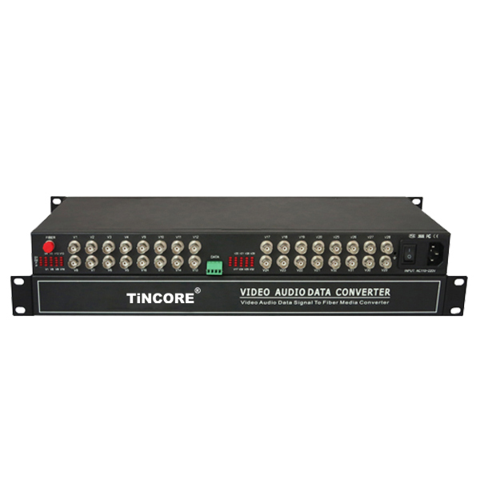
Product Overview
The TCE-SFU32V1FD-S20T/R series digital video optical transceiver has a full-featured all-digital video optical transmission equipment that can transmit 32-Channel high-quality (8 Bit/10 Bit) uncompressed video information and 1-Channel reverse data on one fiber at the same time, optional audio、 data、 switch volume、telephone . This product is convenient for field wiring, no need for any photoelectric adjustment; with power, optical and data loop instructions; optional two structural forms:standalone desktop installation and modular rack-mounted . This series digital optical products are mainly used for long-distance optical fiber transmission monitoring system, such as security monitoring, highways, electronic police, automation, intelligent community, customs, electricity, water, petroleum, chemical and many other fields.
Product Features：
■ Monitoring terminal can be used standard 19 inch 1U chassis, remote using desktop or rack;
■ Remote optical transceiver can be hung on the wall;
■ Single-mode single-fiber transmission of video, audio / speech channel, data, switch and other signals;
■ Digital uncompressed optical fiber transmission;
■ Compatible with PAL, NTSC, SECAM and other standard video transmission;
■ Half-duplex / full-duplex data communication;
■ BIDI audio or speech;
■ Audio / Telephone, Ethernet is optional card (optional interface), user-friendly selection;
■ Industrial design, high reliability;
■ Full surface mount technology;
■ MTBF ≥ 80000 hours

Application environment:
Video Optical Transceiver Series

1/3
security system, TV medical, high-fidelity video and video conference call, real-time monitoring and control system, intelligent traffic monitoring system (ITS), remote multimedia teaching / campus monitoring, long-distance radio and television transmission system.
Parameter
Optical characteristics
Optical interface |  | Conventional FC (optional SC, ST)
Wavelength |  | single mode 1310nm/1550nm ；multimode 850nm/1310nm
Fiber |  | multimode, single mode
Transmission power |  | -9dBm/-5dBm
Transmission length |  | 20km (basic type) (40km, 60km, 80km optional)
Receiving sensitivity |  | better than -36dBm
Video characteristics(V)
Number of Video interface |  | 32 video
Video interface form |  | BNC
Video input/output impedance |  | 75Ω（unbalanced)
Video input/output voltage |  | 1Vp-p
Differential gain |  | <1% (typical)
Differential phase |  | <1 ° (typical)
Video signal to noise ratio (weighted) |  | S/N ≥ 70dB (maximum optical link loss)
Video bandwidth |  | 2Hz～8MHz
窗体顶端  Sampling frequency |  | 16MHz
Quantization level |  | 8/10bit
Signal System |  | PAL/NTSC/SECAM
Color brightness delay difference |  | 10ns
Color brightness gain difference |  | +/- 10%
Data characteristics(D):(Optional)
Data Interface Terminals |  | Standard Industrial Terminals
Data format |  | RS-232 / RS-485 optional
Work mode |  | half duplex / full duplex optional
Transmission rate |  | 0～115.2Kbps
Bit Error Rate |  | ≤10⁻⁹
Audio characteristics(A):(Optional)
input/output voltage |  | 1Vp-p
input/Output impedance |  | 600Ω, unbalanced
Audio bandwidth  Video Optical Transceiver Series  3/3 |  | 10Hz ~ 20KHz
Sampling frequency |  | 8KHz
Switch interface parameters(K):(Optional)
Physical interface |  | Standard Industrial Terminals
Input signal |  | any active or passive alarm, switch signal input, support TTL, or passive switch, button
Output signal |  | any active or passive alarm, switch signal output, support for TTL, or relay contact output
Note: the switch can only access 5V signal or passive switch, the output is used to drive an external controller, and then control the high-voltage equipment
Telephone characteristics (p):(Optional)
Interface Type |  | Automatic (FXS), exchange (FXO)
Sampling frequency |  | 8KHz
Coding |  | A law
Bit rate |  | 64Kbit / s
Maximum loop resistance |  | 2000Ω
Effective transmission bandwidth |  | 300-3400HZ / 600Ω
Idle channel noise |  | <-67dB
Ring current voltage |  | 25 ± 3Hz, 75 ± 15V
Net attenuation frequency |  | to meet the ITU-T recommendations
Free talk noise |  | no more than -65dBm0p
Road cross-talk |  | no more than -65dBm0
Amplitude characteristics |  | Meet ITU-T recommendations
Total distortion |  | Meet ITU-T recommendations
Power supply conditions
-48VDC |  |  | Power supply range -36V ~ -72V, ripple ≤ 240mVp-p
220VAC |  |  | Power supply range 110V ~ 265V, 50Hz
Power consumption |  |  | The whole is less than 3W
Environmental requirements
working environment: | Ambient temperature |  |  | -10 ℃ ~ 55 ℃
working environment: | Relative humidity |  |  | ≤ 90% (non-condensing)
working environment: | Atmospheric pressure |  |  | 86 ~ 106KPa
Storage environment: | Ambient temperature |  |  | -20 ~ 80 ℃
Storage environment: | Relative humidity |  |  | ≤95%
Size |  |  |  | 230x160x43mm

