
Fiber Media Converter Series

1/2
10/100M Internal power supply Fiber Media Converter

Product Description

TBC-MC3302N-D20-SC series 10/100M adaptive fiber media converter through 10Base-TX or 100Base-TX to 100Base-FX photoelectric conversion between the traditional 10M Ethernet or 100M Fast Ethernet through the Fast Ethernet fiber optic link extended to 120 km range, to meet the long-distance, high-speed , High-bandwidth fast Ethernet working group user needs, the product performance is stable and reliable, designed to meet the Ethernet standards, and anti-lightning protection measures, especially for telecommunications, mobile, China Unicom, safe city, radio and television, railway, military, financial securities, customs, civil aviation, maritime transport, electricity, water conservancy and oil fields and other broadband data network and require high reliability data transmission or the formation of IP data transmission network area, it is the best application equipment for broadband campus network，intelligent broadband district fiber to the floor , Fiber to the home and video surveillance .
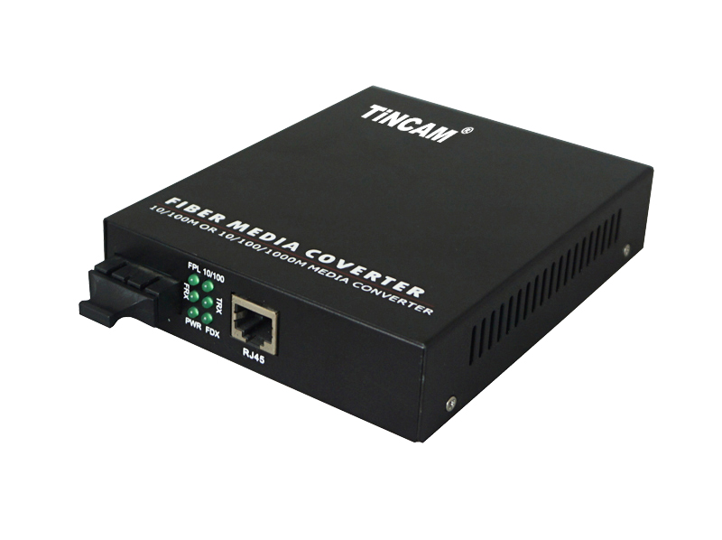

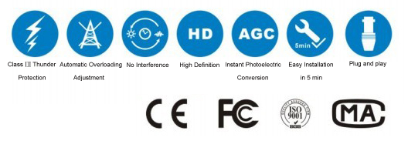

Product Features

- Support IEEE802.3u.100BASE-T and 100 BASE-FL protocol
- Support full duplex or half duplex network communication, and with auto-negotiation capability
- Supports the transmission of long packets of VLANs
- Support for IEEE802.1Q protocol switch products to match the use
- Support LINK LOSS link remote pre-alarm function
- Modular design, plug and play, both stand-alone use
- Automatically adapt to 10Mbps and 100Mbps environment, easy to upgrade the network
- RJ45 port support through or cross automatic recognition function (AUTO-MDIX)
- REMOTE PAUSE function ensures the integrity of packet transmission
- With broadcast storm protection, balance flow, isolation conflicts and detection errors and other functions;
- Meet the electromagnetic interference standard FCC Part15 Class A and CE Mark safety regulations

Fiber Media Converter Series

2/2
Product Specification

Standard Protocol | IEEE 802.3, IEEE 802.3u, IEEE 802.3d,IEEE 802.3Q
Band Width | RJ 45 Port |  | 10/100M |  | Optical Port | 155M
Operation Mode | Full /Half duplex mode,with auto-negotiation capability
Connectors | UTP | RJ45 |  |  | Fiber connector | SC/FC/ST/LC
LED Indicators | FPL,10/100, FRX, TRX , PWR,,FDX.
UTP Cable | Cat5 UTP （the max distance up to 100m）
Fiber Cable | 9/125,(single mode dual fiber 20 -120km)、（wavelength 1310nm，1550nm）
Fiber Cable | Transmission power：≥-12～≥-8dBm  receiving sensitivity：≥-32～≥-36dBm
Power Supply | External power supply |  |  | 5V, 1A
Power Supply | Internal power supply |  |  | DC-48V, AC110-250V/50Hz
Power Supply | Power Consumption |  |  | ≤5W
Working Environment | Work Temperature |  |  | 0℃~50℃
Working Environment | Storage Temperature |  |  | -40℃~70℃
Working Environment | Humidity |  |  | 5%~90% non-condensing
MTBF (Hours) | >50000
Size and Weight | structure |  |  | Dimensions(mm) |  |  | Weight
Size and Weight | Internal power supply |  |  | 166mm*112mm*33mm |  |  | 0.7kg
Certification | FCC Part 15 , Class A, RoHS and CE Mark

LED指示灯

