
Fiber Media Converter Series

1/2
10/100M single port Mini Fiber Media Converter

Product Description

The TBC-MC3302S series of mini (micro) Ethernet fiber optic transceivers, the size is only 67mm * 75mm * 26mm, smaller than the business card, easy to install in a variety of waterproof box or integrated ball machine inside (fiber Ball) and explosion-proof cameras, the product can be stable in the 0 °C ~ +50 °C harsh climate environment, +9 ~ +36 V wide range of power supply design can adapt to many occasions. This series can be a single fiber transmission 1 channel Ethernet , support a video server or network camera access.
This Ethernet optical transceiver (fiber optic transceivers) with Ethernet interface triple lightning protection design, effective against lightning damage.
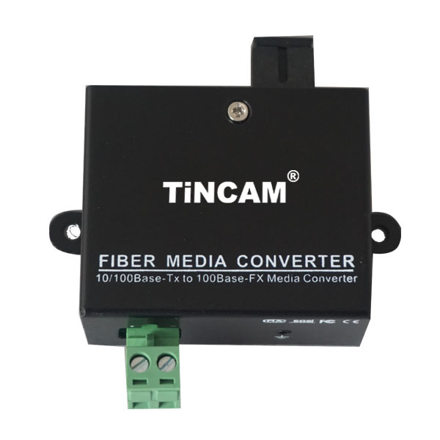
Product Features

- Mini, size only 67mm * 75mm * 26mm
- Dual / single fiber transmission 1 channel Ethernet, effectively saving fiber
- 10/100M adaptive
- Fully support IEEE802.3、IEEE802.3u、IEEE802.3ab、IEEE802.3z
- support IEEE802.3X Full duplex flow control and BACKPRESSURE half duplex flow control
- Detects the VLAN address resolution protocol for packets
- The network port supports parallel / crossover cable adaptation
- Single / dual fiber optional, single mode / multi-mode fiber transmission, no relay Maximum transmission distance 100KM
- No electromagnetic interference (EMI), radio frequency interference (RFI) and common ground circuit interference
- With power, optical, Ethernet status LED instructions, you can monitor the system running
- Industrial design, SMT surface mount technology
- Iron shell Miniature structure
- Low power consumption, plug and play, support hot-swappable, debug-free installation
- + 9 ~ 36V wide range of power supply design
- Ethernet Interface triple lightning protection design

Fiber Media Converter Series

2/2
Product Specification

Fiber interface parameters (single fiber / dual fiber)
Wavelength | Single mode 1310nm/1550nm； Multimode 850nm/1310nm
Number of fiber cores | Duplex , Simplex
Transmission power | -9dBm/-5dBm
Transmission distance | 0-100KM (dual fiber) 0-120 KM
Receiver sensitivity | better than -34dBm
Fiber Connector | FC/SC/ST/LC optional
Ethernet interface
Number of channels | 1channel
Rate | 10M,100M
Standard | IEEE802.3/ IEEE802.3u / IEEE802.3ab / IEEE802.3z
Support VLAN | support IEEE 802.1Q VLAN
Maximum package | supports up to 1600 Bytes of packet transmission
Network port sequence | automatic identification through and cross the line
Ethernet connector | RJ45 interface
Power and environmental indicators
Power | 3W
Power supply | +9V~+36V DC
Operating temperature | -0°C~+50°C
Storage temperature | -50°C~+85°C
Working humidity | 0 ~ 95% non-condensing
Physical characteristics
Independent size (mm) | 67L * 75W * 26H
Card Type size (mm) | 67Lx75Wx12H
Independent weight (kg) | 0.25
Card Type Weight (kg) | 0.05
Mean time between failures (MTBF) | 100,000 hours or more
LED indicator | power, Ethernet, optical link, full / half duplex

LED指示灯

