
Fiber Media Converter Series

1/3
10/100/1000M Fiber Media Converter

Product Description

TBC-MC3612E-S20 series 10/100/1000M adaptive fiber media converter through 100Base-TX or 1000Base-TX to 100Base-FX photoelectric conversion between the traditional 100M Ethernet or 1000M Fast Ethernet through the Fast Ethernet fiber optic link extended to 120 km range, to meet the long-distance, high-speed , High-bandwidth fast Ethernet working group user needs, the product performance is stable and reliable, designed to meet the Ethernet standards, and anti-lightning protection measures, especially for telecommunications, mobile, China Unicom, safe city, radio and television, railway, military, financial securities, customs, civil aviation, maritime transport, electricity, water conservancy and oil fields and other broadband data network and require high reliability data transmission or the formation of IP data transmission network area, it is the best application equipment for broadband campus network，intelligent broadband district fiber to the floor , Fiber to the home and video surveillance .
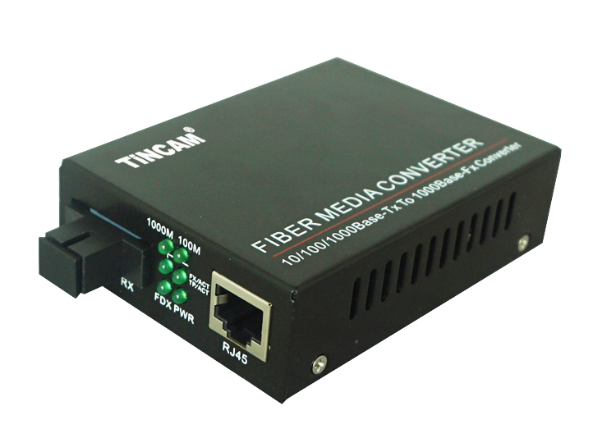

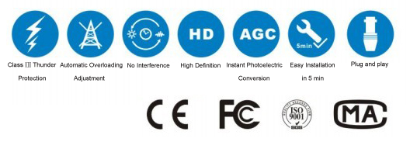

Product Features

- Support IEEE802.3u.1000BASE-T and 1000 BASE-FL protocol
- Support full duplex or half duplex network communication, and with auto-negotiation capability
- Supports the transmission of long packets of VLANs
- Support for IEEE802.1Q protocol switch products to match the use
- Support LINK LOSS link remote pre-alarm function
- Modular design, plug and play, both stand-alone use, can also be used in 14-slot rack
- Automatically adapt to 10Mbps ,100Mbps and 1000Mbps environment, easy to upgrade the network
- RJ45 port support through or cross automatic recognition function (AUTO-MDIX)
- REMOTE PAUSE function ensures the integrity of packet transmission
- With broadcast storm protection, balance flow, isolation conflicts and detection errors and other functions;
- Meet the electromagnetic interference standard FCC Part15 Class A and CE Mark safety regulations

Fiber Media Converter Series

2/3
Product Specification

Standard Protocol | IEEE 802.3, IEEE 802.3u, IEEE 802.3d,  IEEE 802.3x, IEEE 802.3Q
Band Width | RJ 45 Port |  | 10/100/1000M |  | Optical Port | 1.25G
Operation Mode | Full /Half duplex mode,with auto-negotiation capability
Connectors | UTP | RJ45 |  |  | Fiber connector | SC/FC/ST
LED Indicators | 1000M,100M, FX/ACT, TP/ACT , PWR,FDX.
UTP Cable | Cat5 UTP （within 100m）
Fiber Cable | 9/125μm(the max distance up to 20 -120km)
Fiber Cable | 50/125,62.5/125μm(the max distance up to 2km)
Power Supply | External power supply |  |  | 5V, 2A
Power Supply | Internal power supply |  |  | DC-48V, AC110-250V/50Hz
Power Supply | Power Consumption |  |  | ≤5W
Working Environment | Work Temperature |  |  | 0℃~50℃
Working Environment | Storage Temperature |  |  | -40℃~70℃
Working Environment | Humidity |  |  | 5%~90% non-condensing
MTBF (Hours) | >30000
Size and Weight | structure |  |  | Dimensions(mm) |  |  | Weight
Size and Weight | External power supply |  |  | 94mm*70mm*25mm |  |  | 0.4 kg
Size and Weight | Internal power supply |  |  | 140mm*110mm*30mm |  |  | 0.8kg
Size and Weight | Socket Card |  |  | 157mm*128mm*31mm |  |  | 1.0kg
Certification | FCC Part 15 , Class A, RoHS and CE Mark

Fiber Media Converter Series

2/3
LED Indicators
Application
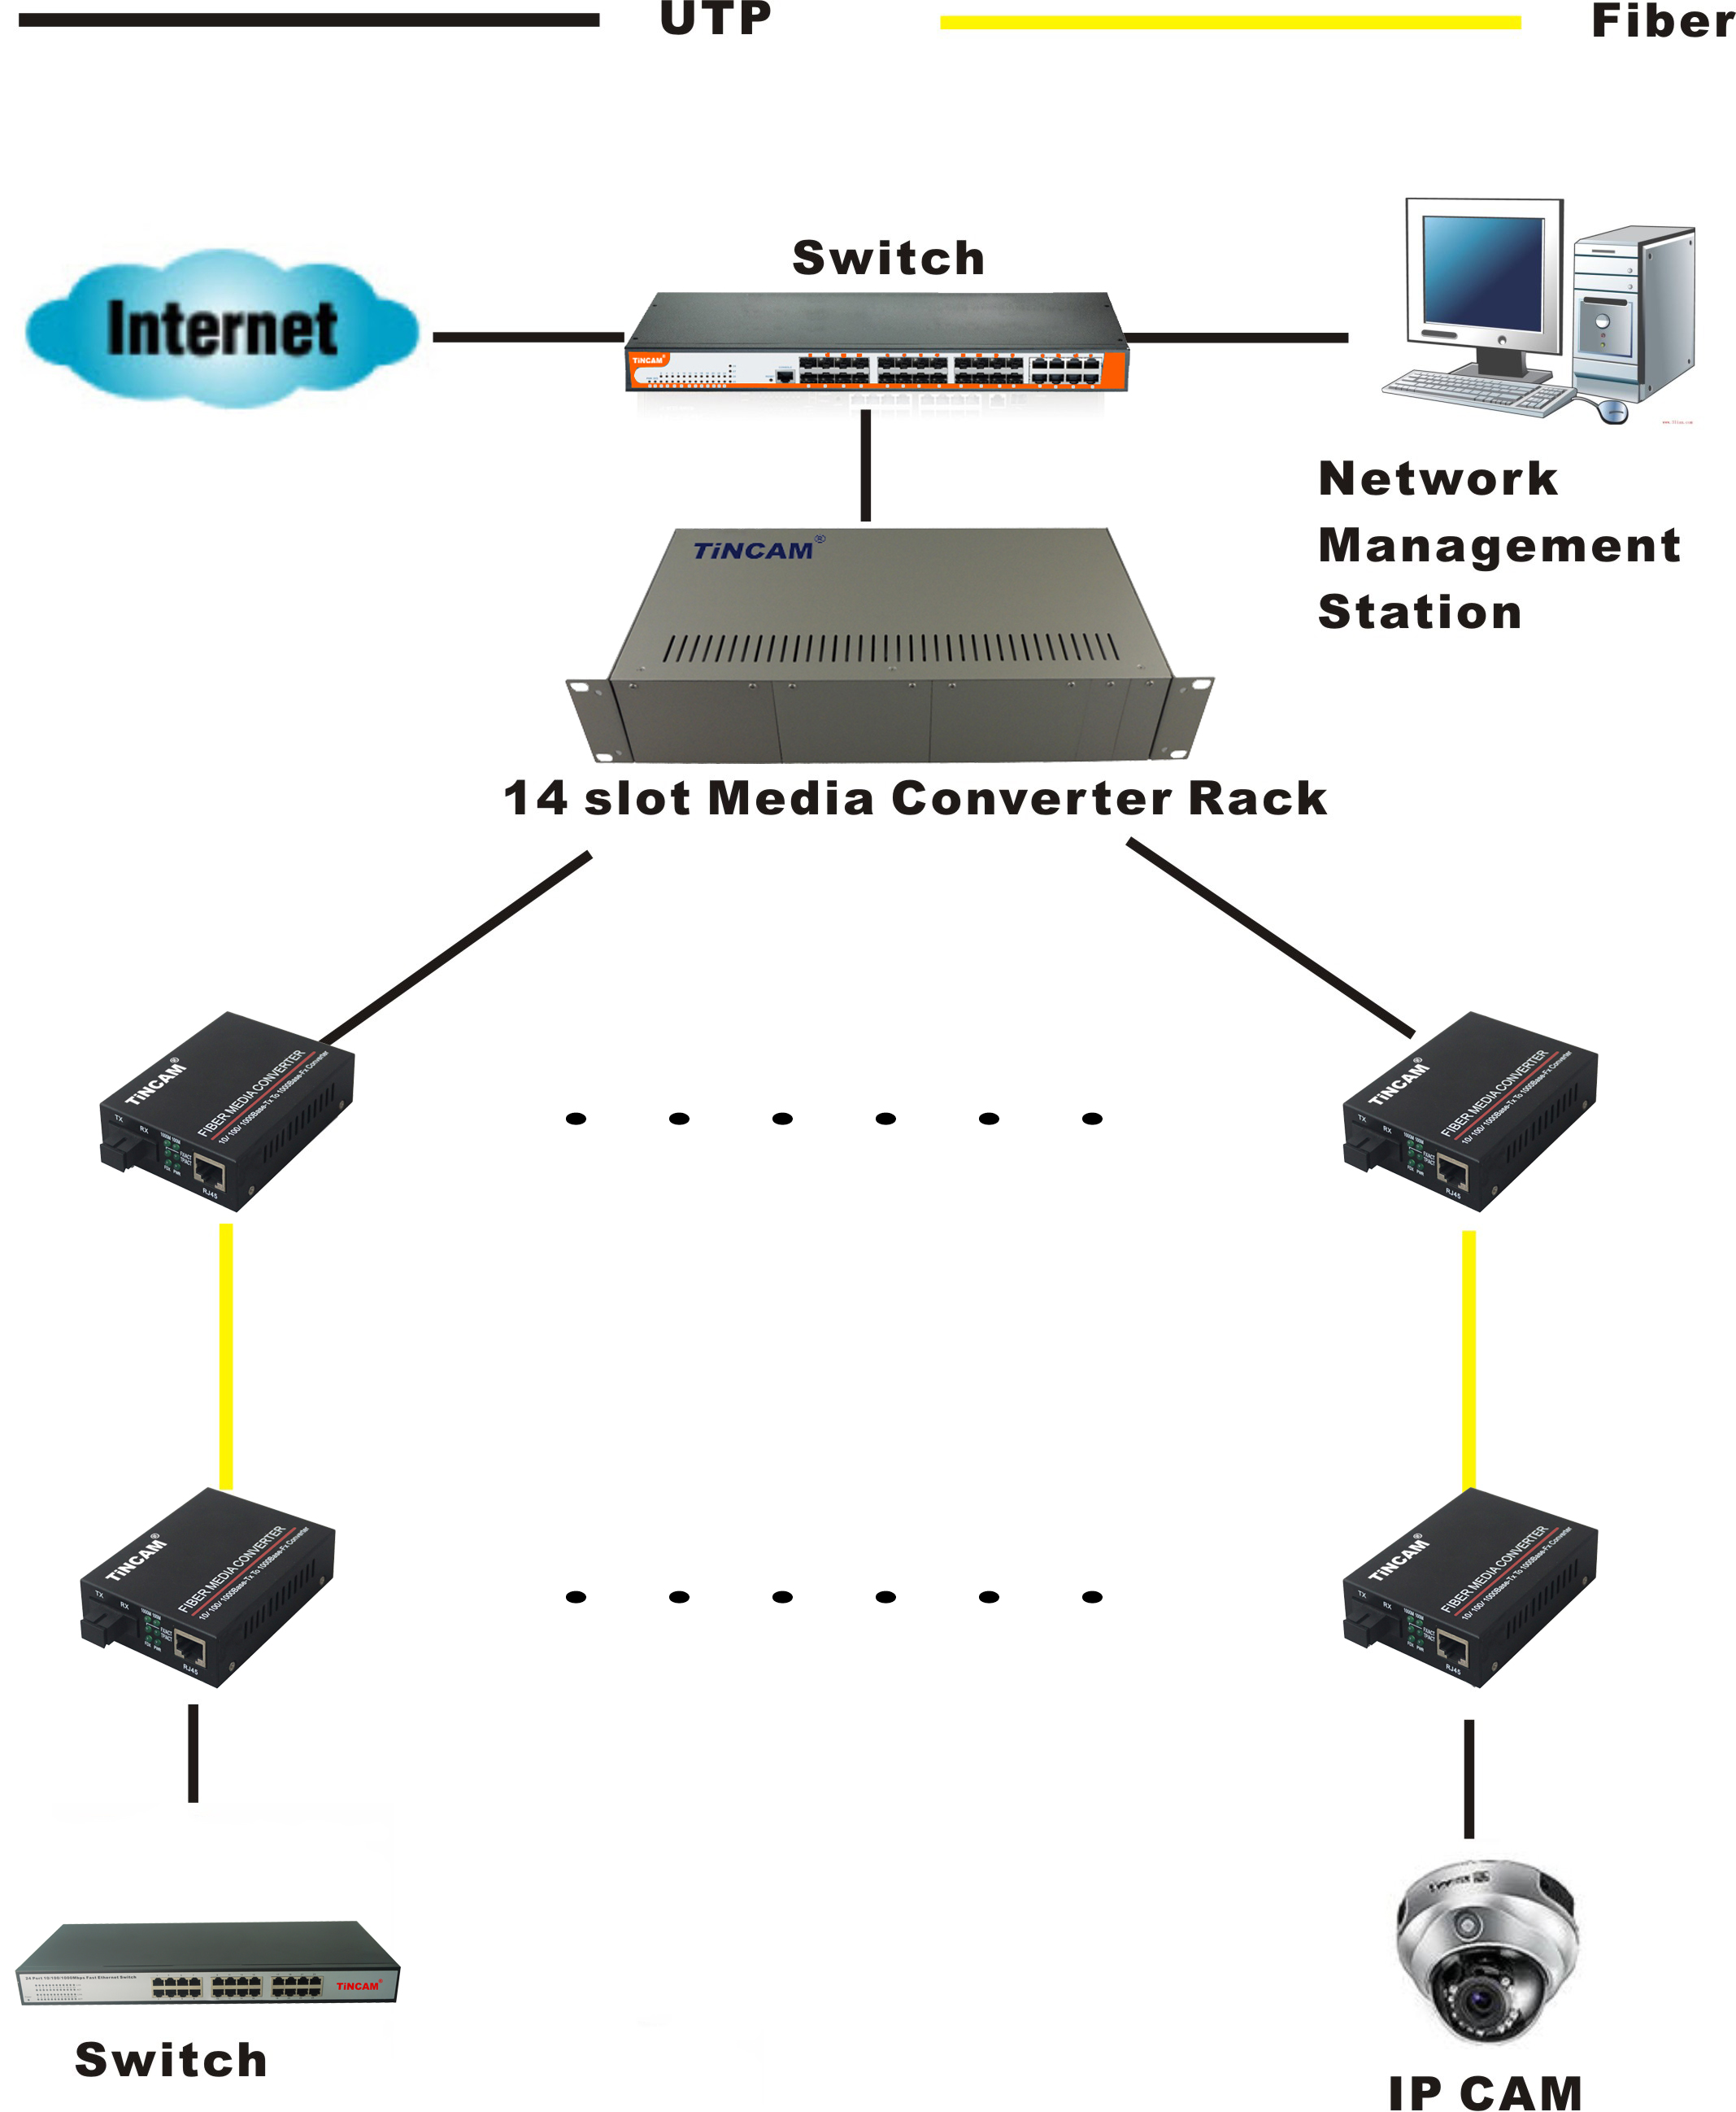
Name | Definition | Specification
PWR | Indicator of power supply | ON when the power supply is turned on and in normal working status
FX/ACT | Optical interface status indicator | Bright : optic fiber cable is connected well, but no data transmission
FX/ACT | Optical interface status indicator | Blinking: when receiving data
TP/ACT | Ethernet interface status indicator | Bright : twisted pair is connected well, but no data transmission
TP/ACT | Ethernet interface status indicator | Blinking: when receiving data
100M | Rate indicator | Bright: The data is being transmitted: 100M
100M | Rate indicator | Off: no data is being transmitted
1000M | Rate indicator | Bright: The data is being transmitted: 1000M
1000M | Rate indicator | Off: no data is being transmitted
FDX | Ethernet interface  Full / half duplex  Signal indicator | Bright: The network interface operates as full duplex
FDX | Ethernet interface  Full / half duplex  Signal indicator | OFF, The network interface operates as half duplex
Application

