
16-slot Media Converter Chassis

1/3
16-Slot Media Converter Chassis
DESCRIPTION

The TBC-RM1600-22 Series 16-Slot Media Converter Rack Chassis is a standard 2U19-inch, centrally-powered fiber optic transceiver system. This Rack Chassis equipped with the main and backup power supply; can be inserted 10/100M series, 10/100/1000M series fiber optic transceiver modules and single-mode converter module and 1 fiber port & 1 RJ45 port fiber switch, and support for hot-swappable. The Media Converter chassis adopts communication isolation technology to separate the power supply from the transceiver module completely, to ensure the reliability of the whole system .
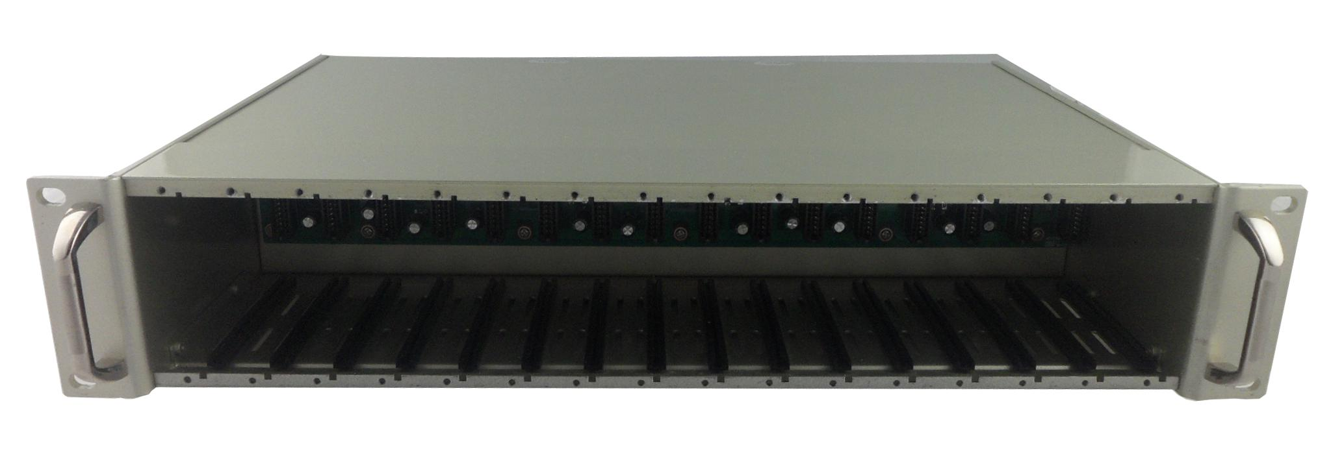

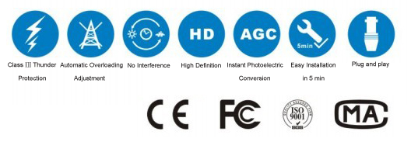

FEATURES

- The configuration of main and backup power supply ensures uninterrupted work of the system;
- AC220V and DC-48V two kinds of power supply to make the system suitable for a variety of work environments;
- Adopting modular power supply is easy to maintain and has good shielding effect;
- Support multiple modules to work at the same time, greatly improving the system's applicability;
- Each module supports hot swap function;
- It is suitable for telecommunication, CATV, Ethernet optical fiber data centralization and network management;
- Requiring high performance network security protection system;
- The functional modules in the 16-slot rack are interchangeable with the structure of the plug-in built-in power supply products;
- The chassis structure is designed with 2U standard, which can be easily installed on the rack of the engine room, and dual fan exhaust have good heat dissipation performance;
- Meet the electromagnetic interference standard FCC Part15 Class A and CE Mark safety regulations.

www.sztincam.com www.sztincam.en.alibaba.com

16-Slot Media Converter Chassis

2/3
TECHNICAL SPECIFICATIONS

Number of power supply | Dual power supply
Power supply | Input voltage:AC 100 ~ 240V, 50~60Hz 3.0A(max);
Power supply | Output voltage:DC5V 9.5A(max)
Power supply | Ripple voltage ≤ 50Mv
Power supply | Noise ≤ 100Mv
Operating Temperature | 0℃ ~ 55℃
Storage Temperature | -40℃ ~ 70℃
Humidity | 5%~90% non-condensing
Dimensions | 483mm* 285mm* 90mm (Standard 19-Inch, 2U height)
Weigh t | 8 k g

APPLICATION

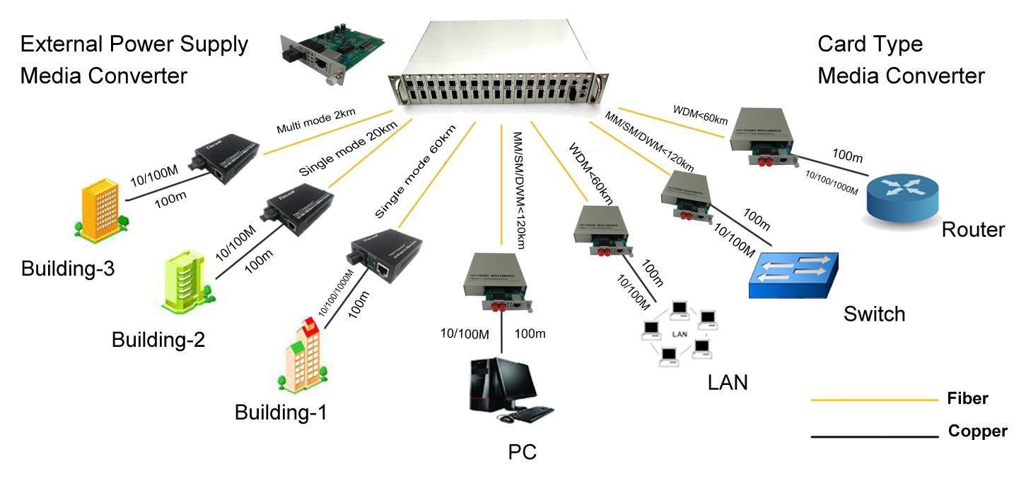
245mm

www.sztincam.com www.sztincam.en.alibaba.com

www.sztincam.com / www.sztincam.en.alibaba.com

