
Fiber Switch Series

1/2
10/100M 1 fiber port + 2 RJ45 ports fiber switch

Product Description

TBC-3412N-S20 fiber switch provides 2*10/100M RJ45 ports,support port rate, working mode, Port VLAN port bandwidth control, priority, port security and other intelligent configuration. Ethernet fiber switch overall performance is superior, easy to use, the price is affordable.It provides the ideal networking solutions for the working group users and intelligent community broadband access .

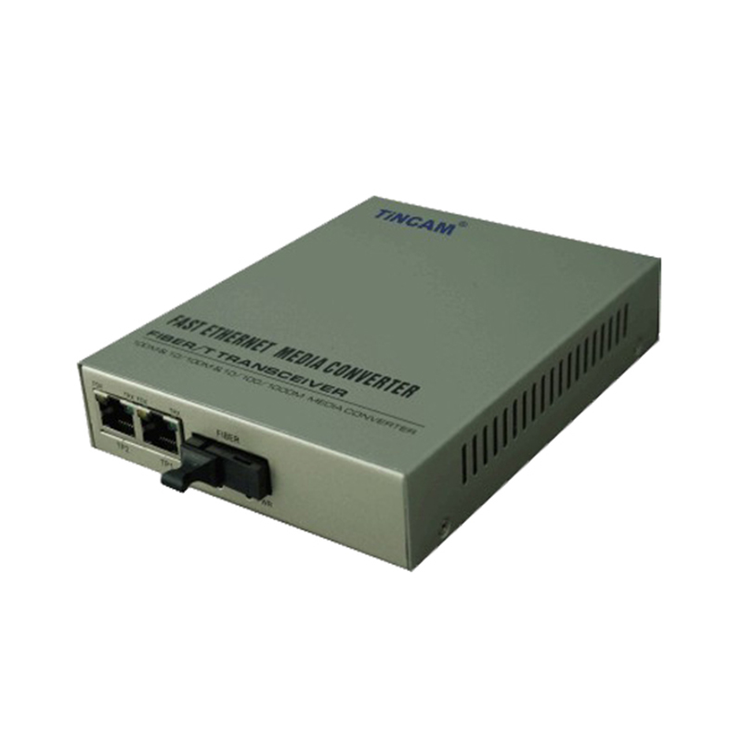

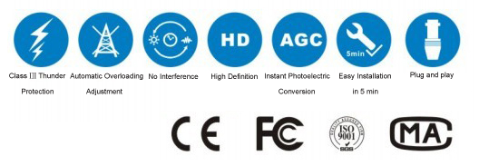

Product Features

- Comply with IEEE802.3、IEEE802.3u standard;
- Flow control mode: full-duplex adopts IEEE802.3x standard, half-duplex using Back pressure technology;
- 2*10/100M adaptive RJ45 ports, support Auto MDI/MDIX;
- Provide 1*100M fiber port, to meet the requirements of long distance transmission.
- Support VLAN function,provide port bandwidth control function, the minimum size of 128kbps;
- Support IEEE802.1p priority protocol mode, secondary static port priority mode and ToS priority mode, support broadcast storm control;
- Provide fixed IP address settings;
- Support the upgrade of the switch system software, save and resume the configuration file;
- Support physical isolation and logical isolation;
- It is powered by an external 5V2A power supply.

Fiber Switch Series

2/2

Standard Protocol | IEEE802.3 10BASE-TEthernet,  IEEE802.3u 100BASE-TX Fast Ethernet,  IEEE802.3x protocol CSMA/CD
Band Width | RJ 45 Port: 2*10/100M | Optical Port: 155M
Operation Mode | Full /Half duplex mode,with full duplex / half duplex automatic negotiation function
Connectors | UTP:RJ45 | Fiber connector: SC/ST/FC
Fiber Cable | 9/125,(up to 20 -120km)
Fiber Cable | 50/125, 62. 5/125μm(up to 2km)
Power Supply | External power supply | 5VDC, 1A
Power Supply | Internal power supply | DC-48V, AC110-250V/50Hz
Power Supply | Power Consumption | ≤5W
Work environment | Work Temperature | 0℃~50℃
Work environment | Storage Temperature | -30℃~60℃
Work environment | Humidity | 5%~90% non-condensing
working life | >30000
Dimensions(mm) | Internal power supply | 104mm*71mm*27mm
Gross Weight | Internal power supply | 0.8kg
Certification | FCC Part 15 , Class A, RoHS and CE Mark
Product Specification

