
Fiber Switch Series

1/3
10/100M 1 fiber port + 4 RJ45 ports fiber switch

Product Description

The TBC-MC3414N-D20 series fiber switch can convert 4 independent 10/100Base-TX twisted pair electrical signals and 1 independent 100Base-FX optical signal to each other.It extends the transmission distance of the network from the 100m limit of copper wire to 120km.Through the use of switching technology , storage and forwarding technology to achieve data of the two networks before connecting the media , greatly improving the flexibility of fiber Ethernet set, and reducing the cost of network construction, support dual-fiber multi-mode, dual-fiber single-mode , Single-mode single fiber and other optical fiber transmission.
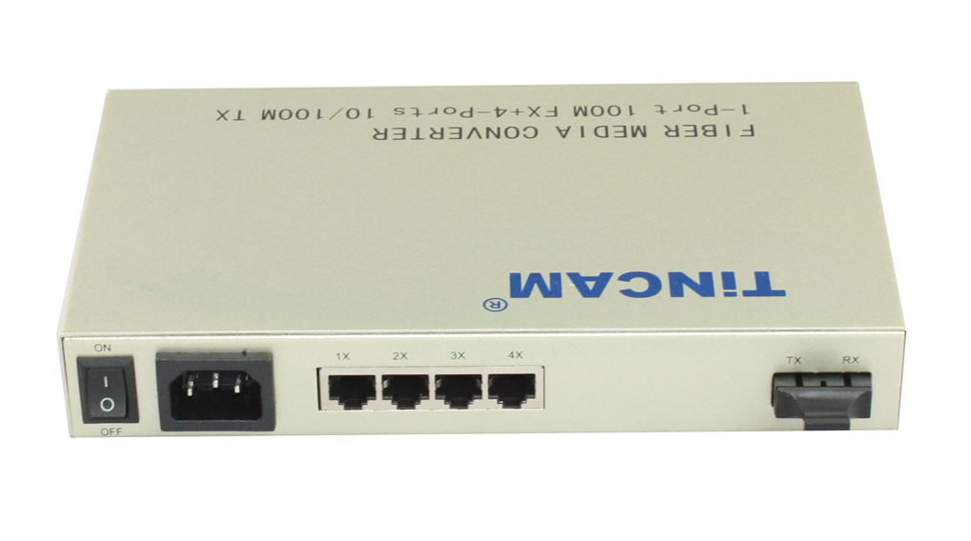

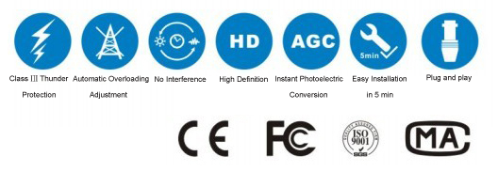

Product Features

- Storage and forwarding capabilities to support rate adaptation and protocol translation;
- Adaptive connection 10M and 100M network and the network port supports full-duplex/ half-duplex adaptation and traffic control;
- Automatic detection and correction of incorrect poles on each port of a twisted pair;
- Data transfer rate (line speed) is 14,880 frames per second (10M);
- Data transfer rate (line speed) is 14,8800 frames per second (100M);
- The amount of power ≤ 5W;
- Support 12K effective MAC address table; MAC Supports MAC address learning and aging automatically;
- 8 MB packet buffer;
- With broadcast storm protection ;
Application

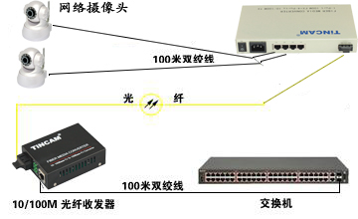

Fiber Switch Series

2/3
Product Specification

Parameter | Specification
Port | 4*100M adaptive Ethernet port  1* 100Base-FX optical port  1* console configuration port
Port features | Interface Type: 4*RJ-45 (UTP), SC (optical port);  Complies with IEEE802.3 and 802.3u standard;  RJ45: 10/100Mbps adaptive, full/half duplex communication mode adaptive  Support straight-through connection / cross-adaptability;
Configuration Interface Type | RJ-45
Cable Type | 10/100Base-TX: twisted pair Category 3, 4, 5 cable (up to 100m)  100Base-Fx: Fiber Type 50/125, 62.5 / 125, 9 / 125μm
Conversion method | quickly store and forward
Power | AC100-240V 50/60Hz
Power consumption | 10W
Work Temperature | 0℃~60℃
Storage Temperature | -40℃~70℃
Work Humidity | 20%~85% non-condensing
Storage Humidity | 5%~90% non-condensing
Weight | 1.2kg

Model | Fiber Type | Wavelength | Bandwidth | Distance | Transmit power | Receive sensitivity
TBC-3414N-D02 | Multi mode dual fiber | 1310nm(850nm) | 10/100M | 0~2 KM | -22 ~ -14dBm | ≤ -31dBm
TBC-3414N-D20 | Single mode dual fiber | 1310nm | 10/100M | 0~20 KM | -12 ~ -8dBm | ≤ -35dBm
TBC-3414N-D40 | Single mode dual fiber | 1310nm | 10/100M | 0~40 KM | -8 ~ -3dBm | ≤ -35dBm
TBC-3414N-D60 | Single mode dual fiber | 1310nm DFB | 10/100M | 0~60 KM | -3 ~ 0dBm | ≤ -35dBm
TBC-3414N-D80 | Single mode dual fiber | 1550nm DFB | 10/100M | 0~80 KM | -5 ~ 0dBm | ≤ -35dBm
TBC-3414N-D100 | Single mode dual fiber | 1550nm DFB | 10/100M | 0~100 KM | -5 ~ 0dBm | ≤ -35dBm
TBC-3414N-D120 | Single mode dual fiber | 1550nm DFB | 10/100M | 0~120 KM | -5 ~ 0dBm | ≤ -35dBm
TBC-3414N-S20 | Single mode single fiber | 1310T/1550R | 10/100M | 0~20 km | -12 ~ -8dBm | ≤ -35dBm
TBC-3414N-S20 | Single mode single fiber | 1550T/1310R | 10/100M | 0~20 km | -8 ~ -3dBm | ≤ -35dBm
TBC-3414N-S40 | Single mode single fiber | 1310T/1550R | 10/100M | 0~40 km | -3 ~ 0dBm | ≤ -35dBm
TBC-3414N-S40 | Single mode single fiber | 1550T(DFP)/1310R | 10/100M | 0~40 km | -5 ~ 0dBm | ≤ -35dBm
TBC-3414N-S60 | Single mode single fiber | 1310T/1550R | 10/100M | 0~60 km | -5 ~ 0dBm | ≤ -35dBm
TBC-3414N-S60 | Single mode single fiber | 1550T(DFP)/1310R | 10/100M | 0~60 km | -5 ~ 0dBm | ≤ -35dBm
TBC-3414N-S80 | Single mode single fiber | 1310T/1550R | 10/100M | 0~80 km | -22 ~ -14dBm | ≤ -31dBm
TBC-3414N-S80 | Single mode single fiber | 1550T(DFP)/1310R | 10/100M | 0~80 km | -22 ~ -14dBm | ≤ -31dBm
TBC-3414N-S100 | Single mode single fiber | 1310T/1550R | 10/100M | 0~100 km | -22 ~ -14dBm | ≤ -31dBm
TBC-3414N-S100 | Single mode single fiber | 1550T(DFP)/1310R | 10/100M | 0~100 km | -22 ~ -14dBm | ≤ -31dBm
Fiber Switch Series

3/3

