
Fiber Switch Series

1/2
10/100M 1 fiber port + 4 RJ45 ports fiber switch

Product Description

The TBC-MC3414E-S20 fiber switch can convert 4 independent 10/100Base-TX twisted pair electrical signals and 1 independent 100Base-FX optical signal to each other.It extends the transmission distance of the network from the 100m limit of copper wire to 120km.Through the use of switching technology , storage and forwarding technology to achieve data of the two networks before connecting the media , greatly improving the flexibility of fiber Ethernet set, and reducing the cost of network construction, support dual-fiber multi-mode, dual-fiber single-mode , Single-mode single fiber and other optical fiber transmission.
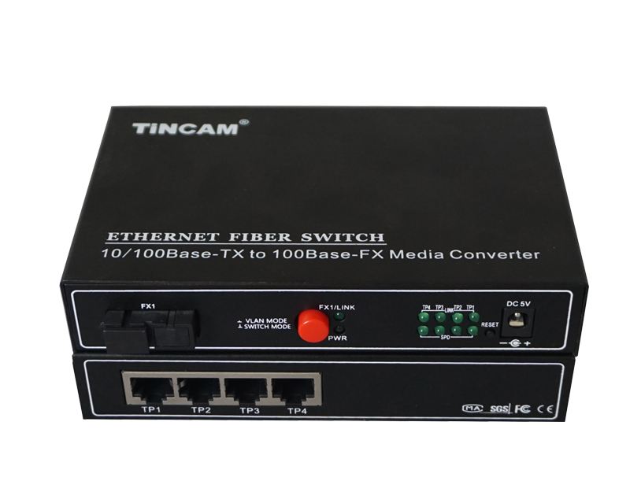

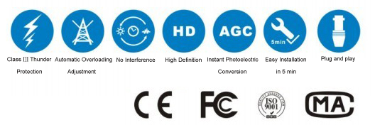

Product Features

- Storage and forwarding capabilities to support rate adaptation and protocol translation;
- Adaptive connection 10M and 100M network and the network port supports full-duplex/ half-duplex adaptation and traffic control;
- Automatic detection and correction of incorrect poles on each port of a twisted pair;
- Data transfer rate (line speed) is 14,880 frames per second (10M);
- Data transfer rate (line speed) is 14,8800 frames per second (100M);
- The amount of power ≤ 5W;
- Support 12K effective MAC address table; MAC Supports MAC address learning and aging automatically;
- 8 MB packet buffer;
- With broadcast storm protection ;in line with IEEE802.3, IEEE802.3u standards;
- Flow control methods: Full duplex IEEE802.3x standard, Half-duplex using Back-pressure technology;
- 4*10/100M adaptive RJ45 ports, support port auto-flip (AutoMDI / MDIX);Provide 1*100M optical port to meet the requirements of long-distance transmission;
- Support 4 groups of Port VLAN and MTU VLAN functions;Provides port bandwidth control with a minimum granularity of 128kbps;
- Support IEEE802.1p priority protocol mode, the second static port priority Level mode and ToS priority mode ;
- Support for broadcast storm control,Provide fixed IP address settings;
- Support switch system software upgrades, configuration file saving and recovery;
- External 5V1A switching power supply;
- Support physical isolation ;

1 fiber port + 2 RJ45 port Series

2/2
Product Specification

Standard | IEEE 802.3 10BASE-T Ethernet,  IEEE 802.3u 100BASE-TX Fast Ethernet,  IEEE 802.3x
Protocol | CSMA/CD
Data Transmission Rate | Ethernet : 10Mbps(Half-duplex) 20Mbps(Full-duplex)  Fast Ethernet : 100Mbps(Half-duplex) 200Mbps(Full-duplex)
Power Input | 5VDC, 2A
Work environment | Work Temperature | 0℃~50℃
Work environment | Storage Temperature | -30℃~60℃
Work environment | Humidity | 5%~90% non-condensing
Dimensions(mm) | 232mm*142mm*45mm
Weight | 0.69kg

