
FE1 Fiber Optical Modem
Fiber Optical Modem Series

1/2
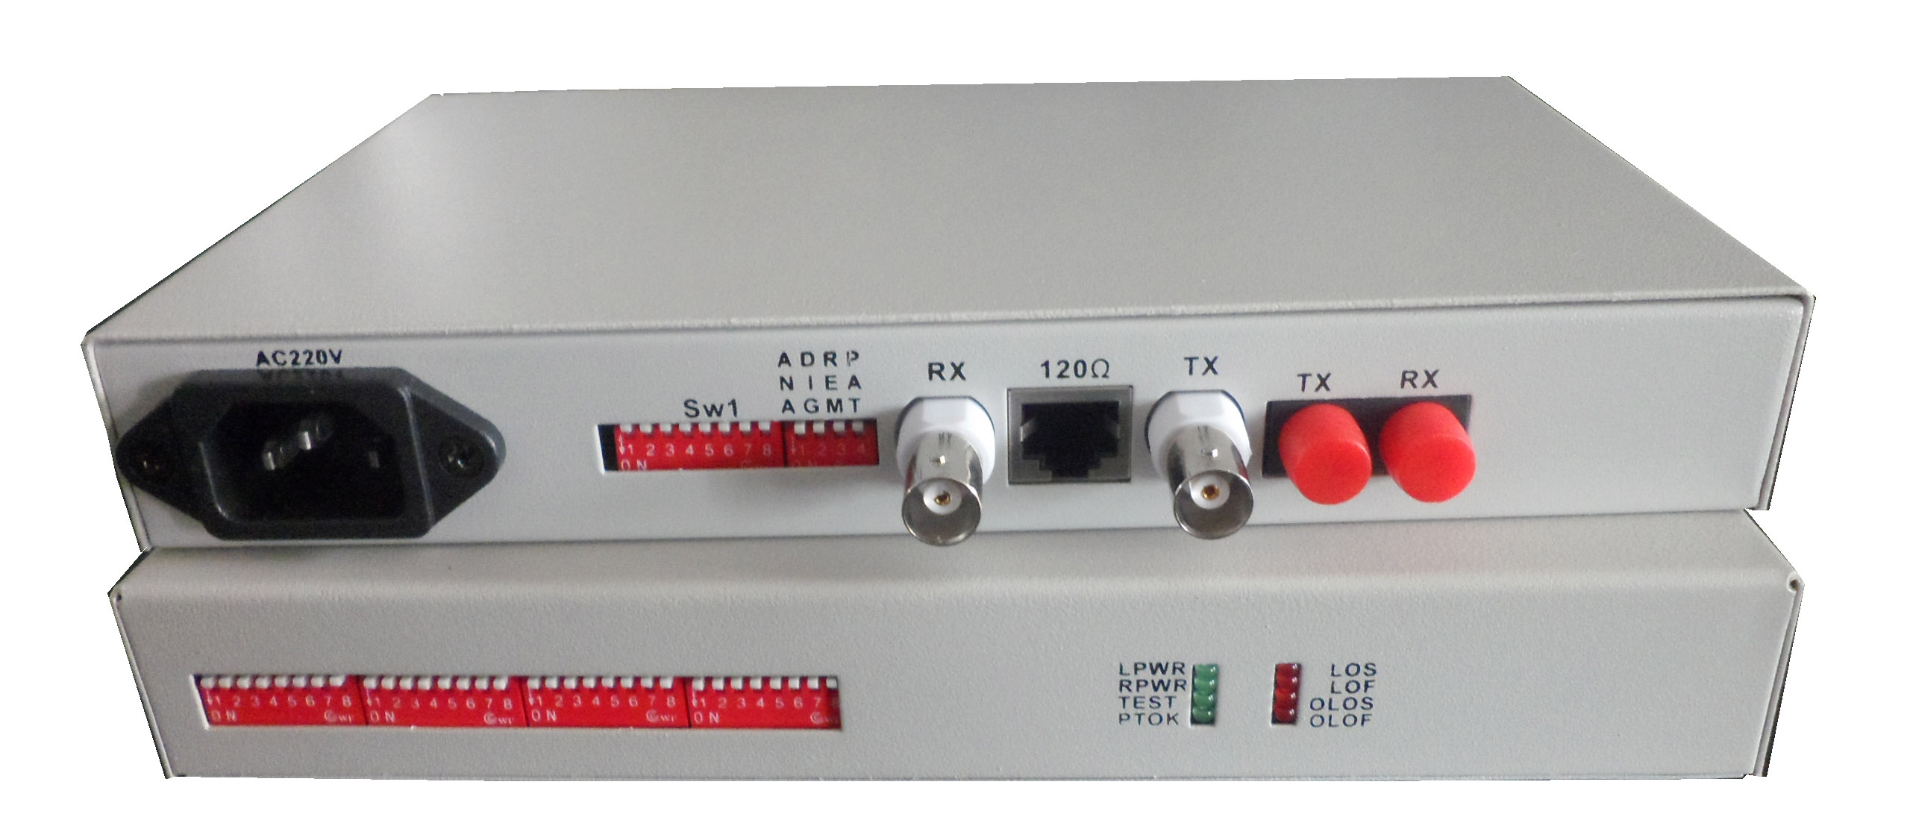

Product Description
The TBC-6101 series devices provide 1 E1 interface and 1 optical interface, can achieve interface conversion, rate conversion and E1 slot extraction between E1 and optical . In unframed mode, the user can utilize the data channel rate of 2.048Mbps. Equipment built-in loop test function, for the project opened and routine maintenance to facilitate.

Features
- Integrated circuit based on independent intellectual property rights;
- It can be detected that when the optical signal is interrupted, it is the fault of the optical fiber line or the remote device, and is indicated by the indicator light;
- Support both adaptive 120Ω( balanced )and 75Ω( unbalanced )two kinds of impedance, no longer need to make settings;
- System through rigorous testing and practical verification, in full compliance with the ITU-T G.703, G.704 and other recommendations;
- Hardware to achieve the choice of any one of 31 time slots (framing effective);
- Provides three kinds of loopback functions: optical port local self-loop (ANA), E1 local self-loop (DIG), the command to the client E1 back to the local loopback;
- Provide pseudo-random code test function (PATT), equivalent to built-in bit error detector, easy to open circuit test;
- Optional AC 220V, DC -48V, DC +24 V, DC power supply without positive and negative points;

Technical Specification
Fiber Optical Modem Series

2/2
Optical Interface | Multimode fiber | 50/125μm or 62.5/125μm,  Max. transmission distance: 5KM 62.5/125μm single-mode fiber, attenuation (3dbm/km)  Wavelength: 820nm  Transmit power: -12dBm (Min) ~ -9dBm (Max)  Receiving sensitivity: -28dBm (Min)  Link budget: 16dBm
Optical Interface | Single-mode fiber | 8/125μm, 9/125μm,  Max. transmission distance : 40KM (actually need to customize for greater distance)  Transmission distance: 40KM @ 9/125μm single-mode optical fiber, attenuation (0.35dbm/km)  Wavelength: 1310nm  Transmit power: -9dBm (Min) ~ -8dBm (Max)  Receiving sensitivity: -27dBm (Min)  Link budget: 18dBm
Optical Interface | Optical interface | FC / SC optional
Optical Interface | Optical code pattern | 1B1H
Optical Interface | Optical Module | single or dual fiber optional
Optical Interface | suitable for optical fiber | single mode 1310nm or multimode fiber optional
Optical Interface | Transmission distance | ordinary 40km (up to 120km)
E1 interface | Equipment E1 interfaces in line with G.703 recommendations
E1 interface | Rate | n * 64Kbps ± 50ppm
E1 interface | Pattern | HDB3
E1 interface | Impedance | Unbalanced 75 / balanced 120 (unbalanced with coaxial interface adapter, adaptable to 75-2 / 3 coaxial cable)
E1 interface | Jitter characteristics | to meet the G.742, G.823 recommendations
E1 interface | Input port allows attenuation | 0 ~ 6dBm
Working environment | Working temperature | 10°C ~ 50°C
Working environment | Storage temperature | -40°C ~ 80°C
Working environment | Relative Humidity | 5%~95% (non-condensing)
Power | Voltage | AC180~260V  DC-48V DC+24V
Power | Power consumption | ≤ 5W
Dimension | 210mm*120mm*30mm

