
4-Channel Telephone Multiplexer
Telephone Multiplexer Series

1/2
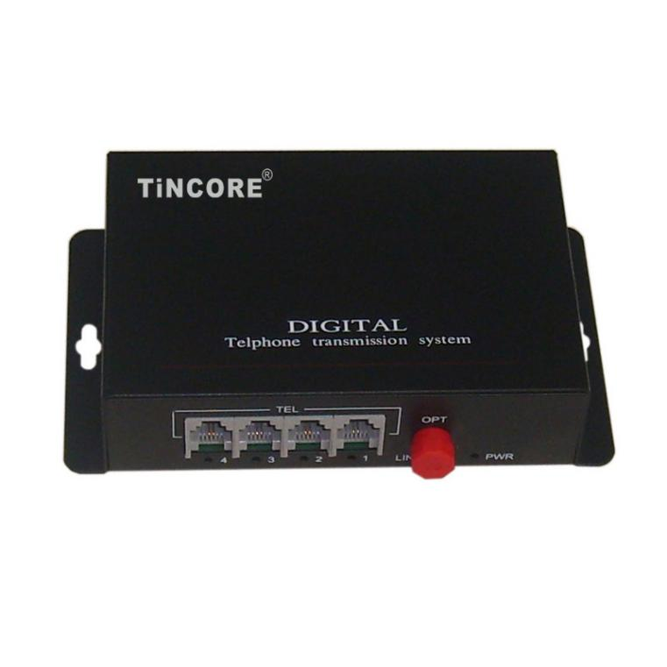
Description
The TCE-DH6804 series Telephone Multiplexer is a point-to-point optical optical transmission equipment developed on the basis of very large-scale integrated circuits. It implements 1*10/100M Ethernet data channel in a compact form and 4-channel voice channel (FXO, FXS), optical multiplexing transmission equipment. With alarm monitoring, functional, high integration, low power consumption, stable performance, easy to use.
Features

- Remote monitoring of the remote device by the local device (unique double-row indicator, upper-row indication and lower-row indication) Integrated circuit based on independent intellectual property;
- Ethernet interface 10M/100M, full / half duplex fully adaptive, support VLAN protocol;
- Provide two kinds of clock: main clock, line clock;
- Provides three kinds of loopback function: The local end of the optical loop, Ethernet local loop, so that the opposite end of the Ethernet ring;
- You can set the auto-rate setting of the remote device commanded by the local device;
- Pseudo-random code test function, easy to open circuit that can be used as a bit error meter;
- Ethernet can support N * 64k rate, the rate is adjustable from 64K-1984K;
- Ethernet monitoring automatic reset function, will not crash;
- Rich Ethernet data prompt function, real-time prompt data communication status;
- Provide 1-4 voice access to support for caller ID and reverse billing functions;
- Support each site put the number function;
- Voice port supports FXO port and FXS port , FXO port and program-controlled switch docking, FXS port and the user's phone connected;
Optical interface (single fiber / dual fiber)
Wavelength | Single mode:1310nm / 1550nm; Multimode 850nm / 1310nm
Fiber | multimode, single mode
Transmit power | 9dBm / -5dBm
Transmission length | multi-mode 2 km, single mode 40,60,120 km
Receiver sensitivity | better than-36dBm (BER <e-11)
Receive dynamic range | > 27dB
Connector | SC / FC / ST
FXS phone interface
Physical interface | RJ11
Ringing voltage | 75V
Ringing frequency | 25Hz
Second-line input impedance | 600Ω (off-hook)
Return loss | 40dB
FXO switch interface
Ringing voltage |  | 35V
Ringing frequency |  | 17Hz-50Hz
Second-line input impedance |  | 600Ω (off-hook)
Return loss |  | 40db
Ethernet
Physical interface | RJ45 , support Auto-MDIX
Protocol | Support IEEE802.3 , IEEE802.1Q(VLAN)
Network Interface Rate | 10 / 100M adaptive
Working mode | duplex / half duplex adaptive
MAC Address Table | You can learn 4096 MAC addresses
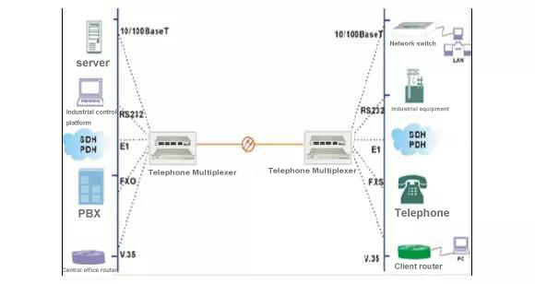
Telephone Multiplexer Series
2/2
Technical Specification
Application

