
16-Channel Telephone Multiplexer
Telephone Multiplexer Series

1/2
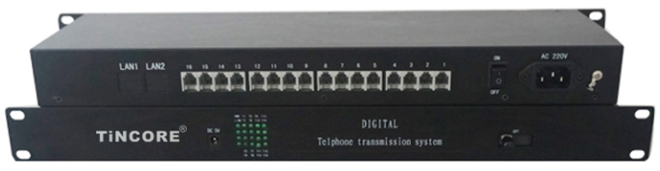
Description
The TCE-DH6816 series Telephone Multiplexer (4E1 16-Channel FXO / FXS) is a point-to-point optical transmission equipment developed on the basis of the ultra-large-scale PDH optical fiber transmission developed by our company. Has a sound alarm function, optional 1 to 4 100M wire speed Ethernet interface and 1 to 4 serial data interface. Device can be built-in SNMP module, stand-alone SNMP management. Electrical equipment for all-digital circuit, the whole work reliable, stable, low power consumption, high integration, small size, easy to install and maintain.

Features

- Integrated circuit based on independent intellectual property rights;
- The whole machine is designed for veneer;
- Can monitor the alarm status of the peer;
- E1 interface complies with G.703 recommendations, using fully digital clock recovery and smooth phase lock technology;
- Provide two expansion interfaces, which can expand 1~4 asynchronous data, such as RS232 / RS485 / RS422 / Manchester code, etc .; or 1~8 switches and 1~4 E1(Therefore, up to 8 E1 channels on this device), 1~4 voice, or two/four-wire audio;
- Ethernet interface 10M / 100M, full / half duplex fully adaptive, VLAN support;
- Each Ethernet port supports Auto-MDIX (cross / straight connection adaptation);
- 1-16 voice access, support for caller ID function;
- Support each site's mutual release number function;
- Voice port support FXO port and FXS port, FXO port and program-controlled switch docking, FXS port and the user's phone connected;
- Desktop equipment can support independent SNMP network management, and support optical network management level connected (optional);
- Can detect the loss of optical signals for the remote device off or fiber fails;
- Can monitor the local temperature and the local voltage;
- Can monitor the voltage and temperature of the remote device and set the temperature alarm threshold;
- A variety of power options: AC220V, DC-48V / DC24V, etc .;
- No relay transmission distance greater than 2 ~ 120 km.
Telephone Multiplexer Series
2/2
Technical Specification
Optical interface
Wavelength | single mode 1310nm / 1550nm multimode 850nm / 1310nm
Fiber | multimode, single mode
Transmit power | -9dBm / -5dBm
Transmission length | 0-50 km / 120 km
Receiving sensitivity | better than-36dBm (bit error rate <10⁻¹¹)
Optical code | Scramble NRZ code
Connector | SC / FC / ST
E1 interface
4 E1 interfaces are in line with G.703 recommendations
Rate | 2048Kb / s ± 50ppm
Pattern | HDB3
Impedance | unbalanced 75Ω
Jitter characteristics | to meet the G.742, G.823 recommendations
Input port allows attenuation | 0 ~ 6dBm
Physical Interface | BNC
Ethernet interface (10 / 100Base-T)
Bandwidth | line speed 100M
Rate | 10 / 100M adaptive, full / half duplex adaptive
Protocol | Supports IEEE 802.3, IEEE 802.1Q (VLAN)
MAC Address Table | learn 4096 MAC addresses
Physical interface | RJ45 , support Auto-MDIX (cross / straight line adaptive)
FXS phone port
Ringing voltage | 75V
Ringing frequency | 25HZ
Second-line input impedance | 600Ω (off-hook)
Return loss | 40 dB
FXO Interface
Ringing detection voltage | 35V
Ringing detection frequency | 17HZ-60HZ
Second-line input impedance | 600Ω (off-hook)
Return loss | 40 dB

