
32-Channel Telephone Multiplexer
Telephone Multiplexer Series

1/2
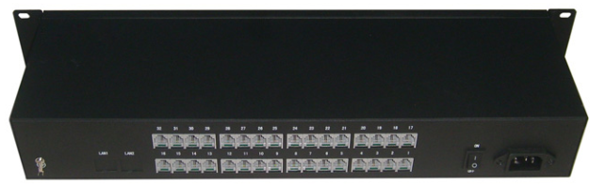

Description
The TCE-DH6832 series PCM Telephone Multiplexer uses the most advanced PCM design, call quality up to broadcast quality.
This series of PCM Telephone Multiplexer can use a fiber optic transmission of 1 to 32 telephone and 2 Ethernet signals at the same time, is a high reliability, cost-effective long-distance transmission equipment.

Features

- Provides 4* 10/100M Ethernet interface;
- Provide 1-32 channels telephone interface (can be customized according to user needs);
- Voice interface supports caller ID and provide anti-polar signal;
- Small size, handsome in appearance, easy installation and operation;
- Perfect status display, easy maintenance and management;
- Adapt to a variety of power environments-48VDC or 220AC;

Working status indicator
1-32 indicates for each call that the light is off when the phone is off-hook, and the phone picks up the light is on ;
LINK is the indicator of the optical link. When the optical link is disconnected, the indicator goes off. When the optical link is connected, the indicator PWR is the indicator of the power. When the power is on, the indicator is off and no power is off.

Optical interface
Type | FC, ST Optional
Wavelength | 1310 / 1550nm
Transmission media | single-mode, multi-mode optional
Transmit power | -12dbm- + 3dbm
Receiving sensitivity | -30dbm ~ -20dbm
Ethernet interface
Rate | 10 / 100BASE-T
Interface Type | RJ45
phone
Number of telephone channels | 1-128
Telephone interface | RJ11
FXS phone port
Ringing voltage | 75V
Ringing frequency | 25HZ
Second-line input impedance | 600Ω (off-hook)
Return loss | 40 dB
FXO Interface
Ringing detection voltage | 35V
Ringing detection frequency | 17HZ-60HZ
Second-line input impedance | 600Ω (off-hook)
Return loss | 40 dB
Power Supply
Send | 5A 5VDC
Receive | 5A 5VDC
Mean time between failures | MTBF> 100,000 hours
Power consumption | 25W
Environment
Operating temperature | -20 ℃ -75 ℃
Storage temperature | -40 ℃ -85 ℃
Humidity | 0-95%
Size | - Channel: 482mm*135mm*45mm  32-Channel: 482mm*135mm*65mm  64-Channel: 482mm*165mm*80mm  128-Channel: 482mm*165mm*150mm
Telephone Multiplexer Series

1/2

