
Fiber Switch Series

1/2
10/100M 1 fiber port + 4 RJ45 ports fiber switch

Product Description

The TBC-MC3414E-D20 fiber switch can convert 4 independent 10/100Base-TX twisted pair electrical signals and 1 independent 100Base-FX optical signal to each other.It extends the transmission distance of the network from the 100m limit of copper wire to 120km.Through the use of switching technology , storage and forwarding technology to achieve data of the two networks before connecting the media , greatly improving the flexibility of fiber Ethernet set, and reducing the cost of network construction, support dual-fiber multi-mode, dual-fiber single-mode , Single-mode single fiber and other optical fiber transmission.Support port speed, working mode, Port VLAN port bandwidth control, priority, port security and other intelligent configuration. Ethernet fiber switch overall performance, easy to use, affordable, for the workgroup users and intelligent residential broadband access to provide the ideal networking solution.
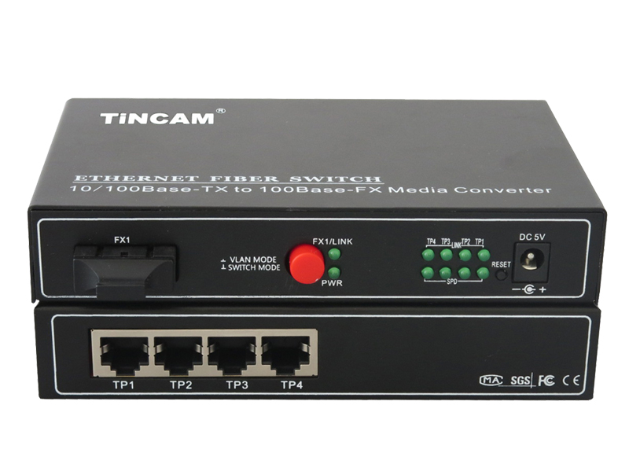

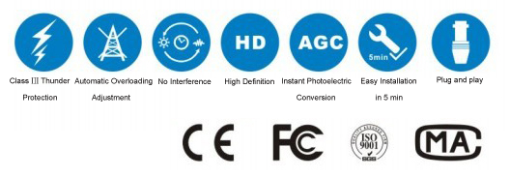

Product Features

- Storage and forwarding capabilities to support rate adaptation and protocol translation;
- Adaptive connection 10M and 100M network and the network port supports full-duplex/ half-duplex adaptation and traffic control;
- Automatic detection and correction of incorrect poles on each port of a twisted pair;
- Data transfer rate (line speed) is 14,880 frames per second (10M);
- Data transfer rate (line speed) is 14,8800 frames per second (100M);
- The amount of power ≤ 5W;
- Support 12K effective MAC address table; MAC Supports MAC address learning and aging automatically;
- 8 MB packet buffer;
- With broadcast storm protection ;in line with IEEE802.3, IEEE802.3u standards;
- Flow control methods: Full duplex IEEE802.3x standard, Half-duplex using Back-pressure technology;
- 4*10/100M adaptive RJ45 ports, support port auto-flip (AutoMDI / MDIX);Provide 1*100M optical port to meet the requirements of long-distance transmission;
- Support 4 groups of Port VLAN and MTU VLAN functions;Provides port bandwidth control with a minimum granularity of 128kbps;
- Support IEEE802.1p priority protocol mode, the second static port priority Level mode and ToS priority mode ;
- Support for broadcast storm control,Provide fixed IP address settings;
- Support switch system software upgrades, configuration file saving and recovery;
- External 5V1A switching power supply;
- Support physical isolation ;

Fiber Switch Series

2/2
Product Specification

Standard | IEEE 802.3 10BASE-T Ethernet,  IEEE 802.3u 100BASE-TX Fast Ethernet,  IEEE 802.3x protocol CSMA/CD
Data Transmission Rate | Ethernet : 10Mbps(Half-duplex) 20Mbps(Full-duplex)  Fast Ethernet : 100Mbps(Half-duplex) 200Mbps(Full-duplex)
Power Input | 5VDC, 2A
Work environment | Work Temperature | 0℃~50℃
Work environment | Storage Temperature | -30℃~60℃
Work environment | Humidity | 5%~90% non-condensing
Dimensions(mm) | 232mm*142mm*45mm
Weight | 0.69kg

