
Fiber Switch Series
1/2
10/100M 2 fiber ports +4 RJ45 ports Switch

Product Description

The TBC-MC3424E-D20 Series 10/100M Adaptive Switched or Isolated Ethernet Fiber Transceiver, which integrates the functions of a single transceiver and a simple switch to convert a standalone 10/100Base-TX twisted pair electrical signal and an independent 100Base-FX optical signal conversion. It extends the network's reach from 100m copper limit to 120km (single-mode full duplex) and supports two different types of network connection media: 10/100Base-TX and 100Base-FX, through the use of switching technologies and storage forwarding Technology to realize the data transmission between two kinds of network connection media, which greatly improves the flexibility of establishing the Ethernet optical network and reduces the network construction cost, and supports dual-fiber multi-mode, dual-fiber single mode and single fiber single Mode and other optical fiber transmission.
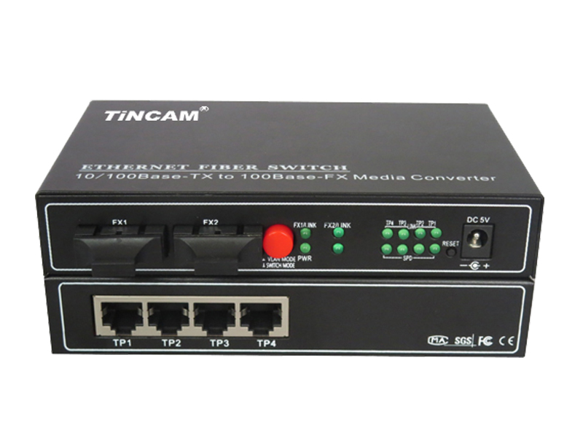

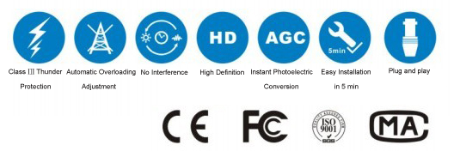

Product Features

- Storage and forwarding capabilities to support rate adaptation and protocol translation;
- Adaptive connection 10M and 100M network and the network port supports full-duplex/ half-duplex adaptation and traffic control;
- Automatic detection and correction of incorrect poles on each port of a twisted pair;
- Data transfer rate (line speed) is 14,880 frames per second (10M);
- Data transfer rate (line speed) is 14,8800 frames per second (100M);
- The amount of power ≤ 5W;
- Support 12K effective MAC address table; Supports MAC address learning and aging automatically;
- 8 MB packet buffer;
- With broadcast storm protection;

Fiber Switch Series
2/2
Product Specification

Port | 4*10/100M adaptive Ethernet port  2*100Base-FX optical port
Connector | RJ45 ,SC,FC,ST,LC
Port features | Interface Type: 4 * RJ-45 (UTP), SC (optical port);  Complies with IEEE802.3 and 802.3u standards;  RJ45 port : 10/100Mbps adaptive, full / half duplex communication mode;  Adaptive;  Support straight-through connection / cross-adaptability;
Configuration port | Interface type ：RJ45
Cable Type | 10/100Base-TX ： twisted pair CAT3/4/5 (up to 100m)  100Base-FX ：Fiber type 50/125,62.5/125,9/125μm
Conversion method | Fast storage and forwarding
Power supply | AC100V ~ 240V ,50/60Hz
Power consumption | 10W
Operating temperature | 0℃ ~ 60 ℃
Storage temperature | -40℃ ~ 70 ℃
Humidity | 5%~90% non-condensing
Weight | 1.2kg



