
Fiber Switch Series
1/2
10/100M 2 fiber ports +6 RJ45 ports Switch

Product Description

The TBC-MC3426E-S20 Series 10/100M 2 fiber ports + 6 RJ45 ports Switch converts 6 independent 10/100Base-TX twisted pair electrical signals and 2 single 100Base-FX optical signals to each other. It extends the network's reach from the 100M copper limit to 120KM. By using switching and store-and-forward technology to enable data before the two kinds of network connections to the media, it greatly increases the fabric flexibility of Fiber Ethernet and Reduces the cost of the network set up to support dual-fiber multi-mode, dual-fiber single-mode, single-mode single-mode fiber and other optical transmission.
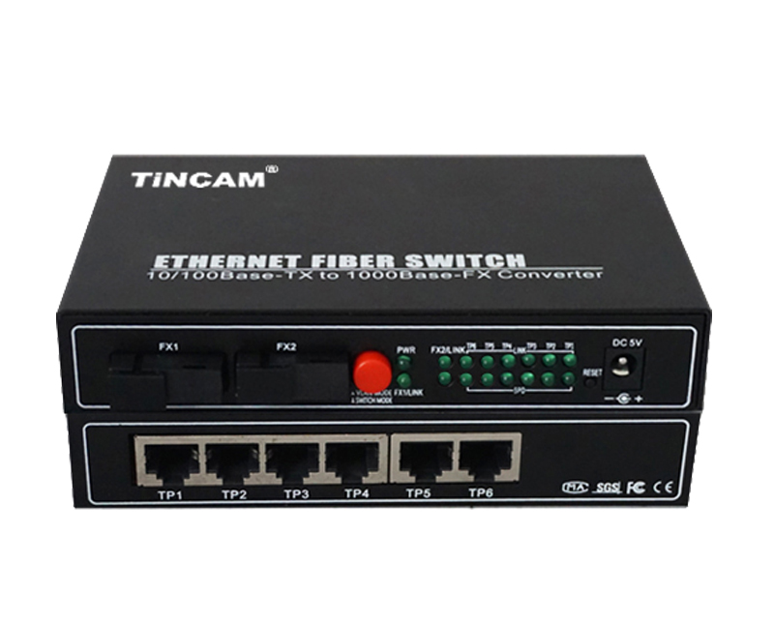

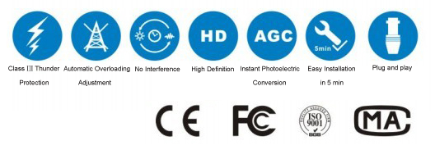

Product Features

- Storage and forwarding capabilities to support rate adaptation and protocol translation;
- Adaptive connection 10M and 100M network and the network port supports full-duplex/ half-duplex adaptation and traffic control;
- Automatic detection and correction of incorrect poles on each port of a twisted pair;
- Data transfer rate (line speed) is 14,880 frames per second (10M);
- Data transfer rate (line speed) is 14,8800 frames per second (100M);
- The amount of power ≤ 5W;
- Support 12K effective MAC address table; Supports MAC address learning and aging automatically;
- 8 MB packet buffer;
- With broadcast storm protection;

Fiber Switch Series
2/2
Product Specification

Port | 6*10/100M adaptive Ethernet port  2*100Base-FX optical port
Connector | RJ45 ,SC,FC,ST,LC
Port features | Interface Type: 6 * RJ-45 (UTP), SC (optical port);  Complies with IEEE802.3 and 802.3u standards;  RJ45 port : 10/100Mbps adaptive, full / half duplex communication mode;  Adaptive;  Support straight-through connection / cross-adaptability;
Configuration port | Interface type ：RJ45
Cable Type | 10/100Base-TX ： twisted pair CAT3/4/5 (up to 100m)  100Base-FX ：Fiber type 50/125,62.5/125,9/125μm
Conversion method | Fast storage and forwarding
Power supply | AC100V ~ 240V 50/60Hz
Power consumption | 10W
Operating temperature | 0℃ ~ 60 ℃
Storage temperature | -40℃ ~ 70 ℃
Humidity | 5%~90% non-condensing
Weight | 1.2kg



