
Fiber Switch Series
1/2
10/100/1000M 1 fiber port +2 RJ45 ports Switch

Product Description

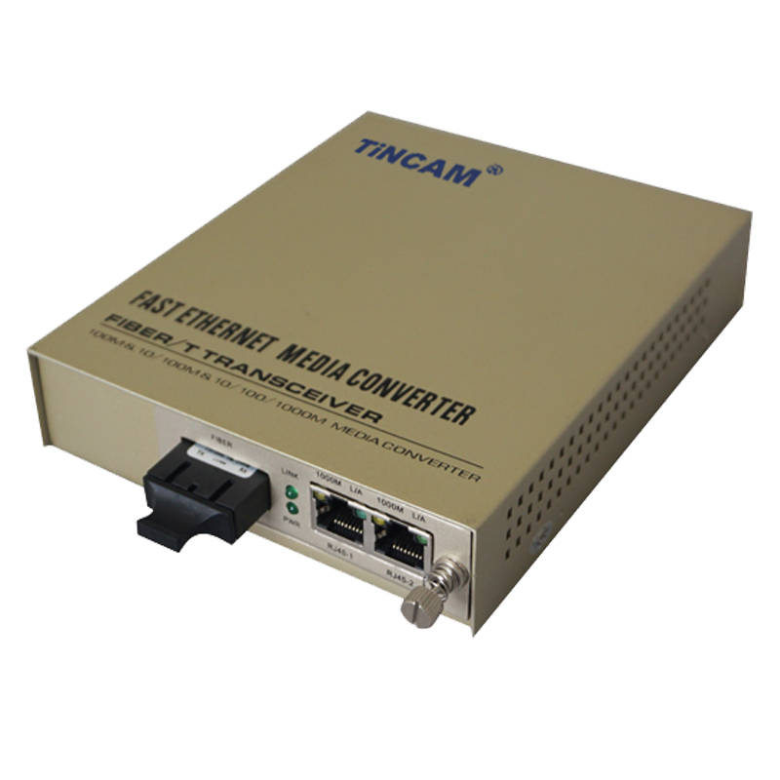
The TBC-MC3712A-D20 series 10/100/1000M adaptive fiber media converter through 10/100/1000Base-TX to 1000Base-FX photoelectric conversion between the traditional 10M ,100M Ethernet or 1000M Fast Ethernet through the Fast Ethernet fiber optic link extended to 120km range, to meet the long-distance, high-speed , High-bandwidth fast Ethernet working group user needs, the product performance is stable and reliable, designed to meet the Ethernet standards, and anti-lightning protection measures, especially for telecommunications, mobile, China Unicom, safe city, radio and television, railway, military, financial securities, customs, civil aviation, maritime transport, electricity, water conservancy and oil fields and other broadband data network and require high reliability data transmission or the formation of IP data transmission network area, it is the best application equipment for broadband campus network，intelligent broadband district fiber to the floor , Fiber to the home and video surveillance .

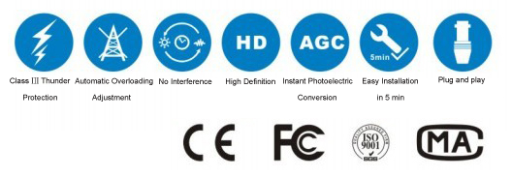

Product Features

- Support full duplex or half duplex network communication, and with auto-negotiation capability;
- Support the transmission of long data packets in VLAN and match the switch products that support IEEE802.1Q protocol;
- Support LINK LOSS link remote pre-alarm function;Automatically adapt to 10M ,100M and 1000Mbps environment, easy to upgrade the network；
- RJ45 port support through or cross automatic recognition function (AUTO-MDIX);
- REMOTE PAUSE function ensures the integrity of packet transmission；
- With broadcast storm protection, balance flow, isolation conflicts and detection errors and other functions;
- Meet the electromagnetic interference standard FCC Part15 Class A and CE Mark safety regulations；
- High-quality laser device has good light characteristics, electrical characteristics and temperature stability;
- Adopt international advanced technology scheme and high performance integrated chip, the circuit layout is scientific, the work is stable, the data transmission is steady, the anti-interference ability is strong, avoiding the circuit voltage, surge, inductive lightning strike, static electricity, hot swap damage equipment;

Fiber Switch Series
2/2
Product Specification

Standard Protocol | IEEE 802.3ab, IEEE 802.3Z, IEEE 802.1X,
Band Width | RJ 45 Port |  | 10/100/1000M |  | Optical Port | 1.25G
Operation Mode | Full /Half duplex mode,with auto-negotiation capability
Connectors | UTP | RJ45 |  |  | Fiber connector | SC/FC/ST/LC
LED Indicators | 1000M,100M, FX/ACT, TP/ACT , PWR,FDX.
UTP Cable | Cat5 UTP （within 100m）
Fiber Cable | 9/125,(single mode dual fiber 20 -120km)、（wavelength 1310nm,1550nm）
Fiber Cable | Transmission power：≥-12～≥-8dBm  Receiving sensitivity：≥-32～≥-36dBm
Power Supply | Dual power supply  built-in power |  |  | AC220V、DC-48V（optional）
Power Supply | Power Consumption |  |  | ≤5W
Working Environment | Work Temperature |  |  | 0℃~50℃
Working Environment | Storage Temperature |  |  | -40℃~70℃
Working Environment | Humidity |  |  | 5%~90% non-condensing
MTBF (Hours) | >50000
Size | 173mm*129mm*33mm
weight | 1.1kg
Certification | FCC Part 15 , Class A, RoHS and CE Mark SGS

LED Indicators

Name | Definition | Description
PWR | Power Indicator | ON when the power supply is turned on and in normal working status
LINK | Optical interface status indicator | Bright : optic fiber cable is connected well, but no data transmission
LINK | Optical interface status indicator | Blinking: optic fiber cable is connected well,data is being transmitted
L/A | Rate indicator | Bright : fiber transceivers operate at 100M
L/A | Rate indicator | Blinking: twisted pair link connectivity receiving data,data being transmitted
FDX | Rate indicator | Bright: fiber transceivers operate at 1000M  The network port works in full duplex mode
FDX | Rate indicator | Blinking, twisted pair link connectivity, data being transmitted

