
Fiber Switch Series
1/3
10/100/1000M 1 fiber port +8 RJ45 ports Switch

Product Description

The TBC-MC3718E series Ethernet optical switch has 1*1000M optical port and 8*10/100/1000M adaptive RJ45 interface, users can choose according to the needs of different 1*9 fixed or hot-swappable SFP Optical modules, such as multi / single mode, single / dual fiber, single mode 550m ~ 120Km and so on. Can realize the Ethernet optical, seamless connection between electrical signals, cascading. Switching chip using the latest American IC, stable performance, good quality, easy to use, with high cost, suitable for small fiber Ethernet and fiber optic Ethernet networks with special needs.
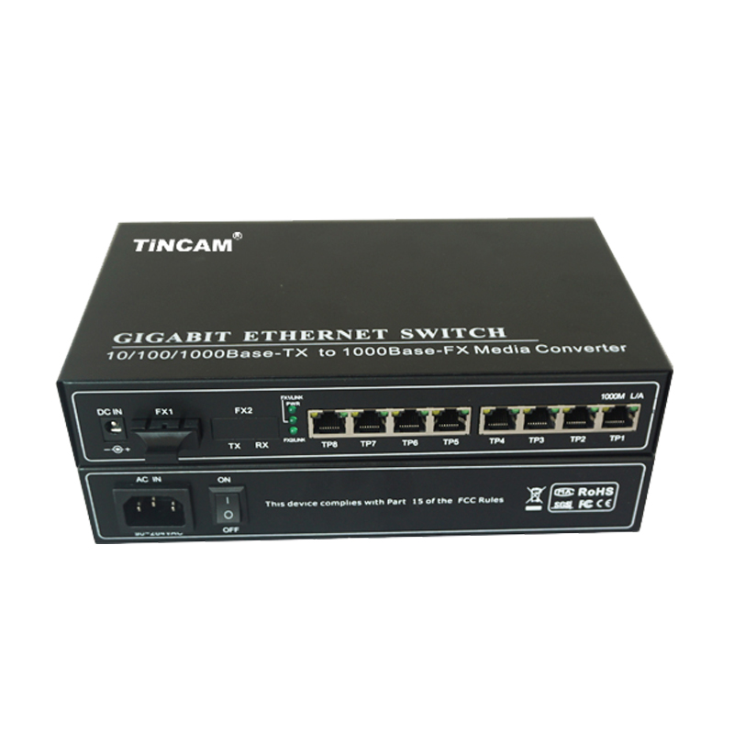
Product Features

- 1*10/100/1000M SC Optical port and 8*10/100/1000M RJ45 ports (optional);
- Optical interface supports three kinds of fiber multimode dual fiber, single mode dual fiber, single mode single fiber ;
- RJ45 electrical port can adapt to 10/100/1000M, full / half duplex mode;
- RJ45 port supports straight or cross automatic identification (AUTO-MDIX);
- Optical port supports 1000M full duplex mode;
- Support flow control, can prevent broadcast storm;
- Support up to 1632 bytes long packet;
- Small power consumption (10W), less heat, good stability;
- SFP module support hot-swappable.

LED Indicator

Name | Definition | Description
PWR | Power Indicator | ON when the power supply is turned on and in normal working status
FX1/LINK FX2/LINK | Optical interface status indicator | Bright :fiber link connectivity, no data transmission;  Blinking: fiber link is connected, data is being transmitted
LINK | Rate indicator | Bright :twisted pair link is connected
LINK | Rate indicator | Blinking: twisted pair link is connected, the data is being transmitted
SPD | Network port mode indicator | Bright: fiber optic transceivers work in 100M; network port full duplex mode of work

Fiber Switch Series
2/3
Product Specification

Standard Protocol |  | IEEE802.3u/z/ab,10Base-T,100Base-TX,1000Base-X
Rate |  | 1Gbps
Operation Mode |  | Full /Half duplex mode
Optical interface |  | SC /ST or FC / LC (default SC interface)
Physical interface |  | RJ45 port
Multi mode | Suitable for optical fiber | 62.5/125,50/125,100/140µm
Multi mode | Transmission distance | 550m 2Km
Multi mode | Transmit power | >-20~-14dBm
Multi mode | wavelength | 850nm//1310nm
Multi mode | Receiving sensitivity | <-31dBm
Single mode | Suitable for optical fiber | 9/125、8.3/125、8.7/125 or 10/125µm
Single mode | Transmission distance | 25km | 40km | 60km | 80km | 120km
Single mode | Transmit power | -12~-8dBm | -8~-3dBm | -3~0dBm | -3~1dBm | -3~2dBm
Single mode | wavelength | 1310nm | 1310nm | 1490nm /1550nm | 1490nm /1550nm | 1490nm /1550nm
Single mode | Receiving sensitivity | < -32dBm | < -34dBm | < -34dBm | < -38dBm | < -38dBm
Work Temperature |  | -20 ℃ ~ +65 ℃ (Commercial ) - 40 ℃ ~ +85 ℃ (Industrial )
Power Supply |  | AC100-260V 48VDC (Internal power supply),DC12V 24V 5V (External power supply)
Storage Temperature |  | -40℃~+90℃
Relative humidity |  | 5%~90% non-condensing
MTBF (Hours) |  | >50000
Certification |  | FCC Part 15 , Class A, RoHS and CE Mark SGS

Packing list

1 fiber port & 8 RJ45 port fiber switch
power cable
user's Guide
Warranty Card

