
Fiber Switch Series

1/2
10/100/1000M 2 GE fiber port & 8 GE RJ45 ports Fiber Switch

Product Description

2*10/100/1000M Optical ports + 8*10/100/1000M adaptive RJ45 ports Ethernet optical switch , the user can choose different 1*9 fixed or hot-swappable SFP Modules, such as multi/single mode, single/dual fiber, single mode 550m ~ 120Km and so on. Can realize the Ethernet optical, seamless connection between electrical signals, cascading. Switching chip using the latest American IC, stable performance, good quality, easy to use, with high cost, suitable for small fiber Ethernet and fiber optic Ethernet networks with special needs.
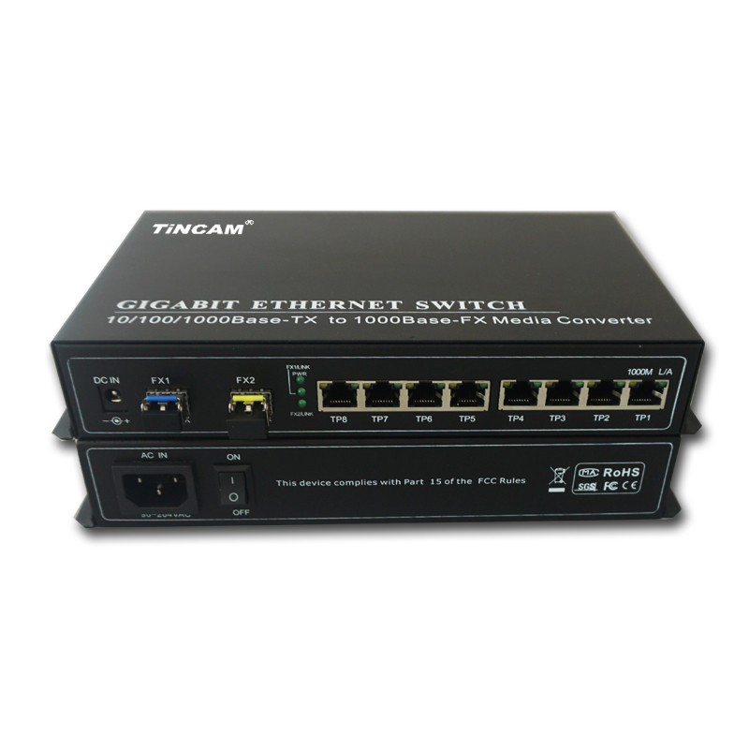
Product Features

- Provide 2 *SFP /1*9 module optical ports and 8*10/100/1000M RJ45 RJ45 ports (optional);
- Optical interface supports multimode dual fiber, single mode dual fiber, single mode single fiber ;
- RJ45 port can adapt to 10/100/1000M, full / half duplex mode;
- RJ45 port supports straight or cross automatic identification (AUTO-MDIX);
- Optical port supports 1000M full duplex mode;
- Support flow control, can prevent broadcast storm;
- Support up to 1632 bytes long packet;
- Small power consumption (10W), less heat, good stability;
- SFP optical module supports hot swap.

LED Indicator

Name | Definition | Description
PWR | Power Indicator | ON when the power supply is turned on and in normal working status;
FX1/LINK  FX2/LINK | Optical interface status indicator | Bright : optic fiber cable is connected well, but no data transmission;  Blinking: when receiving data;
LINK | Rate indicator | Bright: twisted pair link is connected;  Blinking, twisted pair link is connected, data is being transmitted
SPD | RJ45 Port status indicator | Bright: fiber transceivers operate at 1000M  The network port works in full duplex mode

Fiber Switch Series

2/2
Product Specification

Standard Protocol | IEEE 802.3u, IEEE 802.3Z, IEEE 802.3ab,10Base-T, 100Base-TX,1000Base-X
Band Width | RJ 45 Port : 8*10/100/1000M |  |  | Optical Port: 1.25G
Operation Mode | Full /Half duplex mode,with full duplex / half duplex auto-negotiation
Connectors | UTP: RJ-45 |  |  | Fiber connector : SC/FC/ST/LC
Multi mode | Applicable optical fiber: 62.5/125,50/125,100/140μm  Transmission distance: 550m 2Km  Transmit power > -20 ~ -14dBm  Wavelength :850nm / 1310nm  Receiver sensitivity <-31dBm
Single mode | Applicable optical fiber: 9/125,8.3/125,8.7/125 ,10/125µm
Single mode | Transmission distance | 25km | 40km | 60km | 80km | 120km
Single mode | Transmit power | -12~-8dBm | -8~-3dBm | -3~0dBm | -3~1dBm | -3~2dBm
Single mode | Wavelength | 1310nm | 1310nm | 1490/1550nm | 1490/1550nm | 1490/1550nm
Single mode | Receiver sensitivity | < -32dBm | < -34dBm | < -34dBm | < -38dBm | < -38dBm
Power Supply | External Power supply |  |  | DC 12V 24V 5V
Power Supply | Internal Power Supply |  |  | AC 100-260V 48VDC
Environmental Parameters | Work Temperature |  |  | -20℃~+65℃(Commercial) -40℃~+85℃(Industrial )
Environmental Parameters | Storage Temperature |  |  | -40℃~+90℃
Environmental Parameters | Humidity |  |  | 5%~90% non-condensing
MTBF (Hours) | >50000
Certification | FCC Part 15 , Class A, RoHS and CE Mark,SGS
Packing list

- 2*10/100/1000M Optical ports + 8*10/100/1000M adaptive RJ45 ports Ethernet optical switch
- Power Adapter
- User's Guide
- Warranty Card

http://sztincam.en.alibaba.com

