
4-Channel Video Optical Transceiver
Video Optical Transceiver Series

1/3

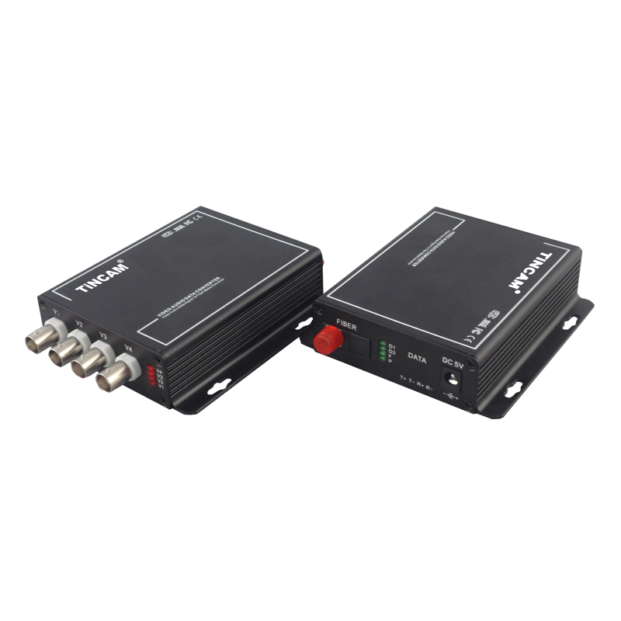

Product Overview
The TBC-SF4V-S20T/R series digital video optical transceiver has a full-featured all-digital video optical transmission equipment that can transmit 4-Channel high-quality (10Bit) uncompressed video information and 1-Channel control signal on one fiber at the same time, optional audio、 data、 switch volume . This product is convenient for field wiring, no need for any photoelectric adjustment; with power, optical and data loop instructions; optional standalone desktop installation and modular rack-mounted two structural forms. The TBC series digital optical products are mainly used for long-distance optical fiber transmission monitoring system, such as security monitoring, highways, electronic police, automation, intelligent community, customs, electricity, water, petroleum, chemical and many other fields.

Optical Characteristics：
fiber type/  parameter | Fiber interface type | Emission wavelength nm | Transmit power dBm | Receiver sensitivity dBm | Light saturation dBm | Optical loss dBm/km | Transmission distance km
Multi Mode | SC/FC | 850 | -18.5~-14 | -35 | -8 | 2 | 0~2
Multi Mode | SC/FC | 1310 | -19.5~-16 | -36 | -9 | 1 | 0~3
Single Mode | SC/FC | 1310 | -15~-10 | -34 | -8 | 0.5 | 0~20
Single Mode | SC/FC | 1310 | -12~-5 | -36 | -3 | 0.5 | 0~40
Single Mode | SC/FC | 1550 | -5~0 | -38 | 2 | 0.25 | 0~60

Product Features：
Video Optical Transceiver Series
2/3
- 10-bit digital encoding and uncompressed video transmission; support any high-resolution video signal;5Hz-10MHz video channel; automatically compatible with PAL, NTSC, SECAM video system ;
- With APC circuit, the output optical power is constant, the dynamic range is large;
- Use the process without downtime maintenance in the process of using, can be hot-swappable;
- The video quality is independent of the transmission distance within the allowable range of optical power;
- Support video, data, audio transmitted in parallel ,bidirectional / unidirectional optional;
- Gigabit fiber transmission, large capacity, easy to upgrade;
- Power and other parameters status indicator LED can monitor the operation status of the system;
- Support any high resolution video signal; support video lossless regenerative relay;
- Support RS232/RS485/RS422 or Manchester code;
- Advanced adaptive technology, does not require on-site electrical or optical adjustment;
- Industrial modular design makes the device reliable and flexible; Can automatically restore the overload protection; unique full built-in power supply design;Desktop, wall mounted, 19 inch 1U rack or 4U card insert; support for user customization.

Parameter
Application environment:
security system, TV medical, high-fidelity video and video conference call, real-time monitoring and control system, intelligent traffic monitoring system (ITS), remote multimedia teaching / campus monitoring, long-distance radio and television transmission system
Optical characteristics:
Optical interface: SC/FC/ST
Wavelength: single mode 1310nm/1550nm ；multimode 850nm/1310nm
Fiber; multimode, single mode;
Transmission power transmission: -9dBm/-5dBm
Transmission length: 0-100km;
Receiving sensitivity: better than -36dBm
Features: Can be customized according to user needs for different interface types.
Video characteristics:
Channel：4-Channel video
Video interface form: BNC
Signal system: PAL/NTSC/SECAM; nominal input/output level: 1Vp-p
Video input/output impedance: 75（unbalanced)
Video Optical Transceiver Series Series

3/3
Video input/output voltage: 1Vp-p
Video bandwidth: 8MHz
Video sampling: 15MHz high speed sampling
Differential gain:(10% -90% APL) DG<1% (typical)
Differential phase:(10% -90% APL) DP<0.7o (typical)
Video signal to noise ratio(weighted):S/N ≥ 70dB (maximum optical link loss)
Color brightness delay difference of 10ns (typical)
Color brightness gain difference: ± 10% (typical);
Note: support forward, reverse, BIDI video.

Ambient temperature: -30 ℃ ~ 75 ℃;
Storage temperature: -40 ℃ ~ 85 ℃
Relative humidity: 0 ~ 95% (non-Condensing);
Size: Standalone (225mm*200mm*40mm)
Size: Card (standard 4U centralized management rack)
Rated supply voltage: AC220V / 50Hz;
Internal power consumption: 2.5 W;
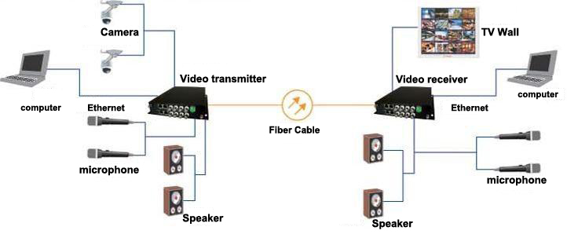
MTBF: ≥10⁵ hours

Application

