
2-Channel Video + 1-Channel reverse RS485 data HD - Video Optical Transceiver
HD-Video Optical Transceiver Series

1/2
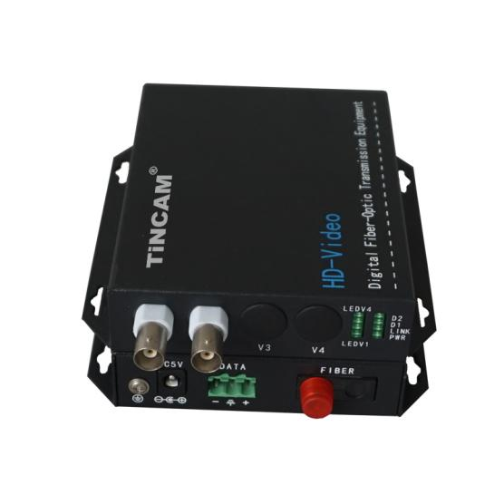
Product Overview
The TBC-CVISF2V1FD-S20 series 4-Channel Coaxial HD video optical transceiver is designed for long-distance optical fiber transmission HD-CVI /TVI /AHD composite video, It adapts self-developed uncompressed digital photoelectric conversion technology,and uses optical fiber point-to-point transmission of megapixel high-definition video, to realize High-definition, high-reliability video transmission. It can simultaneously transmit 1/2/4/8/16-Channel HD-CVI /TVI /AHD composite video.

Product Features
- A variety of compatible mode, the ultimate transmission (to support the AHD/CVI/TVI HD coaxial camera, automatically compatible 720P, 960P, 1080P HD compatible coaxial camera can transmit high-definition video signals on a fiber, all-digital Compression, real-time transmission);
- Built-in three lightning protection chips (imported chips, standard 20 km high-speed optical module transmission image quality is clear, stable performance, selection of materials, transmission more stable, faster, more powerful, more secure, more at ease)
- MTBF > 100,000 hours (radio and television transmission, video surveillance, railway, highway monitoring, security video conferencing ,automation intelligent community, etc.)
- High-quality metal, durable (the product uses 1.0 thickness of the metal shell, effective shielding interference signal strong and durable, can be used in -25 ℃ to 65 ℃ harsh environment, multi-layer low temperature baking process, anti-embroidered corrosion resistance)
- Strong cooling, stable performance (the product uses porous cooling pattern on both sides of the design, to expand the product within the air circulation area, increase the speed of air alternating hot and cold, to ensure long-term stable operation of the product, longer service life)
Video Optical Transceiver Series

2/2
- Can be wall-mounted, can be 2U rack (wall-mounted , user-friendly installation, saving cabinet space; the receiving end can be made on the card-type 2U Optical 14-slot rack, user-friendly centralized management)

Parameter
Optical characteristics:
Wavelength | 1310nm &1550nm
Optical power | -8 ~ -3dBm
Fiber type | 50/125μm Multi mode,62.5/125μm Multi mode,9/125μm Single mode
Receiver sensitivity | -22dBm
Optical interface | FC
Transmission distance | 0-500M (Multi mode)/ 0-40KM (Single mode)

Video characteristics:
Transmitter input level | >500mVp-p
Receiver output level | 1Vp-p
Input and output impedance | 75Ω
Receiver up/down time | <0.8ns
Receiver jitter | <0.2 UI
Physical interface | BNC interface
Indicator | Optical Link, power, data, video source indicator
Power supply | DC5V
Power consumption | ≤5W
Working temperature | -40 ℃ ~ 85 ℃
Storage temperature | -40 ℃ ~ 85 ℃
Operate humidity | 0 ~ 95% (non-Condensing)
MTBF | ≥10⁵ hours

Application
Radio and television transmission, video surveillance, railway highway monitoring, security video conferencing, intelligent automated community and so on.

