
4E1 PDH Multiplexer
PDH Multiplexer Series

1/3
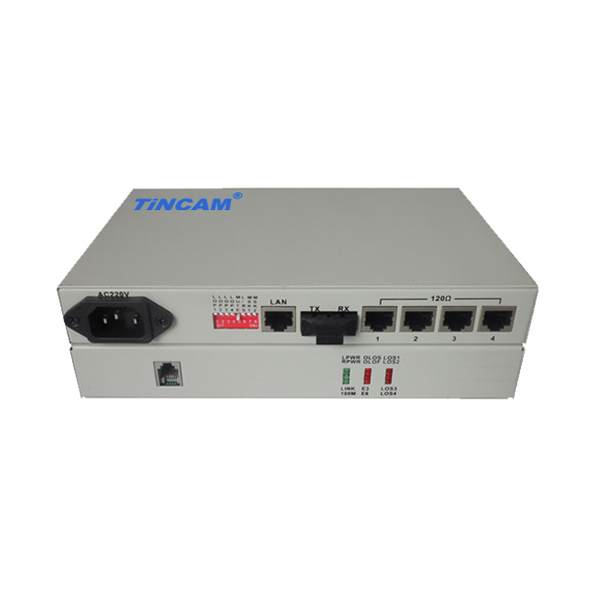
Product Description
The TBC-6120N 4E1 PDH Multiplexer series products are long-distance transmission through optical fiber single or multiple E1 services, which uses industry-leading technology and special large scale integrated circuits, combined with dedicated digital multiplexing chip developed by the optical transmission products. This type of device supports point-to-point networking and is easy to install and maintain. With the chassis, the central office and the remote can be unified to achieve fault location quickly. As a result, the fault response speed is saved and the operation and maintenance costs are saved.
The 4E1 PDH Multiplexer provides 8M transmission capacity for the PDH optical transmission system. The circuit part of the equipment is an all-digital circuit. The whole unit is reliable, stable, low in power consumption, high in integration, small in size and easy to install and maintain. The Equipment to meet the needs of telecom operators and private network users, in line with telecommunications standards. Suitable for power, postal services, banking and China Unicom, mobile telecommunications and other user needs, in line with the standards used by telecom operators.
Product Features
- Provide 4 E1 interface;
- Provide command E1 loopback function, optical path local loop function;
- All-digital clock recovery and smooth phase lock technology, high reliability and compatibility;
- Complete power supply, link and alarm indication function, the local device can monitor the current status of the remote device in real time;
- Provide branch alarm and sound alarm shield;
- Provide 1-channel business telephone interface, do not take up the E1 channel, can easily contact with the opposite end;
- Dual fiber bidirectional and single fiber bidirectional models are optional;
- Optical interface optional SC/PC, FC/PC;
- Conforms to carrier-class operation requirements, mean time between failures (MTBF) more than 100,000 hours;
- High reliability, providing 19 "rack mount, desktop, wall, card, at the same time with AC and DC power supply;
PDH Multiplexer Series

2/3
- Power can choose to AC 220V, DC -48V, the whole power consumption <5W; Provide SNMP network management functions;

Product Parameter
Optical Interface Features | Fiber Type | Single Mode Fiber 8.3 / 125,8.7 / 125,9 / 125,10 / 125
Optical Interface Features | Fiber Wavelength | 1310nm
Optical Interface Features | Fiber Interface | FC / SC / ST optional
Optical Interface Features | Optical code speed | 4E1 PDH is 16.896Mbit / s, 4E1+100M PDH is 55Mbit / s
Optical Interface Features | Optical code pattern | 4E1 PDH is 1B1H, 16.896Mbit / s, 4E1+100M PDH is 1B2B
Optical Interface Features | Optical source | LD
Optical Interface Features | Output optical power | ≥ -13dBm;
Optical Interface Features | Receiver type | PINFET
Optical Interface Features | Receiving sensitivity | ≤-38dBm (BER ≤ 10⁻¹¹)
E1 interface Features | Interface code | HDB3
E1 interface Features | Interface code speed | 2.048Mbit / s ± 50ppm
E1 interface Features | Interface Features | ITU-T G.703
E1 interface Features | Interface Type | BNC, RJ45
E1 interface Features | Interface impedance | 75Ω unbalanced / 120Ω balanced
Transmission distance | Multi mode | 0~2km
Transmission distance | Single mode | 20KM,40KM,60KM,80KM,100KM,110KM
Ethernet interface features | Interface Rate | 10/100M adaptive
Ethernet interface features | Interface Protocol | IEEE802.3,IEEE802.3U,IEEE802.1d,IEEE802.1Q
Ethernet interface features | Physical interface | RJ45
RS232 Interface | Operation mode | ≤19.2Kbit/s Asynchronous serial
RS232 Interface | Interface Type | RJ45
Power | Power supply | AC180~240V DC-36V~DC-72V DC+20V~DC+36V
Power | Power consumption | ＜6W
Working environment | Working temperature | 0°C ~ 50°C
Working environment | Humidity | 5%~95% (non-condensing)
Working environment | Storage temperature | -40°C ~ 70°C
Dimension | 216mm*140mm*31mm（desktop） 482mm*160mm*44mm（Rack-mount）

Application
PDH Multiplexer Series

3/3

Large-scale programmable logic device design makes the replacement of the product much faster than the traditional ASIC-based Optical Transceiver, especially for high reliability requirements of the occasion. Such as: Mobile, China Unicom, telecommunications, electricity, public security, military, road, aviation and other special communications network; E1 line to support the local and remote loopback test capabilities to facilitate the opening of equipment, testing lines, troubleshooting, reduce operators and users Of the maintenance costs; Support SNMP local and remote network management, providing a powerful network management functions; Optical interface support ALS function, user-friendly design, can effectively control the output of optical signals in non-connected state, to avoid glare on the debugger's eyes caused Injury, to give maximum protection and debugging personnel; optional multi-mode / single-mode dual-fiber, single-mode single fiber.
