
16E1+ ETH PDH Multiplexer
PDH Multiplexer Series

1/2
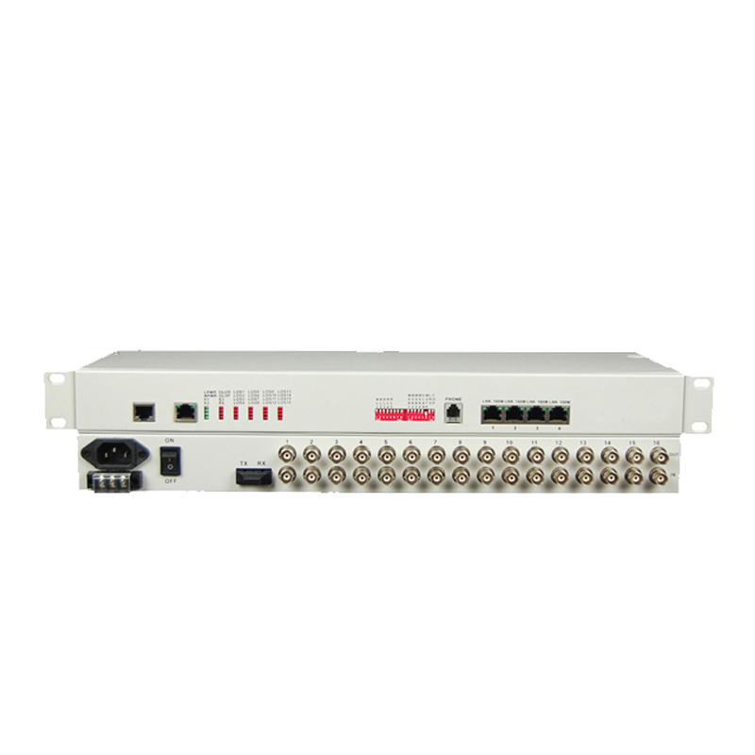
Product Description
The TBC-6480U1FE Series 16E1 +100M optical transceiver is a point-to-point optical transmission equipment developed on the basis of the ultra-large-scale PDH optical fiber transmission developed by our company. It provides 1 linear 10/100M Ethernet channel. It has a sound alarm function, optional 1-Channel digital business telephone . Electrical equipment for all-digital circuit, the whole work reliable, stable, low power consumption, high integration, small size, easy to install and maintain. Equipment to meet the needs of telecom operators and private network users, in line with telecommunications standards. Suitable for power, postal services, banking and China Unicom, mobile telecommunications and other user needs, in line with the standards used by telecom operators.

Product Features
- Provide 16 E1 + 10/100BaseT;
- Ethernet interface speed 10M/100M adaptive, support VLAN protocol;
- E1 port with digital clock recovery circuit and digital platform smooth phase lock circuit;
- Provide command E1 loopback function, optical path local loop function;
- Complete power supply, link and alarm indication function, the local device can monitor the current status of the remote device in real time;
- Provide branch alarm and sound alarm shield;
- Provide 1-Channel business telephone interface(optional);
- Dual fiber bidirectional and single fiber bidirectional models are optional;
- Optical interface optional SC/PC, FC/PC,or SFP slot;
- Conforms to carrier-class operation requirements, mean time between failures (MTBF) more than 100,000 hours;
- High reliability, providing 19 "rack mount,desktop,wall,card ,at the same time with AC and DC power supply;
- Power can choose to AC 220V, DC -48V,24V,12V,5V, the whole power consumption <5W; Provide SNMP network management functions;Support customization and OEM .

Product Parameter
PDH Multiplexer Series

2/2
Optical Interface Features | Wavelength | single mode 1310nm/1550nm,Multi mode 850nm/1310nm
Optical Interface Features | Number of optical fiber | dual-core, single-core
Optical Interface Features | Transmission power | -9dBm / -5dBm
Optical Interface Features | Transmission distance | Multi mode 0~2km  Single mode 40KM,60KM,120KM
Optical Interface Features | Receiver sensitivity | ≤-36dBm (BER ≤ 10⁻¹¹)
Optical Interface Features | Receive dynamic range | > 27dB
Optical Interface Features | Connector | FC / SC / ST optional
E1 interface Features | Interface code | HDB3
E1 interface Features | Interface code speed | 2.048Mbit / s ± 50ppm
E1 interface Features | Interface Features | ITU-T G.703
E1 interface Features | Interface Type | BNC, RJ45
E1 interface Features | Interface impedance | 75Ω unbalanced / 120Ω balanced
Ethernet interface features | Interface Rate | 10/100M adaptive
Ethernet interface features | Interface Protocol | IEEE802.3,IEEE802.1Q(VLAN)
Ethernet interface features | Physical interface | RJ45,Support Auto-MDIX
Ethernet interface features | Operate mode | full / half duplex adaptive
Ethernet interface features | MAC Address Table | can learn 4096 MAC addresses
Power | Power supply | AC 220V, DC -48V,24V,12V,5V
Power | Power consumption | ＜5W
Working environment | Working temperature | 0°C ~ 50°C
Working environment | Humidity | 5%~95% (non-condensing)
Working environment | Storage temperature | -40°C ~ 70°C

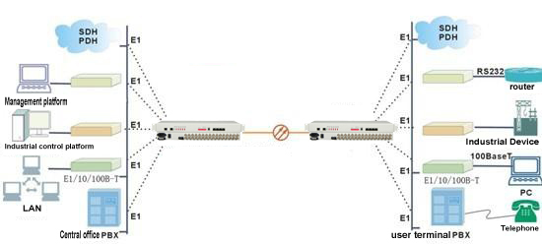
Application

