
Protocol Converter Series

1/3
E1-10/100Base-T Protocol Converter

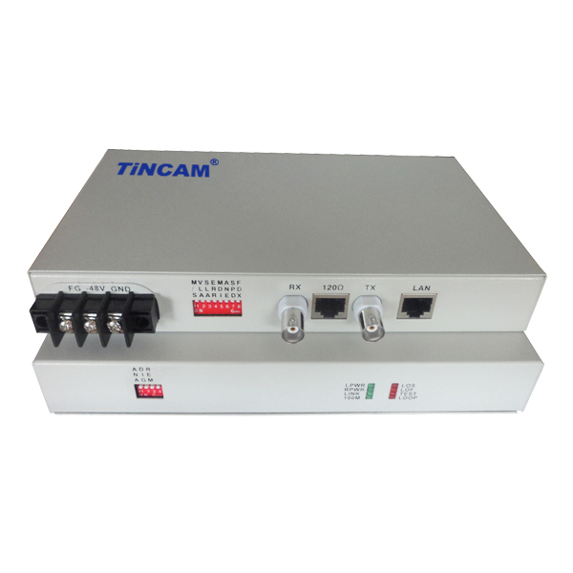
DESCRIPTION

The TBC-CT6002 series E1 to ETH protocol converter uses E1 communication lines to provide the Internet with a data transmission channel with a bandwidth of 1.92M so that the 2 LANs can be connected to two network segments of a local area network by using a transmission device such as an optical transceiver and the same IP address can be used. Automatically learn MAC address, according to the address table to filter the data packet (this function can be closed), the TCP / IP protocol transparent.
The protocol converter takes advantage of the spare time slots in E1 to arbitrarily extract the time slots from the G703 / E1 and provides the Internet with data transmission channels with a bandwidth of N*64K (N=1~ 32);
This protocol converter can convert E1 channels of SDH, PDH, microwave, satellite and other transmission networks into 10/100BaseT data channels. It is suitable for all kinds of data communication network and realizes matching and interconnection between different network equipment interfaces, such as routers, Ethernet switches and other network interfaces, so as to effectively solve the extension problem of Ethernet IP data.
The device has a perfect self-test function and a variety of test functions, allowing users to easily and quickly integrate this device into the network. Widely used in WAN and LAN networking, monitoring and other occasions.
FEATURES

- Ethernet data can be achieved in the E1 line transparent transmission and sub-slot transmission, the bandwidth range 64Kbps-2048Kbps;
- Provides three kinds of loopback function : E1 local loop, Ethernet local loop, remote loop from command to peer;
- With network management capabilities, you can monitor the work of the equipment and set the working status of the equipment;
- With Ethernet auto-negotiation capabilities to support full/half duplex mode of work, while providing cross-and Ethernet port can transmit IEEE 802.1Q provisions of the long frame;
- Support Ethernet switch with VLAN function;
- With two rows of indicator lights, remote monitoring of the remote device can be realized by the local device;
- With local data frame filtering, while providing unbalanced 75Ω and balanced 120Ω E1 interface;
- With E1 circuit detection, easy to open.
- With pseudo-random code testing capabilities for the installation and commissioning of equipment to bring great convenience;
- Support mixed plug, modular protocol converter can be inserted into the 4U rack and can be mixed with PDH optical transceiver, video optical transceiver products.
APPLICATION
Protocol Converter Series

2/3

G703/E1 interface and 10 / 100Base-T Ethernet port conversion.
A high-performance, self-learning remote Ethernet bridge. Small size, low cost, suitable for cost-sensitive bridge applications.
The product can continuously learn the MAC address of the LAN connected to it and decide whether to send back or filter according to the destination MAC address of the data frame. There are up to 10,000 addresses on its LAN table and can be automatically updated. The maximum rate at which filtering and forwarding are performed is 30,000 frames per second (line rate), the buffer can hold 256 frames and the throughput waits for 1 frame.
As a LAN extender or segmenter on a bitstream infrastructure. Filtering and filtering are prohibited two working status, to decide whether to allow all traffic on the WAN line to send.
Rate conversion and slot extraction, arbitrarily extracting designated time slots from the G703 / E1 to form a data channel of N*64K (N = 1 to 32).

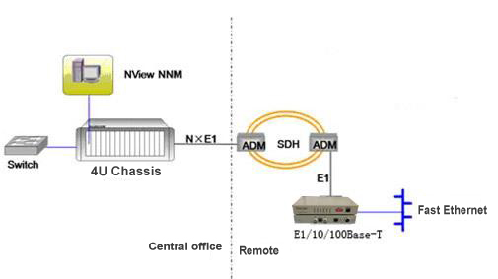

Solution Description: This scheme is suitable for the access of large customer private network, which can utilize the operator's 2M line resources to provide low cost and quick access for large customer branch nodes, and can realize the management of the whole network. Through the 4U chassis SNMP network management, the central office protocol conversion, remote protocol conversion and end of the transceiver for a comprehensive network management.

Ethernet Interface | Number of interface | 1-RJ45 port
Ethernet Interface | Support frame length | 1593 bytes
Ethernet Interface | Protocol | Support automatic cross network cable recognition ability;  Support IEEE 802.3x flow control in full duplex mode;  Support Back pressure flow control when half-duplex mode ;  Support 802.3 (Ethernet protocol), 802.3u (Fast Ethernet protocol);  It can transparently transmit IEEE 802.1d Spanning Tree and IEEE 802.1q VLAN packets.
Ethernet Interface | Transmission rate | 10Base-T port Transmission side: N*64Kbit / s (N = 1 ~ 32)
E1 Interface | Transmission mode | Provide transparent and framed E1 two working modes  Transparent way, bandwidth 2048Kbps  Framing method, the bandwidth can be set N*64Kbps (N = 1 ~ 31)
E1 Interface | Interface Impedance | 75Ω (unbalance), 120Ω (balance)
E1 Interface | Number of interfaces | Provide single E1
Features | Network management capabilities | Can support network management, can manage local / remote
Features | Clock Mode | Three clock modes are provided: master clock (internal clock), slave clock (E1 receive recovery clock),
Features | CRC check | Support CRC4 calibration adaptive
Features | Time slots follow | When framing mode is used in pairs, the time slot configuration of the local device can automatically follow the settings of the remote device
Features | Port loopback | Provides local and remote loopback testing
Features | 窗体顶端  Support mixed insert窗体底端  Support mixed insert | Modular protocol converter can be inserted into 4U chassis, and can be mixed with modular transceiver and optical transceiver products.
Power | Power supply | AC110~240V DC36V~-72V
Power | Power consumption | ＜5W
Physical Dimension | Internal power supply | 216mm*140mm*31mm
Working environment | Working temperature | 0°C ~ 45°C
Working environment | Working Humidity | 5%~90% (non condensing)
Working environment | Storage temperature | -25°C ~ 70°C
Working environment | Storage Humidity | 5%~90% (non condensing)
TECHNICAL SPECIFICATIONS

Protocol Converter Series

3/3
Application 2

