
Protocol Converter Series

1/3
4E1-ETH Protocol Converter
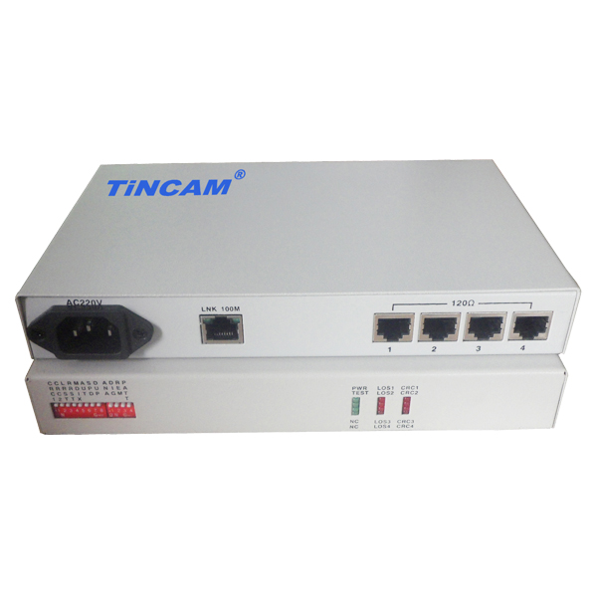
DESCRIPTION

The TBC-CT6004 series interface converters use reverse multiplexing technology, which bundles multiple E1 circuits to transmit Ethernet data of 4E1-10/100BaseT and implements the conversion of 1-4 E1 channels to Ethernet interfaces; This converter can send and receive E1 channel signal point-to-point transmission RJ45 interface, E1 channel and Ethernet interconnection. Unlike a typical remote bridge, this converter supports flexible configuration of 1 to 4 E1 channels, automatically detects the number of E1s and selects available E1s, and allows some transmission delay differences between the E1 circuits. Single-line rate is 1920Kbit/s, 4-channel bandwidth up to 7680Kbit/s. When used in 10/100Mbps full/half duplex mode, the device can be connected to an Ethernet switch or hub and fully utilize the existing large number of E1 circuit resources in the telecommunications network to extend the transmission range and application range of the Ethernet. It is a good solution for Ethernet broadband access. This product can be used for LAN interconnection, central office interconnection, video on demand, remote monitoring, E1 interface card switch and other fields.
FEATURES

- Realize the transparent transmission of Ethernet data in 1 ~ 4E1 circuit;
- CRC alarm threshold can be set to automatically isolate the line with poor transmission quality, and it is unidirectional to cut off when 2M branch;
- When the error rate in one direction exceeds the threshold, the direction is cut off and the other direction is not affected. That is, the two directions of the Ethernet transmission can be asymmetric.
- To allow multi-E1 has 10ms transmission delay difference. When the difference exceeds the allowable range, the system can automatically stop sending data over the E1 with too much delay. Loopback: E1 local loopback and E1 remote loopback;
- Built-in dynamic Ethernet MAC address list (4096), with local data frame filtering;
- E1 interface with ITU-T G.703, G.704 and G0823; E1 interface module contains a built-in clock recovery circuit and HDB3 code circuit;
- Equipment supports E1 channel hot swap, and automatically detects the effective E1 channel, the middle will not interrupt the data transfer;
- Support E1 ~ 4E1 flexible configuration, the number of E1 automatically detects the reset and delay and select the available E1 port;
- Support the local system to reset the remote system; with Ethernet monitoring automatic reset function.

APPLICATION
Protocol Converter Series

2/3

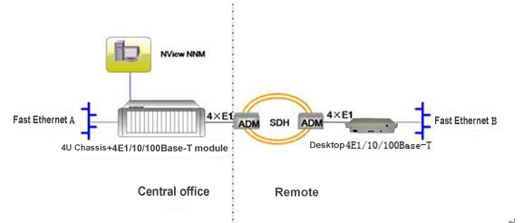

Solution Description: It can provide 2M ~ 8M service channels for two remote LANs of the user. Network management can be used to manage the central office and remote devices.

Ethernet Interface | Number of interface | 1-RJ45 port
Ethernet Interface | Support frame length | Maximum Ethernet data frame length support 1536Byte
Ethernet Interface | Protocol | Support automatic cross network cable recognition ability;  Support IEEE 802.3x flow control in full duplex mode;  Support Back pressure flow control when half-duplex mode ;  Support 802.3 (Ethernet protocol), 802.3u (Fast Ethernet protocol);  It can transparently transmit IEEE 802.1d Spanning Tree and IEEE 802.1q VLAN packets.
E1 Interface | Transmission mode | Only provide E1 framing mode
E1 Interface | Interface Impedance | 75Ω (unbalance), 120Ω (balance)
E1 Interface | Number of interfaces | Provide 4 E1 interface
E1 Interface | Forwarding Index | Each E1 Ethernet packet forwarding the ultimate rate of 1920Kbps;  4 E1 full load, the ultimate forwarding rate of 1920*4 =7680Kbps;
Features | Network management capabilities | Can support the network management; can manage the local / remote
Features | Network management capabilities | card device can be placed in multi-slot chassis to use, to achieve central office, remote network management
Features | Network management capabilities | desktop without CONSOLE, SNMP interface ;can be controlled by dialing switch, set to Remote devices can realize passive network management
Features | Clock Mode | Two clock modes are provided: master clock (internal clock), slave clock (E1 receive recovery clock),
Features | CRC check | Support CRC4 calibration adaptive
Features | Port loopback | Provides local and remote loopback testing
Features | 窗体顶端  Support mixed insert窗体底端  Support mixed insert | Modular protocol converter can be inserted into 4U chassis, and can be mixed with modular transceiver and optical transceiver products.
Power | Power supply | AC110~240V DC36V~-72V
Power | Power consumption | ＜5W
Physical Dimension | Internal power supply | 216mm*140mm*31mm
Working environment | Working temperature | 0°C ~ 45°C
Working environment | Working Humidity | 5%~90% (non condensing)
Working environment | Storage temperature | -25°C ~ 70°C
Working environment | Storage Humidity | 5%~90% (non condensing)
TECHNICAL SPECIFICATIONS

Protocol Converter Series

3/3
Application 2

