
30-Channel Telephone Multiplexer
Telephone Multiplexer Series

1/2
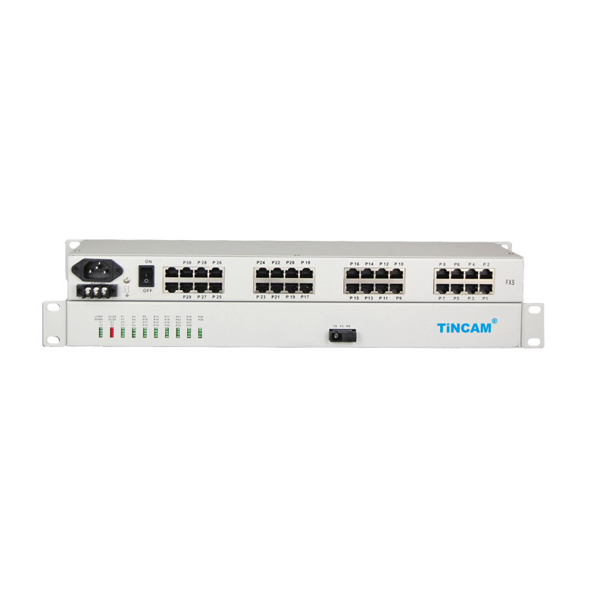
Description
The TBC-6830U series 30-Channel Telephone Multiplexer is a point-to-point optical transmission equipment developed on the basis of very large-scale integrated circuits. It realizes up to 4 E1 circuits and 1*100M linear Ethernet data channel in a simple form. 30-Channel telephone (FXO, FXS), plus 1~2 channels of RS232 voice and optical transmission equipment. With alarm monitoring and control functions, high integration, low power consumption, stable performance, easy to use.
This series of optical transceiver to meet the telecommunications operators and private network phone and data access needs. Suitable for power, postal services, banking and China Unicom, mobile telecommunications and other users of the network set up needs, in line with the use of telecommunications operators standards.

Features

- Industrial design, SMT process ;
- Provide 4 E1 (optional);
- Provide 1*100M wire speed Ethernet port (optional);
- Provide 30-Channel voice port, FXO, FXS port optional;
- Provide 2 RS232 channels, the rate of support from 300-115.2kbps (optional);
- Ethernet interface 10/100M, full / half duplex fully adaptive, VLAN protocol support;
- Ethernet interface supports Auto-MDIX (cross / straight connection adaptive);
- Voice port support FXO port and FXS port, FXO port and program-controlled switch docking, FXS port and the user's phone connected;
- Support caller ID and reverse polarity billing functions;
- Support each site put number function;
- Optical interface supports SC / FC interface, and supports single fiber optical interface.
Telephone Multiplexer Series
2/2
Technical Specification
Optical interface（single fiber / dual fiber）
Wavelength | single mode 1310nm / 1550nm; multimode 850nm / 1310nm
Fiber | multimode, single mode
Transmitter power | -9dBm / -5dBm
Transmission length | multi-mode 2 km, single mode 40,60,120 km
Receiver sensitivity | better than-36dBm (BER <e-11)
Receive dynamic range | > 27dB
Connector | SC / FC / ST
Features: Can be customized according to user needs for different interface types.
E1 interface
Interface code | HDB3 code
Line rate | 2.048Mbps / s ± 50
Interface Impedance | 75Ω / unbalanced, 120Ω / balanced
Interface standard | ITU-T G.703
Interface Features | Meet the G.703 standard
Jitter characteristics | Meet G.704 and G.823
Ethernet interface
Rate | 10 / 100M adaptive
Protocol | Supports IEEE 802.3, IEEE 802.1Q (VLAN)
Physical interface | RJ45 , support Auto-MDIX
Working mode | full duplex / half duplex adaptive
MAC Address Table | You can learn 4096 MAC addresses
FXO / FXS interface (RJ45 /RJ11)
FXS phone port | Ringing voltage: 75V  Ringing frequency: 25HZ  Second-line input impedance: 600Ω (off-hook)  Return loss: 40 dB
FXO switch interface | Ringing detection voltage: 35V  Ringing detection frequency: 17HZ-60HZ  Second-line input impedance: 600Ω (off-hook)  Return loss: 40 dB
Asynchronous data (RS232) Interface parameters (RJ45)
Rate | 300 ~ 19.2 kbps adaptive
Interface Features | Meet the ITU-T V.24 standard
Connection | DCE

