
60-Channel Telephone Multiplexer
Telephone Multiplexer Series

1/3
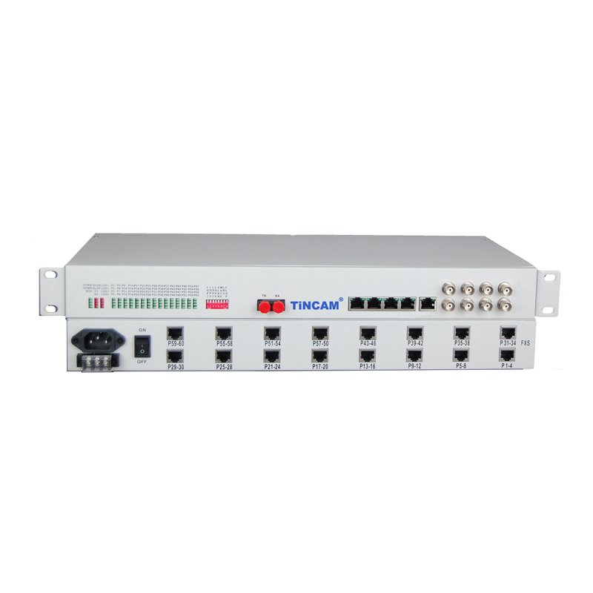
Description

The TBC-6860U Series 60-Channel Telephone Multiplexer is a long-distance transmission of optical fiber 60-channel telephone fiber transmission equipment. The device uses a VLSI design, the appearance of concise, easy to install and debug, maintenance-free, stable performance and other advantages applicable to major telecommunications operators, military units and enterprises and institutions; equipment configuration flexibility, using 155M bandwidth transmission , You can match 100M line speed Ethernet, V.35 and other interfaces.
Telephone Multiplexer can be directly transmitted through the optical cable to provide 60-channel telephone, networking for point to point, support for FXO, FXS way. Solved the edge customer's phone transmission problem. The device features a dedicated digital multiplexer chip that is powerful enough to almost completely integrate digital logic in the device, significantly improving product performance and reducing costs. The whole machine excellent performance, stable and reliable work, low power consumption, high integration, small size, easy to install and maintain.

Telephone Multiplexer Series
2/3
Technical Specification
Optical interface（single fiber / dual fiber）
Wavelength | single mode 1310nm / 1550nm; Multimode 850nm / 1310nm
Fiber | multimode, single mode
Transmit power | -9dBm / -5dBm
Transmission length | multi-mode 2 km; Single mode 40,60,120 km
Receiver sensitivity | better than-37dBm (BER <e-11)
Receive dynamic range | > 27dB
Connection method | FC
Telephone Interface Board - User and Loop Interface
Voice Interface | voice characteristics in line with the "Ministry of Posts and Telecommunications telephone exchange equipment, general technical specifications"
Impedance | 600Ω
Insertion loss | -3 ± 0.75dB
Frequency characteristics | 300 ~ 3400Hz (-0.6 ~ 3dB)
Weighing noise | ≤ 63.7dBmop
Crosstalk attenuation | ≥ 65dB
Subscriber line loop resistance | less than 3KΩ (including phone)
Supply voltage | 48V
Feed current | 20 ~ 50mA
Ringing | AC90 plus or minus 15V
Ethernet interface
Interface rate | Support 10/100M adaptive access
Transmission rate | Support two method:pure 2M and transparent transmission pure 10M , according to the actual needs of users can choose their own
Duplex mode | support half-duplex, full-duplex mode
Physical interface | RJ45
Standard | In full compliance with IEEE802.3 LAN protocol standards
2/4 line audio interface
Impedance | 200Ω 680Ω || 0.1μF
Four-wire AD gain | 14dB (adjustable)
Four-wire DA gain | -2 dB (adjustable)
Four-wire AD frequency | -0.2 - 0.2dB
Four-wire DA frequency | -0.2 - 0.2dB
Second-line AD frequency | -0.2 - 0.2dB
Second-line DA frequency | -0.2 - 0.2dB (adjustable)
Return loss | 40dB
Balance | 70dB
Common mode rejection ratio | 70dB
Power supply rejection ratio | 30dB
Free channel noise | ≥ 65dB
Ring resistance | 600Ω
V.24 interface
Interface Type | V.24 asynchronous
Rate | 0 -19.2Kbps
V.35 interface
Interface Type | V.35 Sync
Rate | Nx64Kb / s (N = 1-15)
Clock method | DCE
E1 interface
Standard E1 interface, in line with ITU-T G.703, G.704 Suggest
Bit rate | 2048Kbps ± 50ppm
Pattern | HDB3
Interface impedance | 75Ω
Interface Features | Meet G.703, G.742 and G.823 standards
Frame structure | No frame structure
Power | 220V / -48V optional
Telephone Multiplexer Series
3/3

