
100-Channel Telephone Multiplexer
Telephone Multiplexer Series

1/2
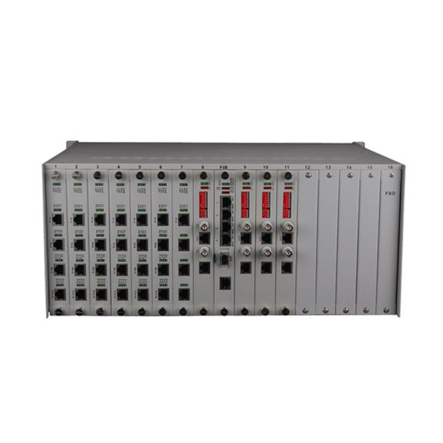
Description
The TBC-68100U series 100-Channel Telephone Multiplexer is a point-to-point optical transmission equipment developed on the basis of very large-scale integrated circuits. It achieves up to four E1 circuits and one 100M linear Ethernet data channel in a simple form, plus 100-channel telephone (FXO, FXS), plus 1 to 2 channels of RS232 voice transmission equipment. With alarm monitoring and control functions, high integration, low power consumption, stable performance, easy to use.
This series Telephone Multiplexer to meet the telecommunications operators and private network phone and data access needs. Suitable for power, postal services, banking and China Unicom, mobile telecommunications and other users of the network set up needs, in line with the use of telecommunications operators standards.
Features

- Provide 4 E1 (optional);
- Provide 1* 100M wire speed Ethernet port (optional);
- Provide 100-Channel voice port, FXO, FXS port optional;
- Provide 2*RS232 channels, speed support from 300-115.2kbps (optional);
- Ethernet interface 10/100M, full / half duplex fully adaptive, VLAN protocol support;
- Ethernet interface supports Auto-MDIX (cross / straight line adaptation);
- Voice port support FXO port and FXS port, FXO port and program-controlled switch docking, FXS port and the user's phone connected;
- Support caller ID and reverse polarity billing functions;
- Support for each site's mutual release number function;
- Optical interface supports SC / FC interface and supports single fiber optical interface

Telephone Multiplexer Series
2/2
Technical Specification
Optical interface(single fiber / dual fiber)
Wavelength | single mode 1310nm / 1550nm; multimode 850nm / 1310nm
Fiber | multimode, single mode
Transmit power | -9dBm / -5dBm
Transmission length | multi-mode 2 km, single mode 40,60,120 km
Receiver sensitivity | better than-36dBm (BER <e-11)
Receive dynamic range | > 27dB
Connector | SC / FC / ST
Features | Can be customized according to user needs for different interface types.

