
Ethernet Switch Series

1/1
16-port 10/100M Ethernet Switch

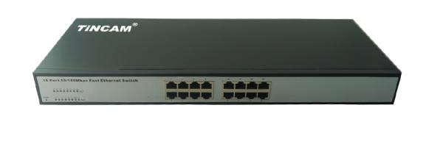

Product Description

TBC-S4016N series switch is based on our company launched a new generation of high-performance, low-power, fanless design, RoHS compliant, meet the green requirements of the two small and medium-sized enterprise switches. Can be widely applied to SMEs, small offices, Internet cafes, hotels, schools, families and other applications.

Product Features

- Exchange capacity: 3.2Gbps, packet forwarding rate:2.4Mpps, MAC address table: 4K;
- Provides 16*10/100Base-Tx electrical interface;
- Security features: support for access to the user MAC address limit and port-based MAC address binding, filtering;
- Support port broadcast / multicast packet suppression; Support 802.1X authentication; Support CPU anti-DoS attack technology;
- Support custom message filtering based on TCP / UDP port;
- VLAN: Support IEEE 802.1Q VLAN, VLAN ID: 1-4094; support management VLAN;
- QOS: Support advanced queue scheduling based on port, 802.1p, ToS, custom TCP / UDP port;
- Support queue scheduling algorithm such as FIFS, SP, WRR;
- Reliability: support static link aggregation; support loop detection; support STP/RSTP;
- Multicast: Support IGMP Snooping;
- Port Features: Support bidirectional bandwidth rate control; support port bi-directional traffic mirroring;
Power consumption | ≤ 8W
Port No., | 16*10/100M RJ45 port
Cascade | All ports can be UP-LINK port
Temperature | Operation temperature : 0 ℃~45℃
Temperature | Storage temperature : -20℃~70℃
Humidity | 10%~90% ,non-condensing
Power supply | AC: Rated voltage range 100 ~ 240V AC; 50/60Hz Maximum voltage range 90 ~ 264V AC; 50 / 60Hz
Product dimension | 280x140x44mm
- NMS: support Web management; support for uploading and downloading configuration files;
Product Features

