
Ethernet Switch Series

1/1
24-port 10/100M Ethernet Switch

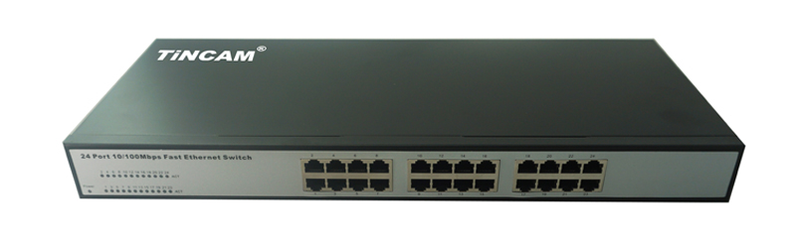

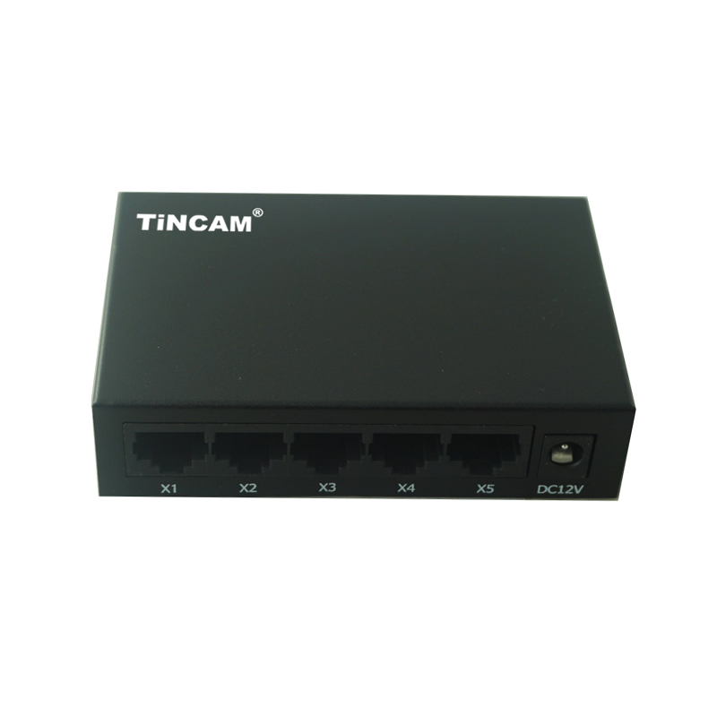

Product Description

TBC-S4024N series switch is based on our company launched a new generation of high-performance, low-power, fanless design, RoHS compliant, meet the green requirements of the two small and medium-sized enterprise switches. Can be widely applied to SMEs, small offices, Internet cafes, hotels, schools, families and other applications.

Product Features

- IEEE802.3 10BASE-T and IEEE802.3u 100BASE-TX network standards;
- 24 *10/100M UTP / STP interface;
- Support auto flip port (Auto MDI / MDIX);
- 10M / 100M dual-speed adaptive;
- Support full duplex / half duplex working mode;
- Support IEEE802.3x full duplex flow control and back pressure half duplex flow control;
- Dynamic LED indicator to provide simple working status prompt and troubleshooting;
- Support MAC address self-learning function;
- Built-in universal power supply, 19-inch standard rack steel structure design;
Standard | IEEE 802.3, IEEE 802.3u,IEEE 802.3ab,IEEE 802.3ab
Protocol | CSMA/CD
Topology | star
Network cable type | 10Base-T: CAT3/4/5 UTP (≤100m)  100Base-TX:CAT 5 UTP(≤100m)
LED indicators | Power, 100Mbps speed indicator, Link / Act indicator
Exchange method | Store-and-Forward, wire-speed filtering and forwarding
Power | 100V~260VAC,
Filtering and forwarding rate | 10Mbps:14,880pps  100Mbps : 148800pps
Temperature | Operation temperature : 0 ℃~40℃
Temperature | Storage temperature : -40℃~70℃
Humidity | Operation humidity :10%~90% ,non-condensing
Humidity | Storage humidity :5%~95%,non-condensing
Product Features

