Attenuator
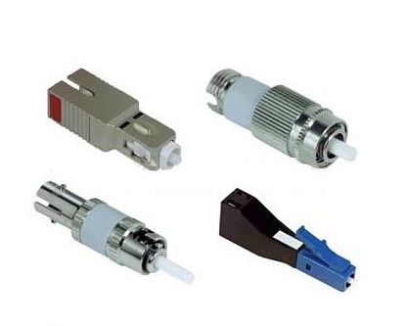
Product Overview：
Attenuator is used to attenuate the input optical power, avoiding the distortions caused by the optical receiver due to the superior input optical power.

Features：
Comply with Bellcore (GR-910-Core) standard;
Low polarization related loss;
High return loss ;
Plug structure, easy to install.

Optical characteristics:
Optical performance
 | Plug type
Working wavelength (nm) | 1250-1620
Attenuation value | 5、10、15、20dB
Type | FC、SC、LC
Type | PC、APC
Return loss | ≥50dB
Polarization-dependent loss | ＜0.2dB
Operating temperature | -25℃ to +70℃
Storage temperature | -40℃ to +80℃
Thermal stability | 0.03dB/℃
Maximum power | 1W

