2*1000M fiber ports+8*100M RJ45 ports Industrial POE Switch
Industrial POE Switch Series
1/4
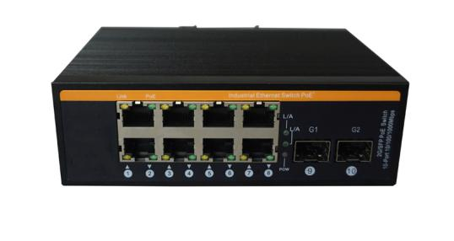
Product Description

8*100M POE RJ45 port +2*1000M-FX optical ports industrial grade Ethernet switch, supporting 8*10/100Base-TX electrical port and 2*1000Base-X optical port. The product complies with FCC and CE standards. This series switches have an operating temperature of -40°C to 85°C. They have excellent robustness to adapt to a variety of harsh environments, and can also be conveniently placed in compact control cabinets. The installation characteristics of the guide rails, wide temperature operation and enclosures with IP40 degree of protection and LED indicators make it a plug-and-play industrial-grade device that provides a reliable and convenient solution for the networking of users' Ethernet equipment.

Product Features

- High quality photoelectric integrated modules provide good optical and electrical properties;
- Guaranteed reliable data transmission and long working life;
- Support full-duplex or half-duplex mode with auto-negotiation capability;
- The network port supports automatic cross recognition;
- Internal storage and forwarding mechanism, support multiple protocols;
- Compliant with carrier-grade operating standards, with an average trouble-free operation of over 300,000 hours;
- Working power supply: DC 48-57V provides reverse connection protection;
- Use SC fiber interface (optional ST, FC, SFP interface);
- Lightning surge protection (power supply): 5000A (8/20μs);

Industrial POE Switch Series

2/4
Technical Specification

Technical Parameters
Product Name | 2*1000M fiber ports+8*100M RJ45 ports Industrial POE Switch
Product Description | 8*100M POE RJ45 ports + 2*1000M fiber ports Industrial POE Switch
Network protocol | IEEE802.3 10BASE-T; IEEE802.3i 10Base-T;IEEE802.3u;100Base-TX/FX;  IEEE802.3ab 1000Base-T; IEEE802.3z 1000Base-X; IEEE802.3x;IEEE802.3af; IEEE802.3at;
POE Standard | Standard POE : IEEE802.3af/ IEEE802.3at
POE Standard | POE port: 1~8 ports supports POE
POE Standard | Output Power :  Maximum power 15.4W (IEEE 802.3af)  Maximum power 25.5W (IEEE 802.3at)  POE port automatically recognizes af/at
POE Standard | Output voltage : DC48-57V  Power supply mode : 1/2+; 3/6-
RJ45 port | 10/100BaseT (X) automatic detection, full / half duplex MDI / MDI-X adaptive
Fiber port | 1000BaseFX port (SC/FC/ST/SFP optional)
Twisted pair | 10BASE-T : Cat3, 4, 5 UTP (≤100 meter)  100BASE-TX : Cat5 or later UTP (≤100 meter)  1000BASE-TX : Cat6 or later UTP (≤100 meter)
Cable | multimode: 850nm 0 ~ 550M  1310nm 0~2KM  Single mode: 1310nm 0~40KM  1550nm 0～120KM
Switch Properties | Application Level: Layer 2  Total backplane bandwidth: 5.6Gbps  Overall package forwarding rate: 4.16Mpps  MAC table: 8K  Packet buffer: 1M  Delay time: <4μs  Exchange method: store-forward
Protection level | IP40
LED indicator | Power indicator : PWR  Interface indicator: Electrical port, Optical port (Link/ACT)
Power supply  Industrial POE Switch Series  3/4 | Input voltage: DC48-57V (dual power redundant backup)  Access terminal: Phoenix terminal  Support dual power redundancy  Support built-in overcurrent 4.0A protection  Support reverse connection protection
Other specifications
Working environment | Operating temperature: -40 ° C ~ + 85 ° C  Storage temperature: -40 ° C ~ + 85 ° C  Relative humidity: 5 ~ 95% (non- condensing)
Industry Standard | EMI: FCC Part 15 Subpart B Class A, EN 55022 Class A.  EMS:  IEC61000-4-2 (ESD): ±8kV (contact), ±15kV (air)  IEC61000-4-3 (RS): 10V/m (80-1000MHz)  IEC61000-4-4 (EFT): Power Port: ±4kV; Data Port: ±2kV  IEC61000-4-5 (Surge): Power Port: ±2kV/DM, ±4kV/CM; Data Port: ±2kV  IEC61000-4-6(CS):3V(10kHz-150kHz);10V(150kHz-80MHz)  IEC61000-4-16 (Common mode conduction): 30V (cont.), 300V (1s)  IEC(EN )61000-4-8  Shock ：IEC 60068-2-27  Freefall ：IEC 60068-2-32  Vibration ：IEC 60068-2-6
Mechanical properties | Shell: metal material  Installation: DIN rail type, wall-mounted installation  Weight: 0.64Kg
MTBF | 300,000 hours
Warranty | 5-years

Installation size (unit: mm)

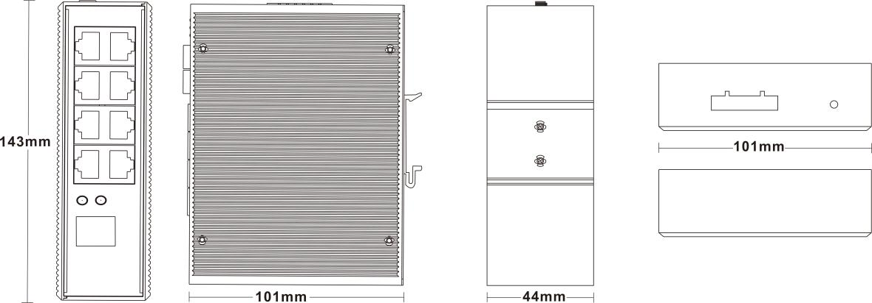

Industrial POE Switch Series

4/4
Installation method

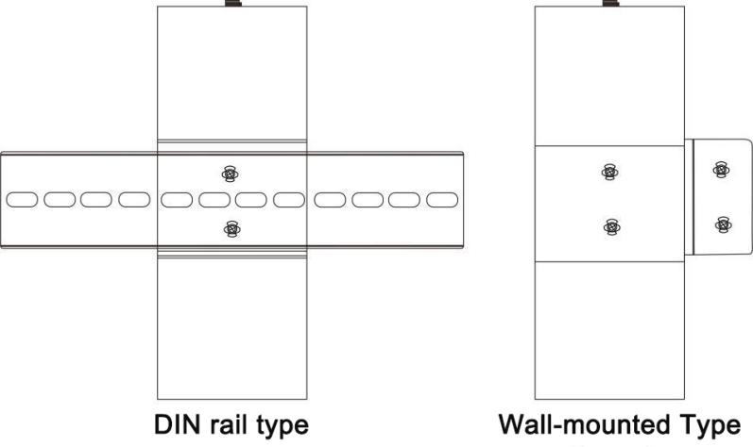

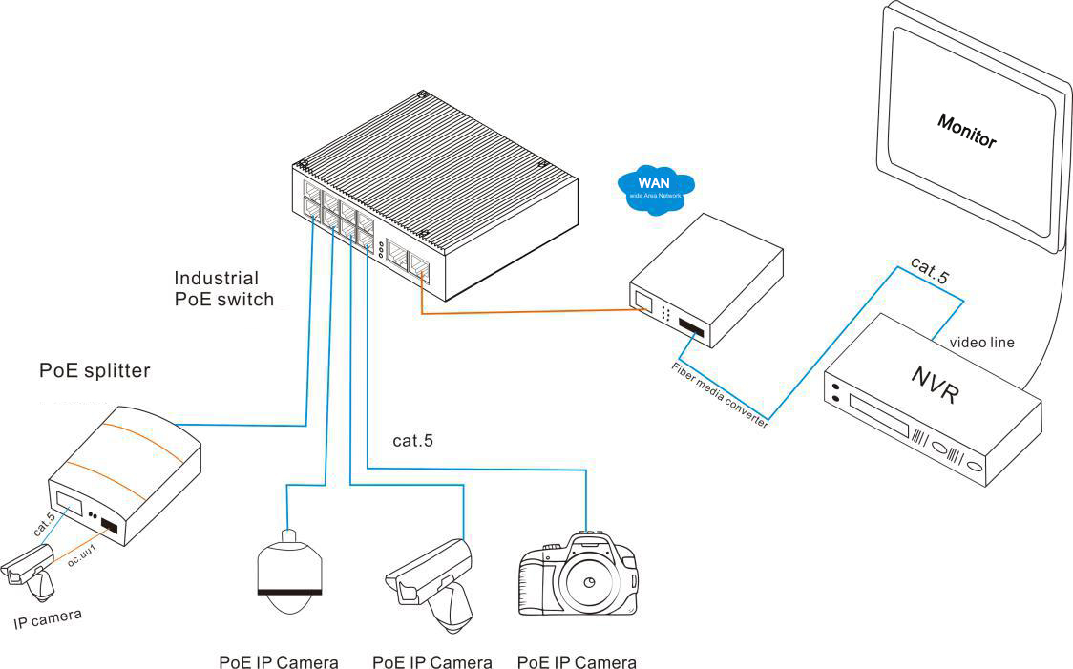
Application

