POE Switch Series

1/3
10/100M POE Switch series

Product Description
The POE Powered Switch supports the IEEE802.3af/at power over Ethernet standard with a power distance of 100 meters and only powers 802.3af/at terminal devices, so there is no need to worry about compromising proprietary standards for POE or non-POE devices. In addition, the POE device stops supplying power when it is not connected. These devices, which are far from the power outlet, are suitable for hanging on the wall or on the ceiling, and the POE eliminates the need to connect the power outlets for these devices, making the connection to equipment that is difficult to connect to AC power more flexible and with minimal installation costs. This series POE Powered switches are ideal selection for small business networks that want to use the economic deployment of wireless access points (AP) and IP-based network surveillance cameras .
Power supply mode
Power supply mode

Poe power supply: refers to a kind of professional technical application of IP camera and related equipment to be powered through network cable, that is, bidirectional transmission of data and power supply function in a network cable: the transmission voltage meets the different site requirements of international standard AF / at: 15.4v/25.5v. Advantages of use: simple construction, flexible and convenient, wire saving, reduced operation and maintenance costs; can ensure the safety of existing structured cabling while ensuring the normal operation of existing network data; in order to have a longer working life, it is recommended to use a quality guaranteed network cable and transmission distance within 80 meters;

Product Features

1. Meet IEEE802.3 10Base-T and ie802.3u 100Base-T Ethernet standards
2. Flow control mode: IEEE 802.3x standard is adopted for full duplex and back pressure standard is adopted for half duplex;
3. Port supports 10 / 100M adaptive and auto flip (automdi / mdix)
4. Ethernet port two-level lightning protection technology ensures product stability
5. Support fixed port VLAN (ieee802.1q1 VLAN)
6. The exchange mechanism of store and forward
7. All ports support line speed switching. Line speed can be achieved within 1536k frame length. Line speed switching is supported,
8. Imported chip, automatic cooling
9. With MAC address automatic learning, automatic update function;
10. 1-2 uplink 10 / 100Mbps adaptive ports are used for cascade or external network access platform;
11. The 8-port Poe Ethernet switch has 8 downlink 10 / 100Mbps adaptive Poe intelligent power supply ports, supports ieee802.3af/at power supply international standard, 12 + / 36 -, 15.4/25.5w power supply output by end bridging method;
12. Poe transmission with extended network extended signal mode, the network power switch can transmit up to 250m by itself

- Support auto MDI / mdix;
Product parameters

Product model | TBC-BPS4306N | TBC-BPS4310N | TBC-PSF4314ES20A | TBC-PSF4318ES20A
PoE port | 1-4port | 1-8port | 1-4port | 1-8port
PoE distance | 100m or 250m（Switch and indicator analysis）
Voltage range | AC220V/DC52V
Port power | IEEE802.3af/at standard 15.4W（16W）/25.5W（30W）
Whole machine power | 65W/120W | 120W/250W | 65W/120W | 120W/250W
UPLINK | ２*10/100Mbps Ethernet port |  | 155M fiber ：SC/FC（20km）
working temperature | -20℃~+65℃
exchange capacity | 12Gbps | 20Gbps | 10Gbps | 18Gbps
Packet forwarding rate | 0.9Mpps | 1.488Mpps | 0.7Mpps | 1.339Mpps
Product size | Built in power supply 190*140*44mm |  | External power supply 134*185*28mm | External power supply 200*104*28mm
Product model | TBC-PSF4316U-2PM |  | TBC-PSF4324U2-2PM
PoE port | 1-16port |  | 1-24port
Voltage range | AC220V/DC52V
Port power | IEEE802.3af/at standard 15.4W（16W）/25.5W（30W）
Whole machine power | 300W/450W |  | 450W/800W
UPLINK | 2*gigaibit uplink RJ45 port  +2*1.25G uplink SFP fiber port（fiber complex）
working temperature | -20℃~+65℃
exchange capacity | 40Gbps |  | 56Gbps
Packet forwarding rate | 8.33Mpps |  | 9.52Mpps
Product size | 1U19 Inch standard rack430*295*44mm （Desktop construction optional）
POE Switch Series

2/3

Application

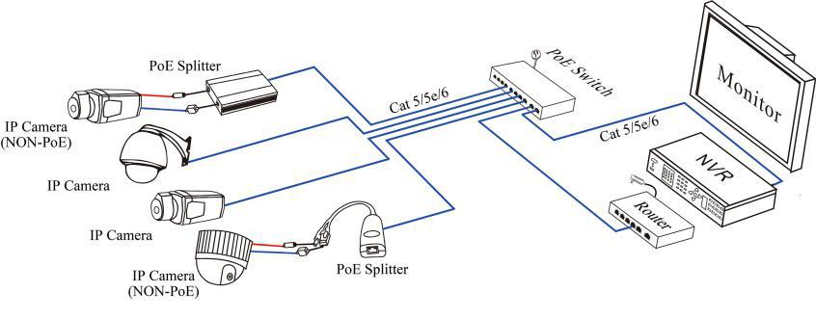

Product Structure

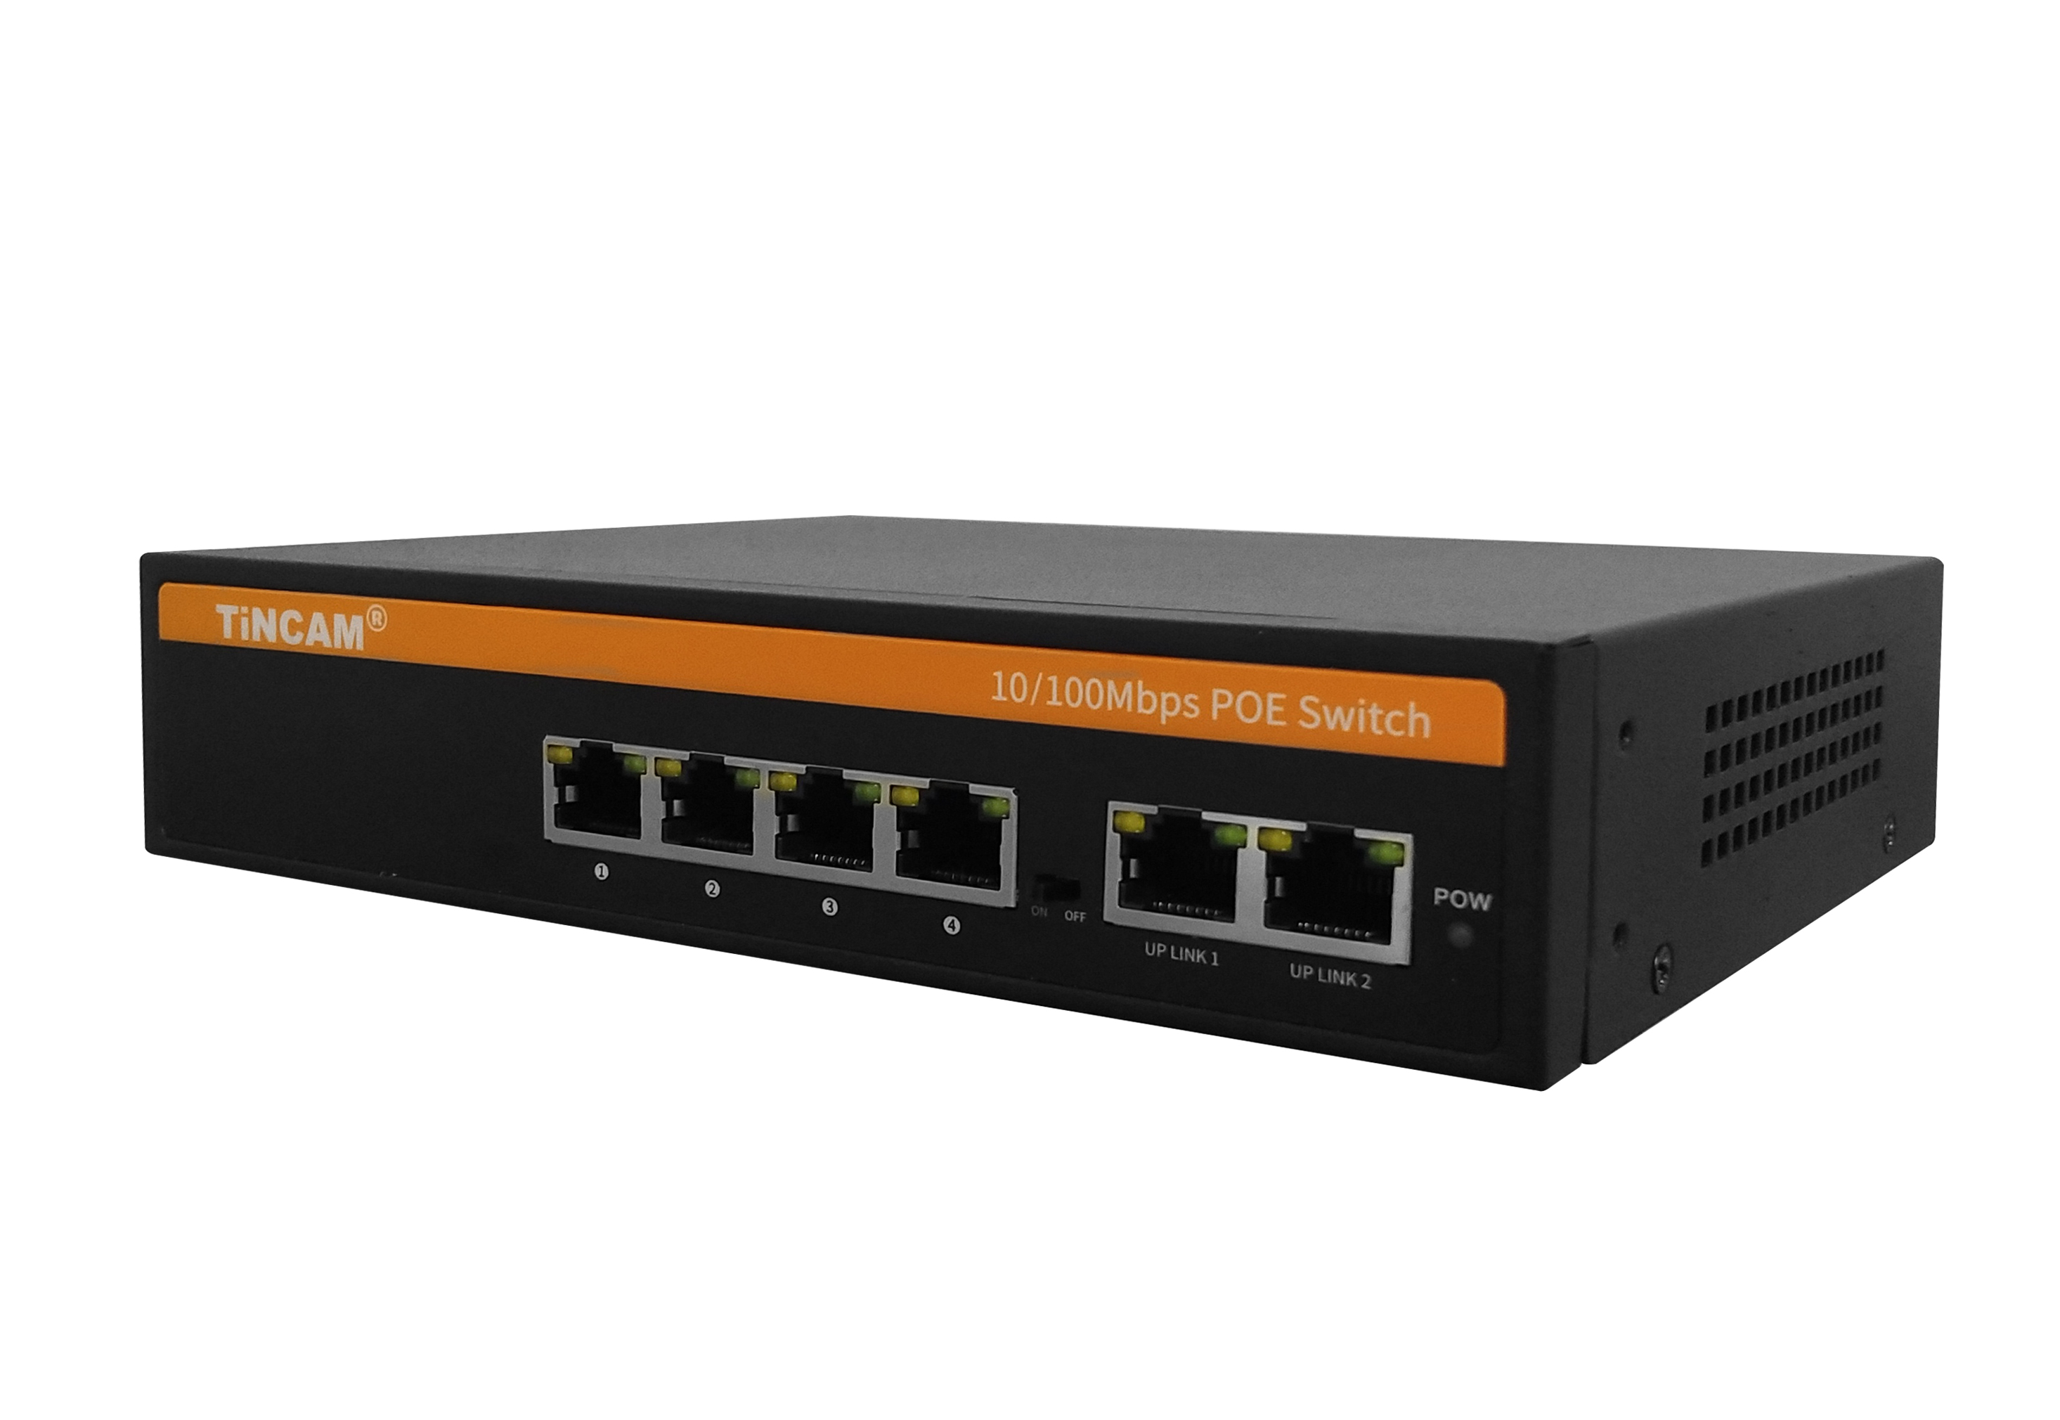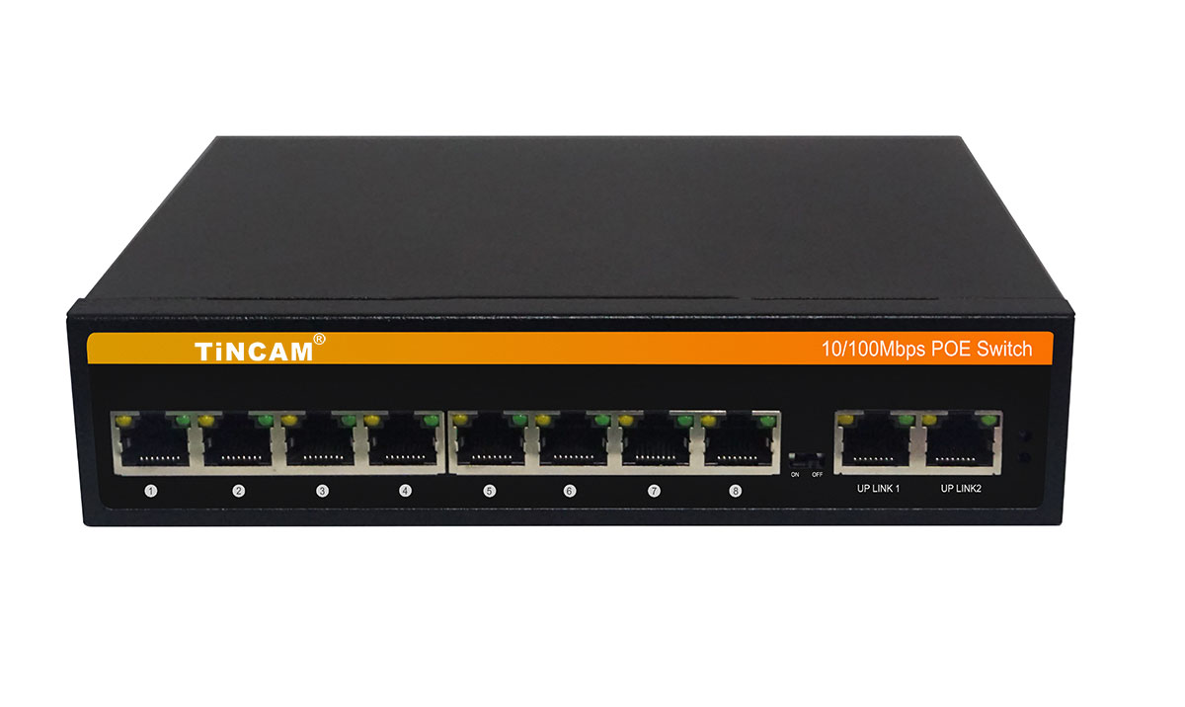

TBC-BPS4306N TBC-BPS4310N

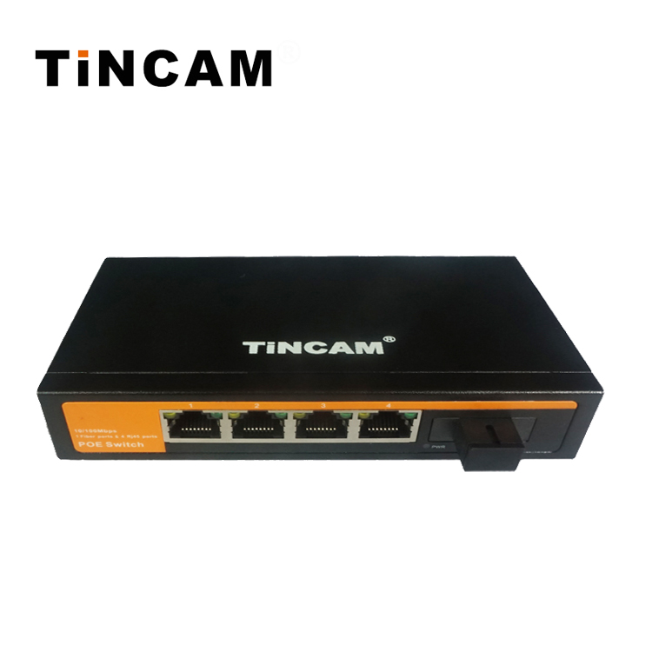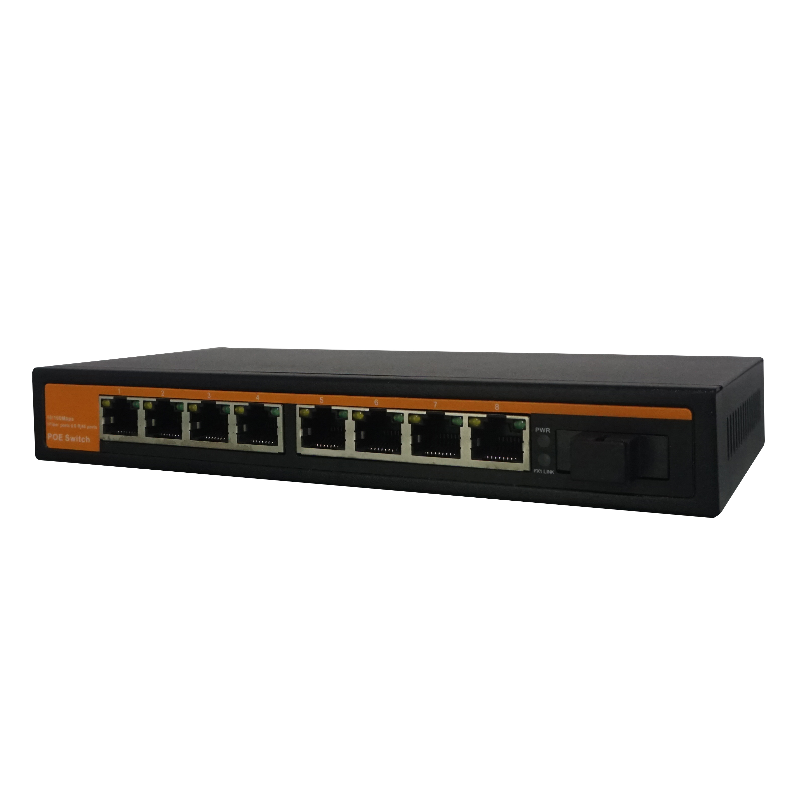
POE Switch Series

3/3

TBC-PSF4314ES20A TBC-PSF4318ES20A
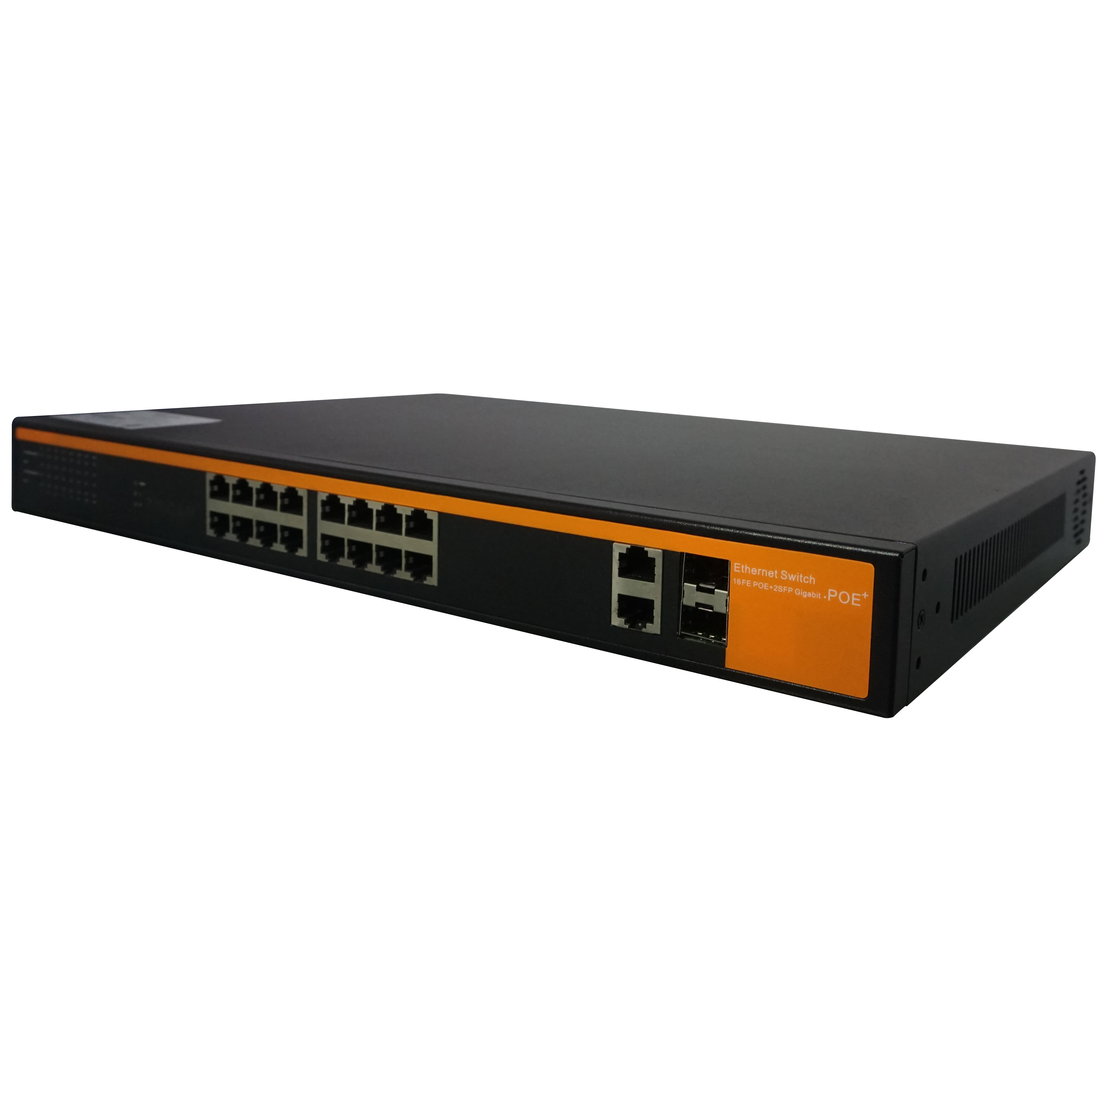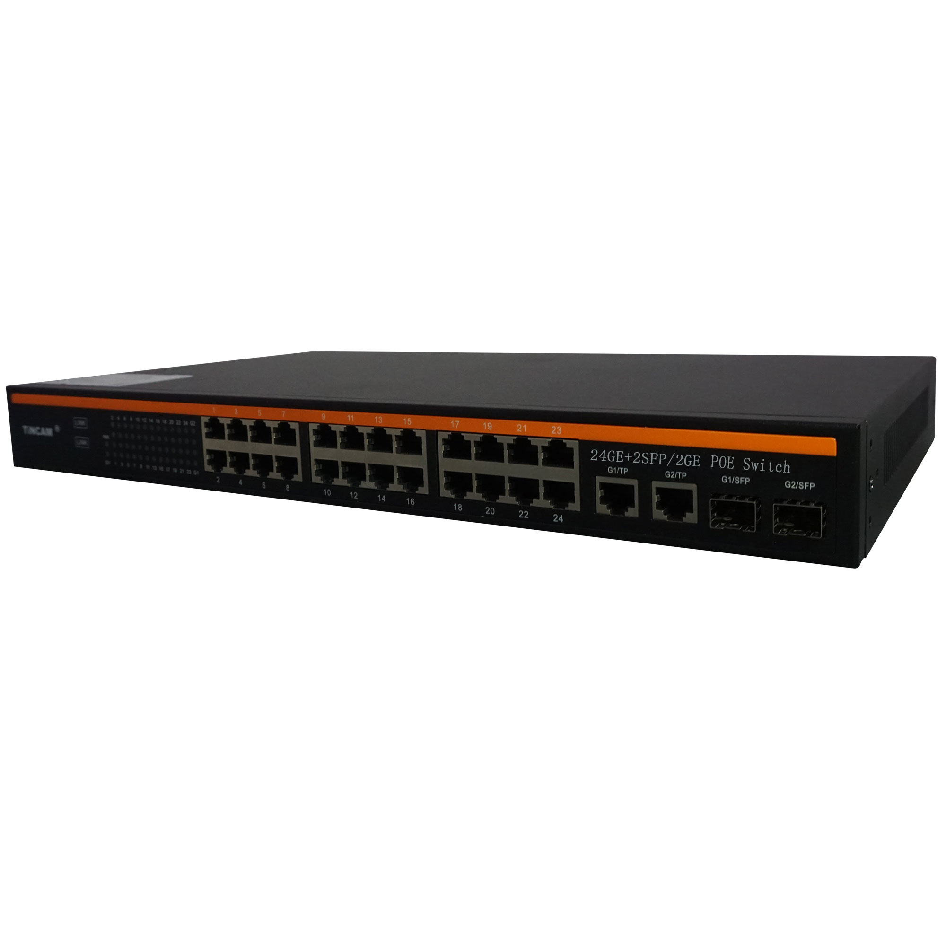
TBC-PSF4316U-2PM TBC-PSF4324U2-2PM

