TBC-PTR1200
300M Wireless panel AP
▼Product description
This is a high-performance dual-band 802.11ac in-wall AP that supports intelligent channel analysis, automatic optimal channel selection, and can support a total bandwidth of up to 1.2Gbps (2.4GH supports 300Mbps+5GHz 802.11ac supports 900Mbps). This product supports gateway, AP and other modes, which can provide users with a variety of networking methods, making user application scenarios more extensive.
▼Product picture

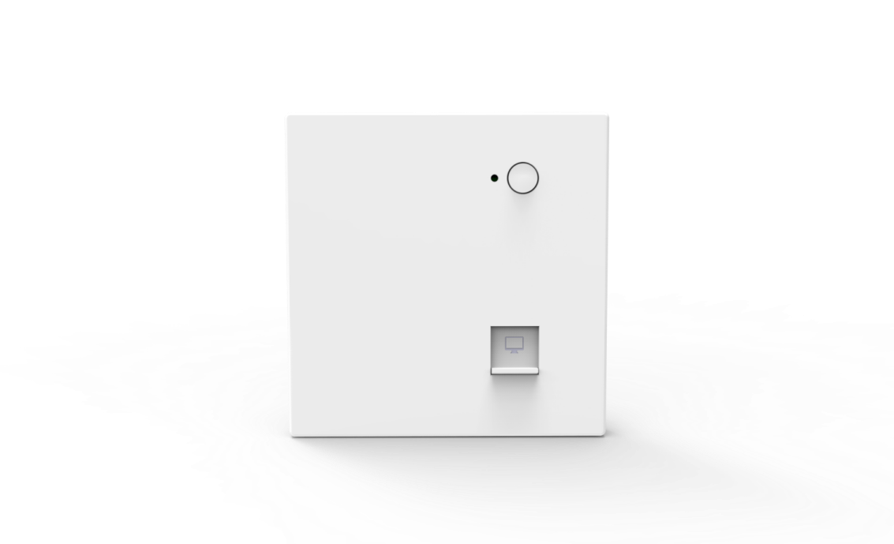

▼Product feature
- Compared with 802.11n AP, the connection speed is doubled and the coverage area is expanded
- Support hardware watchdog function, maintenance-free
- Simultaneous operation of 2.4GHz (300Mbps) and 5GHz (900Mbps) for maximum wireless throughput
- Button design: turn off the light and turn off the WiFi function to ensure that the user is in a comfortable environment
- Integrated PoE (IEEE 802.3af PoE) to reduce deployment overhead

▼Product parameters
Specification
CPU | MT7628DAN+MT7613BEN
Flash | 8M
DDR2 | 64M
2.4G Working frequency | 2.4GHz – 2.484GHz
2.4G WIFI Transfer Protocol | 802.11 b / g / n
5G Working frequency | 5.150GHz～5.850GHz
5G WIFI Transfer Protocol | 802.11 a / n / ac
Built-in antenna 2 .4G | Omnidirectional antenna 2pcs, each gain: 2dBi
Built-in antenna 5G | Omnidirectional antenna 2pcs, each gain: 2dBi
SSID hide | Support
Top speed | 1200Mbps
Maximum support for wireless access | 100+
Maximum transmit power | <21dBm
Interface (WAN) | 1 10/100M adaptive WAN port, support 48V POE power supply
Interface （LAN） | Interface (LAN) 1 10/100M adaptive LAN port
POE | 48V 0.5A
Reset | reset key (short press once to turn off the light, short press twice in a row to turn off the light and WIFI, long press for 10 seconds to restore the factory default configuration)
Status Indicator | system lights
Maximum power consumption | <8W
ESD test- I | air discharge:±4KV
Surge test- I | common mode：±2KV
Product size | 87mm*86mm*35.8mm
working environment | Normal operating temperature: -20°C to 55°C; Extreme operating temperature -30°C to 70°C; Storage temperature: -40°C to 70°C; Humidity: 5%～95% (non-condensing)

▼Software function
Support mode | Gateway mode: The device connects to the WAN through the WAN port and then uses static IP, DHCP or PPPOE to access the Internet
Support mode | AP mode: The device covers the wireless network signal to other clients or devices, and uses an Ethernet cable to connect to other routers.  into the WAN
wireless function | SSID broadcast
wireless function | Number of SSIDs: 4 (2.4GHz) + 4 (5GHz), support Chinese SSID
wireless function | Hide SSID feature
wireless function | Wireless authentication method: OPEN, WPA/WPA2-PSK
wireless function | Channel and channel bandwidth can be set
wireless function | Wireless MAC address filtering: support whitelist (100)
wireless function | VLAN ID: VLAN-ID range must be 3~4094, 0 means not enabled
wireless function | Spectrum Navigation (5G Priority)
wireless function | WiFi timer off function
wireless function | User isolation: isolation between wireless networks,  AP internal isolation
wireless function | Transmit power setting
wireless function | The number of wireless clients is limited, and the maximum number of users supported is 100
wireless function | Provides the WIFI analysis function of the current environment
Network features | IPv4 address: supports static addresses, supports obtaining addresses from management servers, and obtaining addresses from network management
Network features | DHCP server: either a built-in DHCP server or an external DHCP server
Network features | Cloud platform server
Network features | Firewall function
Network features | Layer 2 and Layer 3 roaming: By working with the AC controller, wireless users can roam seamlessly between Layer 2 and Layer 3 networks
Network features | PPPOE function: Support PPPOE dial function
Device management | Backup configuration information
Device management | Restoring configuration information
Device management | reset
Device management | Restart includes timed restart and immediate restart
Device management | change Password
Device management | Firmware upgrade, optional whether to restore factory settings after the upgrade is complete
Device management | Time management including system display time and time synchronization
Device management | System log
Device management | Fat and thin AP switching function

▼Product picture
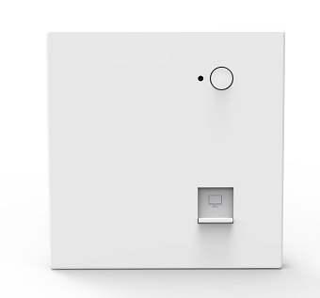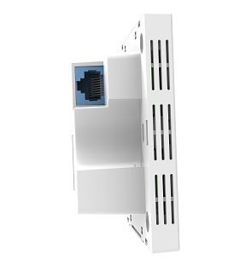
Product Instruction Chart
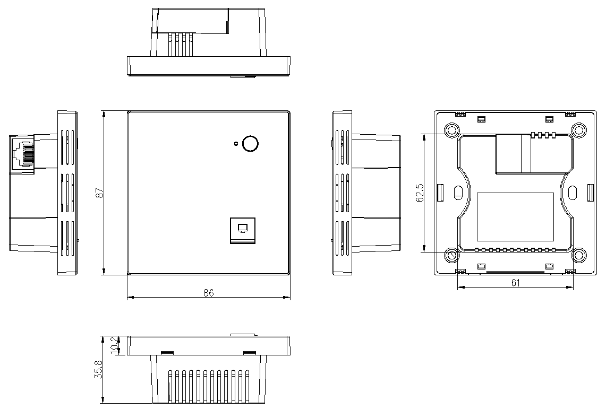
Product outline

