TBC-APE2521AB
5.8G Wireless bridge
▼Product description
TBC-APE2521AB is a 5G_11AC high-performance, high-speed outdoor long-distance wireless bridge. It has the characteristics of long transmission distance, strong penetrating ability, and strong anti-interference ability.

▼Product picture

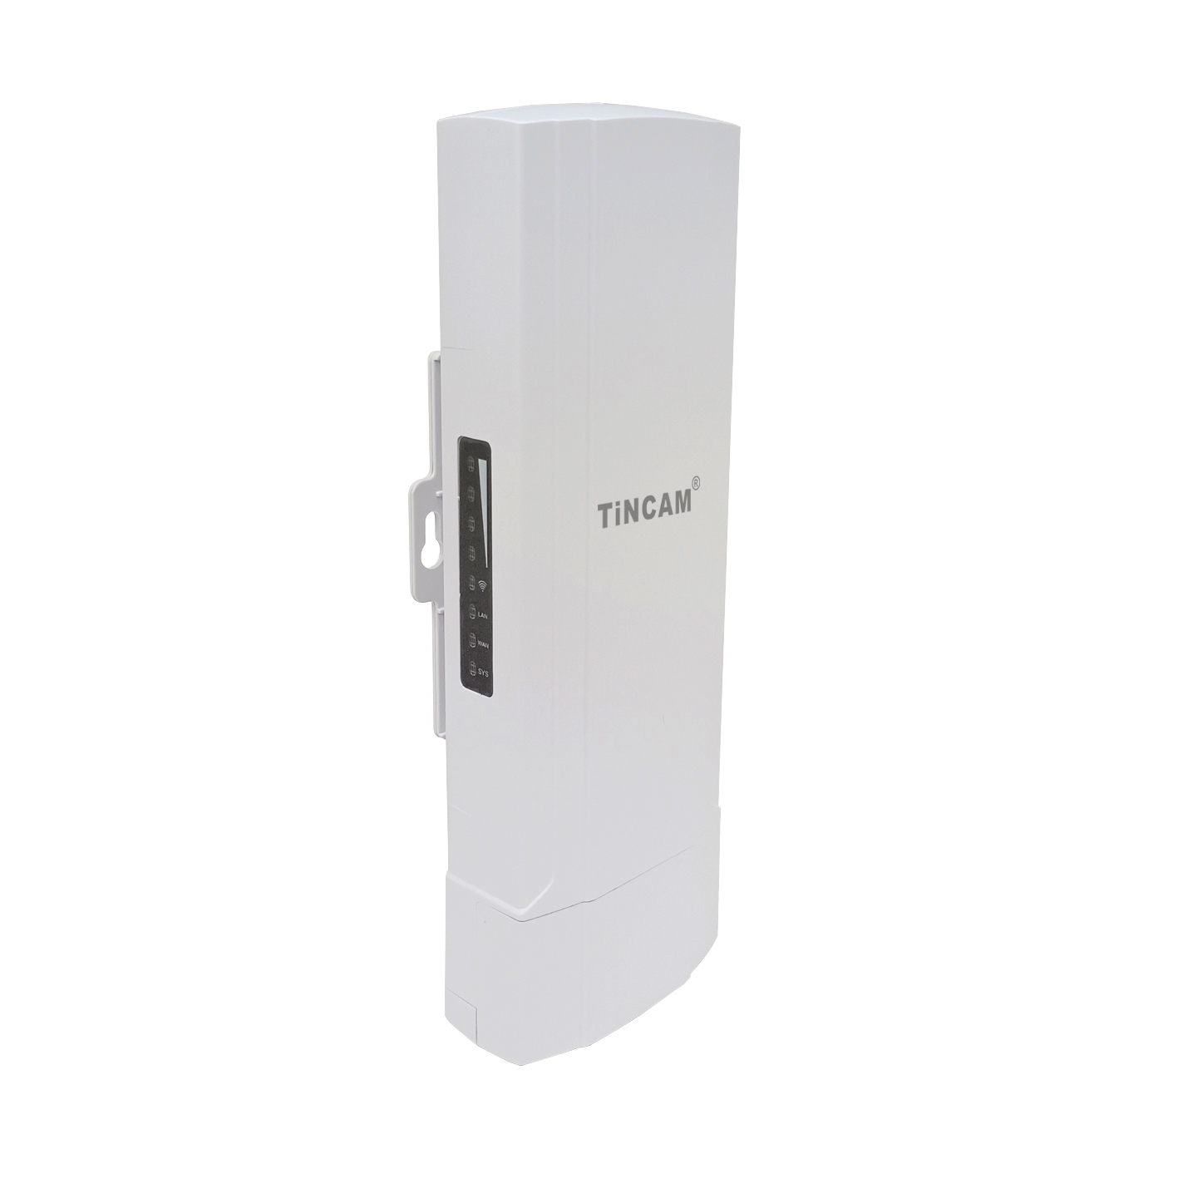

▼Product feature
- Support intelligent signal road analysis, automatic selection of the highest quality signal road, and the maximum rate is 900Mbps.
- The high-power and high-gain directional antenna design is adopted to make the transmission distance of the product longer and the coverage area wider.
- Support 48V POE or 24V POE (choose one of the two), DC 12V two power supply modes.
Using a dedicated TVS protection device to improve the stability of the product in harsh environments.

▼Product parameter
Specifications
Product name | TBC-APE2521AB
CPU | MT7628DAN+MT7613BEN
Flash | SPI NOR 8MB
DDR2 | 64MB
5G Working frequency | 5.150GHz～5.850GHz
5G WIFI Transfer Protocol | 802.11 a / n /ac
Directional 5G antenna | Gain：14dbi
SSID hidden | Support
Highest rate | 900Mbps
Maximum support for wireless access | 50+
Maximum transmit power | < 27dBm
Port (WAN) | 1个10/100M Adaptive WAN port, support POE power supply
Port（LAN） | 1个10/100M Adaptive LAN port
POE | 48V 0.5A or 24V 0.5A （choose one）
DC | 12V 1A
Button | reset button (long press for 6-10 seconds to restore the factory default configuration, short press for 1 second to initiate pairing)
Button | DIP switch
Status Indicator | PWR light, WAN port light, LAN port light, 5G WIFI light, signal strength light*4
Waterproof performance | IP65
ESD test | ±6KV
Surge test | Signal difference±2KV
Maximum power consumption | < 8W
Product size | 230mm*75mm*55mm
working environment | Normal working temperature: -30°C to 55°C;  Maximum operating temperature: -35°C to 75°C;  Storage temperature: 0°C to 70°C;  Humidity: 5%～95% (non-condensing)

▼Software function

Operation mode | AP mode: The device covers the wireless network signal to other client terminals and devices, and uses Ethernet to connect to other routers to access the WAN。
Operation mode | Universal relay: The device is connected to other wireless AP devices through wireless signals, and the wireless network signals of this device are covered by other client terminals and devices
Wireless function | SSID broadcast
Wireless function | Number of SSID: 4, support Chinese SSID
Wireless function | Hide SSID function
Wireless function | Wireless encryption：OPEN、WPA、WPA-PSK、WPA2-PSK
Wireless function | VLAN ID: The range must be 3-4094, 0 means not enabled.
Wireless function | Wireless MAC address filtering: support whitelist (64)
Wireless function | Relay function
Wireless function | WiFi Timing off function
Wireless function | User isolation: isolation between wireless networks, isolation within APs
Wireless function | Country selection
Wireless function | 5G mode: 11AN or 11AC
Wireless function | Transmit power setting
Wireless function | Short GI on or off
Wireless function | The number of wireless clients is limited, and the maximum number of users is 64
Internet function | Set IP address statically or obtain IP address dynamically
Internet function | DHCP server
Internet function | Cloud platform server
Equipment management | Backup configuration information
Equipment management | Restore configuration information
Equipment management | Reset
Equipment management | Restart includes scheduled restart and immediate restart
Equipment management | Firmware upgrade
Equipment management | Time management includes system display time and time synchronization
Equipment management | System log
Equipment management | Support local unified management function

