1200M Dual frequency ceiling type AP specification
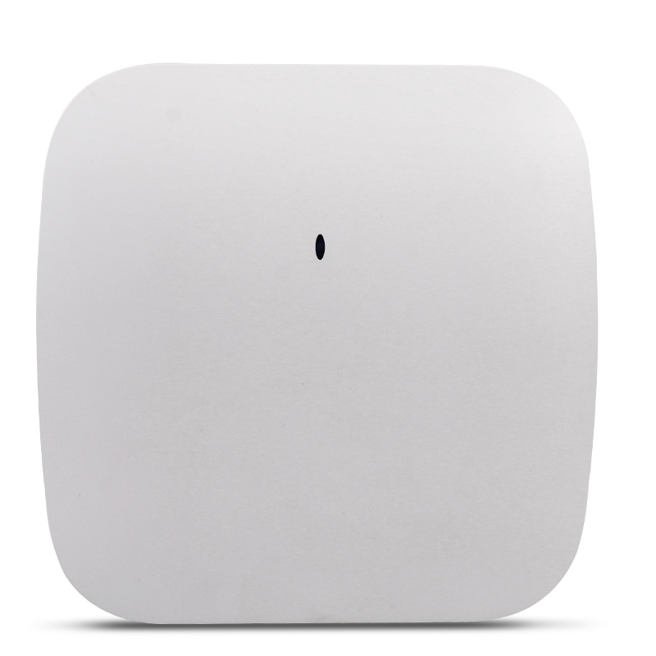

product description
TBC-STR1200 Dual-band wireless high-power AP can work in 2.4GHz/5GHz two frequency bands at the same time, support 900Mbps 11ac (5GHz) and 300Mbps 11n (2.4GHz) concurrent, the highest wireless rate can reach 1200Mbps, can access more wireless clients, solve Wireless access problems in crowd-intensive environments such as restaurants, conference halls, and KTV;TBC-STR1200 dual-band wireless high-power AP can provide 5GHz wireless services, provide a cleaner wireless environment, and more stable wireless access. MIMO technology can be used through the home page to provide better wireless transmission performance, stability and wireless coverage. TBC-STR1200 also supports practical functions such as wireless AP, and WISP, and is your preferred device for wireless Internet access. Using excellent shape design, give you a brand-new experience.
Features：
1200Mbps high speed and NAT high conversion rate
TBC-STR1200 adopts 802.11ac technology and provides wireless access speeds of up to 1200Mbps, which is about 4 times that of 802.11a/b/g/n products in the same environment. At the same time, the conversion rate of NAT is >93%s to realize downloading through the external network. Upload faster and surf the web as you like.
Transparent and energy efficient
The product supports IEEE802.3az, which can be implemented in a transceiver without a frame that can be sent into low power consumption mode. When a new frame arrives, the transceiver will return to active mode within a few microseconds, thus realizing the agreement The upper layer is almost transparent energy saving. It can automatically adjust energy consumption according to the actual traffic of the port, and can quickly switch between full-speed operation and low-power idle mode, saving users 30% of power consumption and greatly saving operating costs.
Beamforming technology
The wave velocity shaping technology can automatically adjust the signal weighting value of each element in the array when the interference direction is unknown, so that the zero point of the antenna pattern is aligned with the interference direction to suppress the interference, enhance the detection ability of the useful signal of the system, and optimize Antenna pattern, and can effectively track useful signals, suppress and eliminate interference and noise, even in the case of close-distance distribution of multiple interference and the same frequency of the signal, it can successfully suppress interference
Dual frequency wifi analyzer
The wifi analyzer function can be used to analyze the field strength and channel of the surrounding wireless signals, and follow the results of the analysis to select a channel with relatively less interference as the reference channel, which can effectively control the channel interference and facilitate the reasonable selection of the channel for engineers.
Linear power manual adjustment
The high-power AP transmit power is linearly adjustable, and the high-power AP transmit power can be adjusted reasonably according to the actual environment. In environments with high traffic and high AP density such as bars/KTV leisure center halls, the transmission power of high-power APs can be reduced to reduce mutual interference between APs and improve wireless quality; in industrial parks, where AP density is small and the building layout is more complicated Environment, can increase the transmission power of high-power AP, improve the coverage effect.。
characteristic | Subcharacteristics | Specification Value
Power supply | DC/POE | DC powered by 12~48v
Power consumption |  | Typical Dual Frequency ≤12W；
CPU | CPUmodel | Qualcomm QCA9563+QCA9882+QCA8334
CPU | Main frequency | Main frequency 1200MHz
Baseband | model | QCA9563
Memory | DDR2 SDRAM | 128M
Memory | Flash | 16MB(SPI FLASH)
interface | Console | 4pin
interface |  | 2*100/1000BASE-T
 | LED light | 1*2 Green network port indicator
 | WLAN | Dual frequency green, single frequency blue
 | DC | Power socket
 | antenna | Omnidirectional antenna
 | Reset button | button
Environmental requirements | Operating temperature | -10 ~ 45℃
Environmental requirements | storage temperature | -40 ~ 85℃
Environmental requirements | Working humidity | 0% ~ 100% No condensation
Environmental requirements | Air pressure requirement | Altitude 3000m
RF characteristics | working frequency | 2.400~2.472GHz；5180~5825GHz
RF characteristics | Transmit power | 2.4GHzRF index  11b:21±2dbm  11g\ht20\ht40 Low rate：21±2dbm  54M\HT20_MCS7\HT40_MCS7 High rate：18±2dbm  5GHzRF index11a：Low rate：17±2dbm  54M\HT20_MCS7\HT40_MCS7 High rate：16±2dbm  VHT40_MCS9\VHT80_MCS9：15±2dbm
RF characteristics | EVM | Firing rate EVM  11Mbps（11b） ≤0.35  54Mbps ≤-25 （dBm）  MCS7 ≤-28（dBm）  MCS15 ≤-28（dBm）  VHT40_MCS9\VHT80_MCS9 ≤-32（dBm）
RF characteristics |  | 802.11b：  1M： -95  11M： -88
RF characteristics |  | 802.11a/g：  6M： -89  54M： -70
RF characteristics |  | 802.11a/b/g/n（HT20）：  MCS0：-86  MCS7：-68
RF characteristics |  | 802.11a/b/g/n（HT40）：  MCS0：-83  MCS7：-65  VHT20：  VHT20 MCS0:-86  VHT20 MCS8:-63  VKT40：  VHT40 MCS0:-84  VHT40 MCS9:-60  VHT80:  VHT80 MCS0:-82  VHT80 MCS9:-51
Network side interface | Interface Type | RJ45
Network side interface | Transmission rate | Full duplex 10/100/1000m
Network side interface | Transmission distance | Maximum 100m
Network side interface | Cable type | Category 5 twisted pair

