POE Switch Series

1/3
24-port 10/100/1000M POE Switch

Product Description
The POE Powered Switch supports the IEEE802.3af/at power over Ethernet standard with a power distance of 100 meters and only powers 802.3af/at terminal devices, so there is no need to worry about compromising proprietary standards for POE or non-POE devices. In addition, the POE device stops supplying power when it is not connected. These devices, which are far from the power outlet, are suitable for hanging on the wall or on the ceiling, and the POE eliminates the need to connect the power outlets for these devices, making the connection to equipment that is difficult to connect to AC power more flexible and with minimal installation costs. This series POE Powered switches are ideal selection for small business networks that want to use the economic deployment of wireless access points (AP) and IP-based network surveillance cameras .

Product Features

- 2 uplink 10/100/1000M SFP optical ports ;
- The 24-port POE Ethernet switch provides 24*10/100/1000Mbps POE RJ45 ports, supports af/at power supply standard, End-spanning method, and 30W power output;
- Flow control mode: Full-duplex adopts IEEE 802.3x standard and half-duplex adopts Back pressure standard;
- Support port auto-flip (Auto MDI/MDIX);
- Maximum POE power: 450/800W optional (all POE ports, 1 to 24 ports);
Application

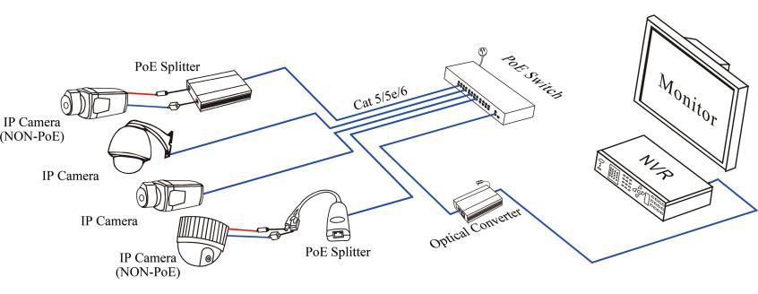

POE Switch Series

2/3
Specification

Item |  | Description
Power | Power Supply | Internal Power Supply
Power | Voltage range | AC100-240V
Network Information | Network Ports | 1-24 Downlink：10/100/1000Mbps
Network Information | Network Ports | 2*UPLINK Optical port：10/100/1000Mbps
Network Information | Transmission distance | 1-24 Downlink：0-100m
Network Information | Transmission distance | 2*UPLINK ：Depends on the Optical Module
Network Information | Transmission medium | Cat5 and above Unshielded twisted pair
Network Information | Network Standard | IEEE 802.1Q,IEEE802.1s,IEEE802.1x, IEEE 802.3ad, IEEE 802.3az
Network Information | Switching Capacity | 52Gbps
Network Information | Packet Forwarding Rate | 36.688Mpps
Network Information | MAC Table | 8K
POE Information | POE Standard | IEEE802.3af/at
POE Information | POE Type | End-Span（1/2+，3/6-）
POE Information | POE port Features | 15.4/30W output power, 450/800W total power
LED Status Indicator | Power | Red light indicates that power normal work;
LED Status Indicator | Network indicator | Green light indicates that Link/act is working normally;
LED Status Indicator | POE indicator | Flashes Yellow indicates that POE is working normally;
Operating Environment | Operating Temperature | 0℃～55℃
Operating Environment | Storage temperature | -20℃~70℃
Operating Environment | Humidity | 20~95% (non-condensing)
Mechanical | Dimension (L×W×H) | 430*230*45mm
Mechanical | Material | Sheet metal
Mechanical | Color | Black
Mechanical | Weight | 3645g

