POE Switch Series

1/3

8 10/100M*POE ports+ 1*155M fiber optical POE Switch

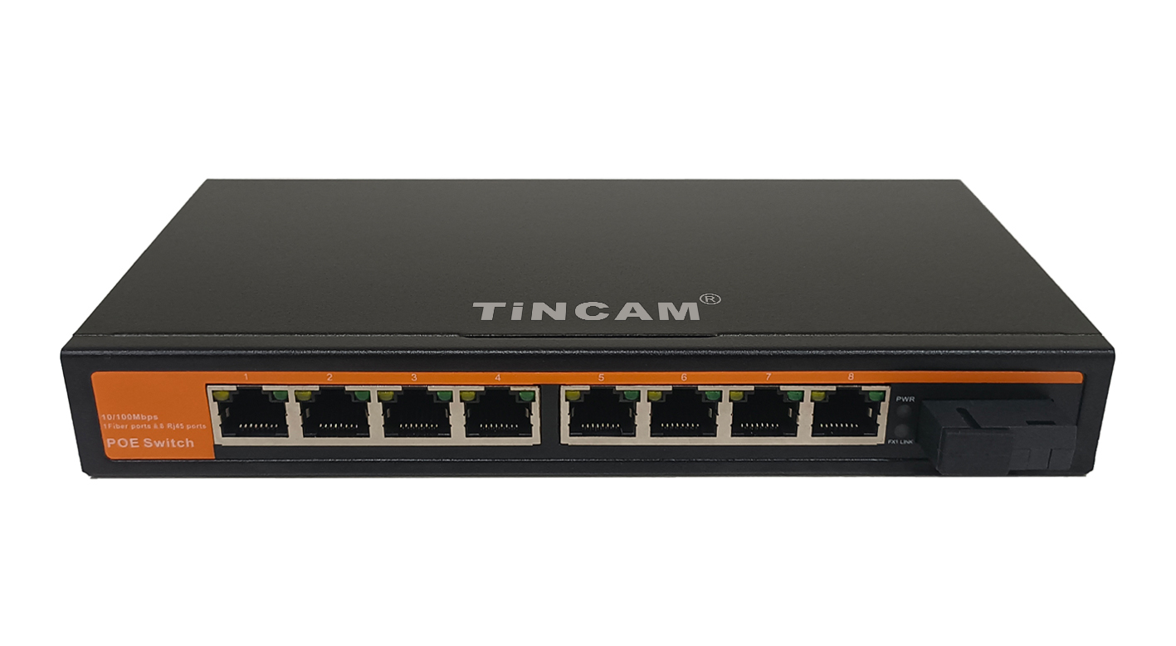
Product Description

8* 10/100M Poe ports and 1*155M optical port in the Poe switch. The POE power supply switch supports IEEE802.3af/at Ethernet power supply standard, with a power supply distance of 100m, and only supplies power for 802.3af/at terminal equipment, so there is no need to worry about damaging the private standard Poe or non Poe equipment. In addition, when the POE device is not connected, it will stop power supply. Simple, reliable design, automatic identification of Poe requirements, duplex and network cable types using auto uplink TM. The economic price of this series provides some commercial networks that need to simplify the installation of wireless access point (AP) and IP based webcam. These devices far away from the power socket are very suitable for hanging on the wall or ceiling. Poe eliminates the hassle of connecting power outlets to these devices. It makes the connection of the equipment which is difficult to connect the AC power more flexible, and the installation cost is minimized. With compact and flexible design, this series of Poe power switch is an ideal choice for small commercial networks that want to use Poe economically to deploy wireless access point (AP) and IP based network monitoring cameras.

Product characteristics
1. Meet IEEE802.3 10Base-T and ie802.3u 100Base-T Ethernet standards
2. Flow control mode: IEEE 802.3x standard is adopted for full duplex and back pressure standard is adopted for half duplex;
3. Port supports 10 / 100M adaptive and auto flip (automdi / mdix)
4. Ethernet port two-level lightning protection technology ensures product stability
5. Support fixed port VLAN (ieee802.1q1 VLAN)
6. The exchange mechanism of store and forward
7. All ports support line speed switching. Line speed can be achieved within 1536k frame length. Line speed switching is supported,
8. Imported chip, automatic cooling
9. 8 ports 10 / 100Mbps adaptive Poe intelligent power supply ports, supports ieee802.3af/at power supply international standard, 12 + / 36 -, 15.4/25.5w power supply output by end bridging method;
10. Support auto MDI / mdix;

Stable and reliable equipment

Simple operation and strong expansibility

Easy to use, no need to configure, plug and play, strong compatibility, no burning device

High speed transmission, no packet loss, flexible expansion, so that the network is not limited by power line layout, saving user costs

Meet the demand of high density Poe power supply network environment

It is suitable for financial institutions, government agencies, hotels, shopping malls, campuses, hospitals and small and medium-sized enterprises to establish a cost-effective network.
Application

Product parameters

Product information |  | Describe
Power information | Power supply mode | Internal power adapter
Power information | Voltage range | DC48V-52V
Power information | Network port | 1*Uplink Optical ports：155M
Power information | Transmission Distance | 1-8downlink port：100Mbps
Power information | Transmission Distance | 1*optical ports：SC Slot
Power information | Transmission Distance | 1*Ethernet ports:100m
Power information | Transmission Medium | Unshielded twisted pair of category 5 and above
Power information | Network standard | IEEE802.3,IEEE802.3u,IEEE802.3ab,IEEE802.1d,IEEE802.1w,IEEE802.1s,IEEE802.1Q,IEEE802.1pIEEE802.3x,IEEE802.3af,/at
Power information | Forwarding mode | Store and forward (line speed forward store and forward can be realized)
POEinformation | POE standard | IEEE802.3af/at
POEinformation | POE type | End bridging （1/2+，3/6-）
POEinformation | POE Port characteristics | Port output power 15.8/25.5w，total power 65w
Status light | Power lamp | The green light is on, indicating normal operation
Status light | POE Indicator light | The green light is on, which means Poe works normally
Status light | Network indicator | The yellow light flashes, indicating that link / act works normally
Physical properties | Work Tempreature | -20℃~65℃
Physical properties | size | 200*104*28mm

