POE Switch Series

8 10/100/1000M*POE ports+ 2*SFP fiber optical +2*RJ45
Ports POE Switch

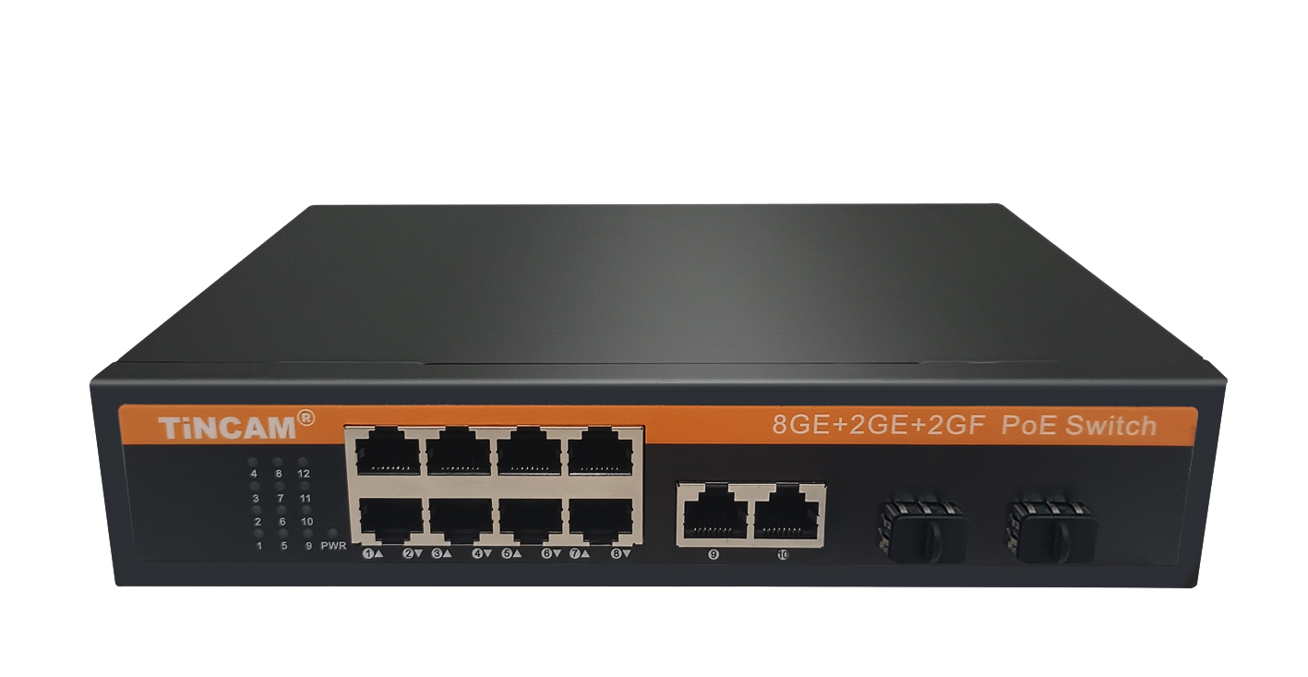
Product Desription

8* 10/100/1000M Poe ports and 2*gigabit optical port in the Poe switch. The POE powersupply switch supports IEEE802.3af/at Ethernet power supply standard, with a power supplydistance of 100m, and only supplies power for 802.3af/at terminal equipment, so there is no need to worry about damaging the private standard Poe or non Poe equipment. In addition, when the POE device is not connected, it will stop power supply. Simple, reliable design, automatic identification of Poe requirements, duplex and network cable types using auto uplink TM. The economic price of this series provides some commercial networks that need to simplify the installation of wireless access point (AP) and IP based webcam. These devices far away from the power socket are very suitable for hanging on the wall or ceiling. Poe eliminates the hassle of connecting power outlets to these devices. It makes the connection of the equipment which is difficult to connect the AC power more flexible, and the installation cost is minimized. With compact and flexible design, this series of Poe power switch is an ideal choice for small commercial networks that want to use Poe economically to deploy wireless access point (AP) and IP based network monitoring cameras.

Product characteristics

◆ Support the power supply through the wireless access point (AP) and the surveillance cameras
of the two Ethernet cables. 1-8 ports support the standard ieee802.3af/at power supply;
◆ 2 uplink 10 / 100 / 1000Mbps optical port+2*Uplink RJ45 ports , easy to use, economical and
high energy;
◆ 1-8 down connected 10/100M Poe ports, supporting AF / at power supply standard, terminal
jumper method, 15.4/25.5w power supply output;
◆ flow control mode: IEEE 802.3x standard is adopted for full duplex and back pressure standard
is adopted for half duplex;
◆ support auto MDI / mdix;

Stable and reliable equipment

Simple operation and strong expansibility

Easy to use, no need to configure, plug and play, strong compatibility, no burning device

High speed transmission, no packet loss, flexible expansion, so that the network is not limited by power line layout, saving user costs

Meet the demand of high density Poe power supply network environment

It is suitable for financial institutions, government agencies, hotels, shopping malls, campuses, hospitals and small and medium-sized enterprises to establish a cost-effective network.
Application
Product parameters

PoE port | 1-8port
Voltage range | AC220V/DC52V
Port power | IEEE802.3af/at standard 15.4W（16W）/25.5W（30W）
Whole machine power | 120W
UPLINK | 2*10/1000Mbps Ethernet port+2*1.25G SFP Slot
working temperature | -20℃~+65℃
exchange capacity | 9.6Gbps
Packet forwarding rate | 7.14Mpps
Product size | 202*140*45mm

