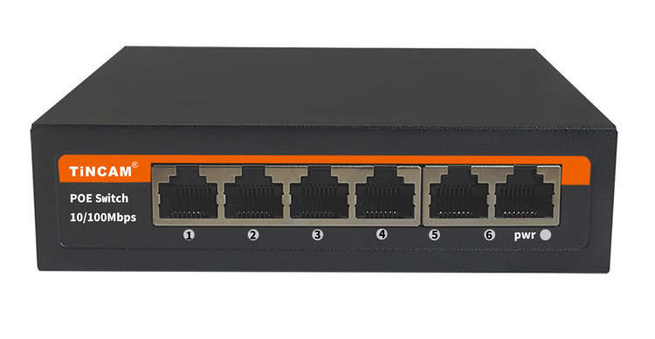
POE Switch Series

8*100M*POE ports+ 2*RJ45 Ports POE Switch

Product Description

TNC-PS4310N9 POE Powered Switch supports the IEEE802.3af/at power over Ethernet standard with a power distance of 100 meters and only powers 802.3af/at terminal devices, so there is no need to worry about compromising proprietary standards for POE or non-POE devices. In addition, the POE device stops supplying power when it is not connected. These devices, which are far from the power outlet, are suitable for hanging on the wall or on the ceiling, and the POE eliminates the need to connect the power outlets for these devices, making the connection to equipment that is difficult to connect to AC power more flexible and with minimal installation costs. This series POE Powered switches are ideal selection for small business networks that want to use the economic deployment of wireless access points (AP) and IP-based network surveillance cameras .
Product characteristics
◆ Support the power supply through the wireless access point (AP) and the surveillance cameras of the two Ethernet cables. 1-8 ports support the standard ieee802.3af/at power supply;
◆ 2*Uplink 100M RJ45 ports , easy to use, economical and high energy;
◆ 1-8 down connected 10/100M Poe ports, supporting AF / at power supply standard, terminal jumper method, 15.4/25.5w power supply output;
◆ flow control mode: IEEE 802.3x standard is adopted for full duplex and back pressure standard is adopted for half duplex;
◆ support auto MDI / mdix;
Stable and reliable equipment

Simple operation and strong expansibility

Easy to use, no need to configure, plug and play, strong compatibility, no burning device

High speed transmission, no packet loss, flexible expansion, so that the network is not limited by power line layout, saving user costs

Meet the demand of high density Poe power supply network environment

It is suitable for financial institutions, government agencies, hotels, shopping malls, campuses, hospitals and small and medium-sized enterprises to establish a cost-effective network.
Application
Product parameters

PoE port | 1-8port
Voltage range | AC220V/DC52V
Port power | IEEE802.3af/at standard 15.4W（16W）/25.5W（30W）
Whole machine power | 96W
UPLINK | 2*10/100Mbps Ethernet port
working temperature | -20℃~+65℃
exchange capacity | 2Gbps
Packet forwarding rate | 1.5Mpps
Product size | 200*118*44mm

