POE Switch Series

4*100M*POE ports+ 2*RJ45 Ports POE Switch

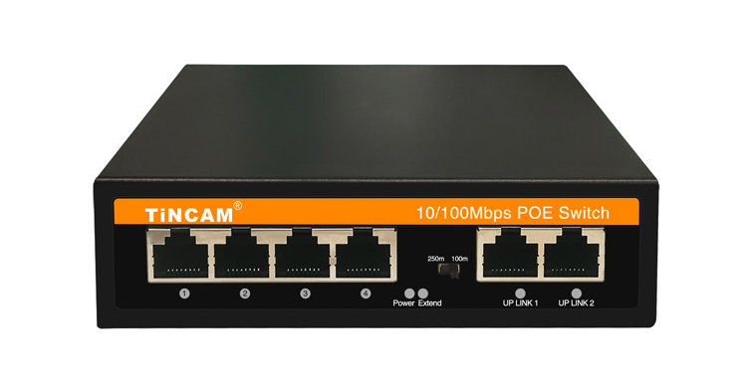
Product Description

TCE-PS4306N4 adopts imported main chip and PSE power supply chip to transmit fast Ethernet and intelligent Ethernet POE power supply with AI intelligent management function, never burning the machine; Featuring an ultra-high backplate design and high-speed data processing capability, it enhances smooth data transmission performance. The precision steel alloy body is coated with electrostatic paint, promoting dual flow heat dissipation, stable performance, and fault free operation for at least 30000 hours; Excellent port performance. Supports full load IEEE802.3af/at international standard power supply, POE power supply pins: 12+/36- (data synchronous transmission). Supports wireless access (AP) through CAT5/6 cable and network monitoring IPC, VOIP and other data signal transmission from 100 meters to 250 meters with switch selection.
Product characteristics
1. Compliant with IEEE802.3 10Base-T and IE802.3u 100Base-T Ethernet standards
2. Flow control method: Full duplex adopts IEEE 802.3x standard, and half duplex adopts Back pressure standard;
3. The port supports 10/100M adaptive and automatic flipping (AutoMDI/MDIX)
4. Ethernet port secondary lightning protection technology ensures product stability
5. Supports fixed port VLANs (IEEE 802 1Q1 VLAN)
6. Adopting a store and forward exchange mechanism
7. All ports support line speed switching, and line speed can be achieved within a 1536k frame length range, supporting line speed switching,
8. Adopting imported chips and automatic heat dissipation
9. 1-2 upstream 10/100Mbps adaptive ports for cascading or connecting to external network access platforms;
10. The 6-port PoE Ethernet switch has 4 downstream 10/100Mbps adaptive PoE intelligent power supply ports, supporting the IEEE802.3af/at power supply international standard, with a 12+/36- terminal jumper and 15.4/25.5w power output;
11. POE transmission band Extend network extension signal mode, network power switch optional transmission up to 250 meters
Stable and reliable equipment

Simple operation and strong expansibility

Easy to use, no need to configure, plug and play, strong compatibility, no burning device

High speed transmission, no packet loss, flexible expansion, so that the network is not limited by power line layout, saving user costs

Meet the demand of high density Poe power supply network environment

It is suitable for financial institutions, government agencies, hotels, shopping malls, campuses, hospitals and small and medium-sized enterprises to establish a cost-effective network.
Application
Product parameters

PoE port | 1-4port
Voltage range | AC220V/DC52V
Port power | IEEE802.3af/at standard 15.4W（16W）/25.5W（30W）
Whole machine power | 65W
UPLINK | 2*10/100Mbps Ethernet port
working temperature | -20℃~+65℃
exchange capacity | 1.2Gbps
Packet forwarding rate | 0.9Mpps
Product size | 130*120*30mm

