POE Switch Series

16*100M*POE ports+ 2*RJ45 Ports+ 1*SFP fiber optical POE Switch

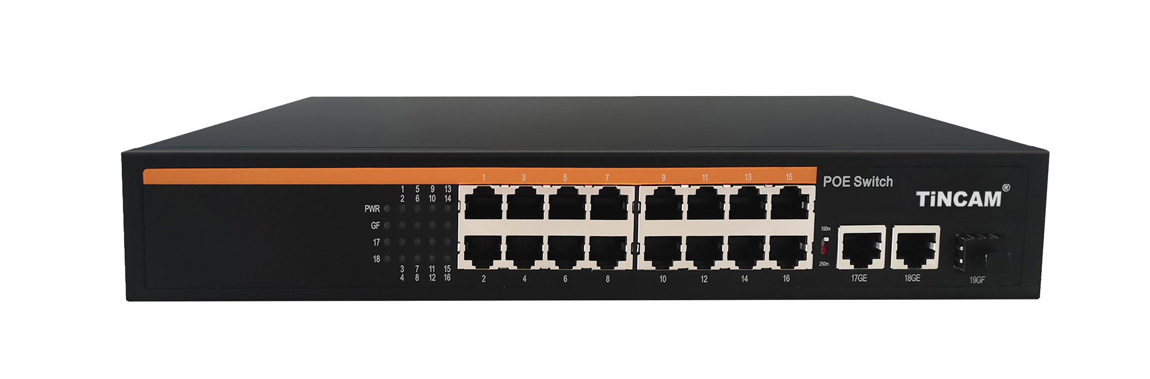
Product Description

TBC-5PSF4516N-3PF adopts imported main chip and PSE power supply chip to transmit fast Ethernet and intelligent Ethernet POE power supply with AI intelligent management function, never burning the machine; Featuring an ultra-high backplate design and high-speed data processing capability, it enhances smooth data transmission performance. The precision steel alloy body is coated with electrostatic paint, promoting dual flow heat dissipation, stable performance, and fault free operation for at least 30000 hours; Excellent port performance. Supports full load IEEE802.3af/at international standard power supply, POE power supply pins: 12+/36- (data synchronous transmission). Supports wireless access (AP) through CAT5/6 cable and network monitoring IPC, VOIP and other data signal transmission from 100 meters to 250 meters with switch selection.

1. Support full port IEEE802.3af/at standard
Product characteristics
2. Transmit Ethernet data through a network cable and provide power supply function;
3. It can automatically detect and identify PD power receiving equipment that
meets the IEEE802.3af/IEEE802.3at standard;
4. Support port power supply priority to ensure continuous power supply at network gateways;
5. It has a short-circuit protection function. When the current is too large or the PD device fails, the power supply will be stopped to protect the PD powered device;
6. It comes with energy-saving and environmental protection, supports automatic standby mode and cable length and other functions, that is, automatically standby to save energy when the port is not connected. When the cable length is less than 10 meters, it provides the power transmission rate;
7. Support SNMP protocol, WEB management, flexible configuration of switch related parameter functions;
8.Full-series product line: 1-16 POE power supply port selection, 1-2 uplink electrical ports and SFP optical port cascade applications;

Stable and reliable equipment

Simple operation and strong expansibility

Easy to use, no need to configure, plug and play, strong compatibility, no burning device

High speed transmission, no packet loss, flexible expansion, so that the network is not limited by power line layout, saving user costs

Meet the demand of high density Poe power supply network environment

It is suitable for financial institutions, government agencies, hotels, shopping malls, campuses, hospitals and small and medium-sized enterprises to establish a cost-effective network.
Application
Product parameters

PoE port | 1-16port
Voltage range | AC220V/DC52V
Port power | IEEE802.3af/at standard 15.4W（16W）/25.5W（30W）
Whole machine power | 200W/300W
UPLINK | 2*10/100Mbps Ethernet port+1*optical ports
working temperature | -20℃~+65℃
exchange capacity | 9.2Gbps
Packet forwarding rate | 6.94Mpps
Product size | 310*182*45mm

