Product Description
The POE Powered Switch supports the IEEE802.3af/at power over Ethernet standard with a power distance of 100 meters and only powers 802.3af/at terminal devices, so there is no need to worry about compromising proprietary standards for POE or non-POE devices. In addition, the POE device stops supplying power when it is not connected. These devices, which are far from the power outlet, are suitable for hanging on the wall or on the ceiling, and the POE eliminates the need to connect the power outlets for these devices, making the connection to equipment that is difficult to connect to AC power more flexible and with minimal installation costs. This series POE Powered switches are ideal selection for small business networks that want to use the economic deployment of wireless access points (AP) and IP-based network surveillance cameras .

Product Features

- 16* 10/100/1000Mbps downlink POE Ethernet Ports, 2* 10/100/1000Mbps uplink Ethernet Ports and 1* 1.25G SFP Ports;
- Supports port auto-flip (Auto MDI/ MDIX);
- Each of 16 ports all support IEEE802.3af/at;
- Maximum power per port: 15.4W/30W;
- Maximum POE power: 200W/300W;
- Adopts store-and-forward architecture;
- Built-in 1U rack power supply series, easy installation.
Application

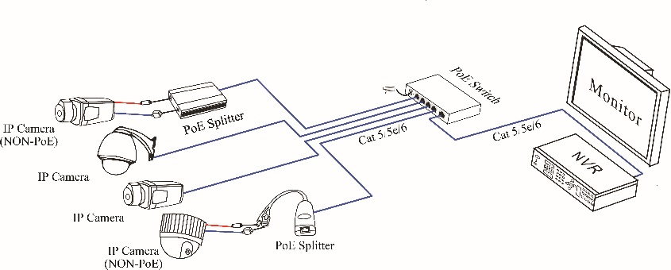

Specification
Item |  | Description
Power | Power Adapter Voltage | AC100-240V
Power | Consumption | 200W / 300W
Network Connector | Network Port | 1～16 Port : 10/100/1000Mbps POE Ethernet Port
Network Connector | Network Port | Uplink Port : 10/100/1000Mbps Ethernet Port  Uplink Port : 1000Mbps SFP Port
Network Connector | Transmission Distance | 1～16 Port : 0~100m
Network Connector | Transmission Distance | Uplink Port : 0~100m  SFP: depends on the optical module
Network Connector | Transmission Medium | Cat5/5e/6 standard network cable
Network Switch | Network Standard | IEEE 802.1Q, IEEE 802.1s, IEEE 802.1x, IEEE 802.3ad, IEEE 802.3az
Network Switch | Switching Capacity | 38Gbps
Network Switch | Packet Forwarding Rate | 26.784Mpps
Power Over Ethernet | POE Standard | IEEE 802.3af/at
Power Over Ethernet | POE Power Supply Type | End-Span(1/2+;3/6-)
Power Over Ethernet | POE Power Consumption | af≤15.4W , at≤30W , (every port)
LED Status Indicator | POE Ethernet LED Indicator | Power: 1 red light indicates that the power normal work;
LED Status Indicator | POE Ethernet LED Indicator | POE: 16 yellow lights indicate that the POE is power on;
LED Status Indicator | POE Ethernet LED Indicator | Ethernet: 19 green lights indicate that the Ethernet link and act;
Environmental | Working temperature | 0℃~55℃
Environmental | Relative Humidity | 20~95% non-condensing
Environmental | Storage temperature | -20℃~70℃
Mechanical | Dimension (L×W×H) | 305*225*45mm
Mechanical | Weight | 3100g
Stability | MTBF | >30000h

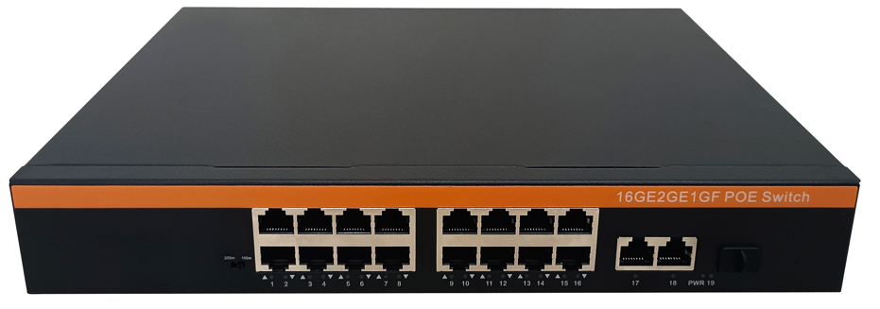

Instruction:
- Front board have 19 ports, Provide 16 * 10/100/1000Mbps downlink POE Ethernet Ports, 2 * 10/100/1000Mbps uplink Ethernet Ports and 1 *1.25G SFP Ports.
- LED Indicator State:
Power: 1 red light indicates that the power normal work;
POE: 18 yellow light indicates that the POE is power on;
Ethernet: 19 green light indicates that the Ethernet link and act;

Please check below device and accessories before installation, if there are missing, please contact with your supplier.
- POE Switch 1 PCS
- Power Adapter/Power Adapter Cable 1 PCS
- User Manual 1 PCS

Please follow the following steps
◆ Please turn off the signal source and the device's power before installing, installation with power on may damage the device;
◆ Use the network cables to connect the IP cameras with Ethernet switch's every POE port;
◆ Use network cable to connect Ethernet switch’s UPLINK port with NVR or Other Device;
◆ Connect Ethernet switch with power adapter;
◆ Check if the installation is correct and device is good, make sure all the connection is reliable and power for the system;
◆ Make sure every network device has power supply and work normally.

Please remove the problem according to the following steps
◆ Please confirm if the device installation is correct;
◆ Please confirm if the RJ45 reach the standard of EIA/TIA568A OR 568B;
◆ The maximum transmission distance depends on the signal source and cable quality, please do not over the maximum transmission distance;
◆ Please replace a normal device with a failure one to check if the device is broken;
◆ If the problem still exist , please contact the factory.

