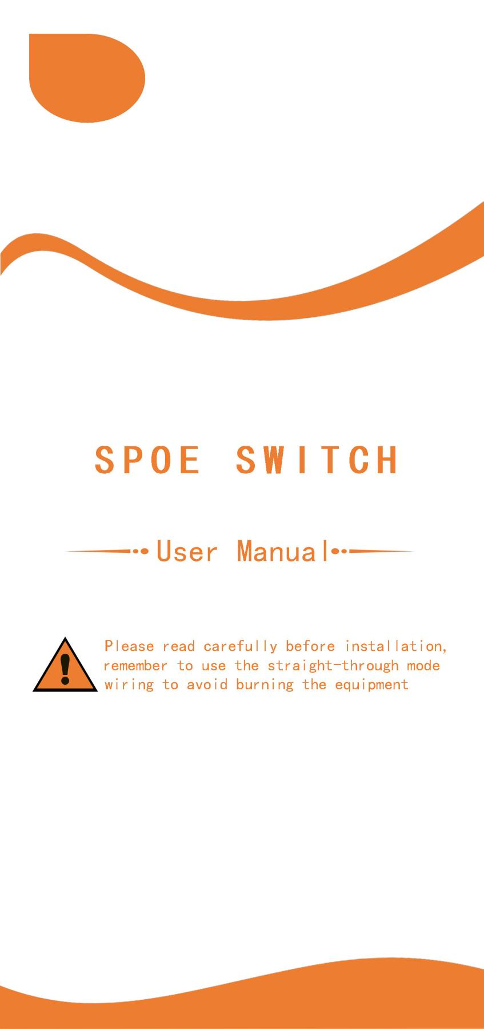

product description

This series of SPOE switches is mainly aimed at the needs of building networking and security monitoring field equipment, that is, network communication and smart transmission. This type of big data is smooth and high-performance transmission. Seiko steel alloy body electrostatic paint, promote dual-flow heat dissipation, trouble-free work ≥ 50,000 hours; excellent port performance. Support port full load IEE802.3af/at power supply standard, according to the needs of on-site access equipment, select SPOE power supply 15V or 24V And pin position: 12+/36-. 45+/78-, and monitor IPC, building intercom and other power supply and data signal transmission distance from 100 meters to 250 meters through CAT5/6 network cable, easy and convenient configuration of switch related functions, for video surveillance, smart building and network communication maintenance provide assurance.
The SPOE switch is a non-standard power supply, that is, the power is directly transmitted through the empty line pin 12+36- or 45+ 78- in the network cable to transmit data and power supply. It will not automatically detect whether the connected device has the PD function, and will directly feed it Input voltage to form a power supply state; if the IP terminal does not support SP0E power supply, if the spare wire in the network cable is used as the corresponding power line, it is likely to burn the device or the switch will self-destruct.
Product Features

◆Ultra-high backplane bandwidth design has extremely fast data processing capabilities and improves the smooth transmission performance of data signals;
◆Support DC power supply through five categories or more than five categories.
◆Easy to use, plug and play, lightning protection design, non-destructive transmission security monitoring and zero jams, network power supply cables are not restricted by power lines, saving labor and wiring costs.
◆The switch meets the needs of network power supply, and is suitable for supporting the use of IP camera monitoring and building intercom equipment, and is widely used in network communication fields such as smart communities, smart education, smart medical, smart office parks, hotels, and small and medium-sized enterprises.
◆SPOE network port with network extension signal mode: switch optional to determine the transmission distance;

Switch instructions

100m:When the control key is adjusted to this position, the port bandwidth rate is

-1-

100Mbps, and the transmission distance is 100 meters。
250m:When the control key is adjusted to this position, the port bandwidth rate is 10Mbps, and the transmission distance is 250 meters
◆Reminder: Remember to use the pass-through mode!

LED indicator description
Indicator light | color | Working status | State description
Power  Indicator light | green | on | Equipment power supply is normal
Power  Indicator light | green | off | The device is not powered or the power supply is abnormal
Link/Act link  Indicator light | green | on | Connect to the network equipment normally
Link/Act link  Indicator light | green | Flashing | Data transmission, POE power supply synchronization
Link/Act link  Indicator light | green | off | Abnormal connection or device not connected
Extend light | green | off | 100m
Extend light | green | on | 250m

Specifications

Product panel diagram | 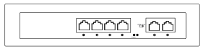 | 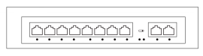
Product name | 4 ports SPOE switch | 8*ports SPOE switch
POE port | 1-4 | 1-8
POE distance | 100m or 250m（DIP switch settings）
Voltage | 15V/24V | 15V/24V
Port power | 15.4W(16W)/25.5W(30W)
Total power | 65W | 120W
UPLINK | 2*10/100Mbps ETH ports | 2*10/100Mbps ETH ports
Power supply pin | 1 2 +/3 6- | 1 2 +/3 6-
Power supply pin | 4 5 +/7 8- | 4 5 +/7 8-
tempreture | -20℃~65℃
size | 202*140*45mm internal power supply
规
格参数
-2-

16 ports Product panel diagram
24 ports Product panel diagram | 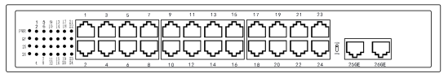
Product name | 16 ports SPOE switch | 24 ports SPOE switch
POE port | 1-16 | 1-24
POE distance | 100m or 250m（DIP switch settings）
Voltage | 15V/24V |  | 15V/24V
Port power | 15.4W(16W)/25.5W(30W)
Total power | 150W/200W | 200W/300W
UPLINK | 2*10/100/1000MbpsETH ports | 2*10/100/1000MbpsETH ports
Power supply pin | 1 2 +/3 6- | 1 2 +/3 6-
Power supply pin | 4 5 +/7 8- | 4 5 +/7 8-
tempreture | -20℃~65℃
size | 310*182*45mminternal power supply

Product panel diagram | 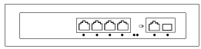 | 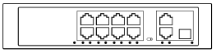
Product name | 4 ports SPOE switch | 8 ports SPOE switch
POE port | 1-4 | 1-8
POE distance | 100m or 250m（DIP switch settings）
Voltage | 15V/24V | 15V/24V
Port power | 15.4W(16W)/25.5W(30W)
Total power | 65W | 120W
UPLINK | 1*10/100/1000MbpsETH ports+1*1.25G SFP fiber port | 2*10/100/1000MbpsETH ports+1*1.25G SFP fiber port
Power supply pin | 1 2 +/3 6- | 1 2 +/3 6-
Power supply pin | 4 5 +/7 8- | 4 5 +/7 8-
tempreture | -20℃~65℃
size | 202*140*45mminternal power supply

-3-
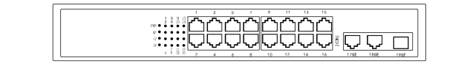
16ports Product panel diagram
24 portsProduct panel diagram | 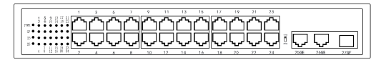
Product name | 16 ports SPOE switch | 24 ports SPOE switch
POE port | 1-16 | 1-24
POE distance | 100m or250m（DIP switch settings ）
Voltage | 15V/24V | 15V/24V
Port power | 15.4W(16W)/25.5W(30W)
Total power | 150W/200W | 200W/300W
UPLINK | 2*10/100/1000MbpsETH ports+1*1.25G SFP fiber port | 2*10/100/1000MbpsETH ports+1*1.25G SFP fiber port
Power supply pin | 1 2 +/3 6- | 1 2 +/3 6-
Power supply pin | 4 5 +/7 8- | 4 5 +/7 8-
tempreture | -20℃~65℃
size | 310*182*45mm internal power supply

Product panel diagram | 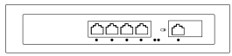 | 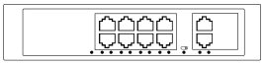
Product name | 4 ports SPOE switch | 8 ports SPOE switch
POE port | 1-4 | 1-8
POE distance | 100m or 250m（DIP switch settings）
Voltage | 15V/24V |  | 15V/24V
Port power | 15.4W(16W)/25.5W(30W)
Total power | 65W | 120W
UPLINK | 1*10/100/1000MbpsETH ports | 2*10/100/1000MbpsETH ports
Power supply pin | 1 2 +/3 6- |  | 1 2 +/3 6-
Power supply pin | 4 5 +/7 8- |  | 4 5 +/7 8-
tempreture | -20℃~65℃
size | 202*140*45mm internal power supply
-4-
Network cable connection method:
straight-through mode
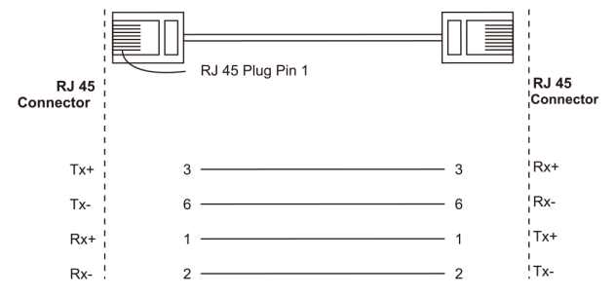

Application diagram
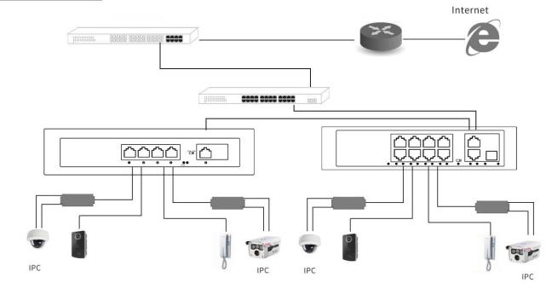

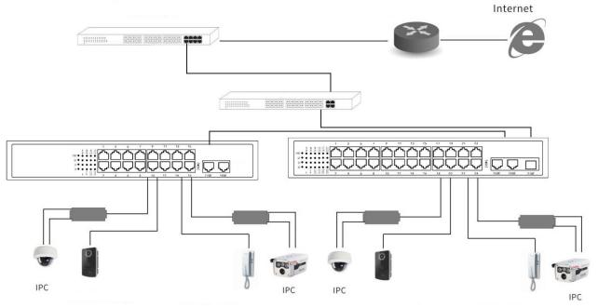

Item list

● SPOE switch 1pcs
● power cord 1pcs
●One copy each of user manual, warranty card, and certificate
1. When you encounter product questions, please call our engineers;
2. If the operation is incorrect and the machine malfunctions, it will not be covered by the warranty.
3. The final interpretation right of the content of this product description belongs to our company.
-5-

