
Ethernet Switch Series

1/2
8-port 10/100M Ethernet Switch

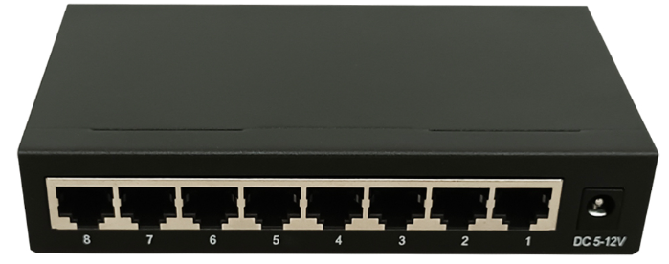
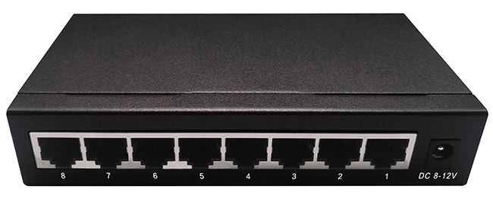
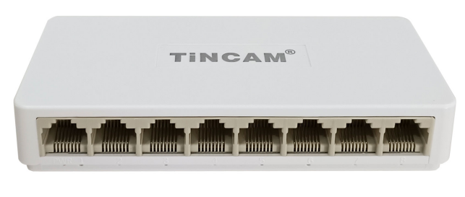

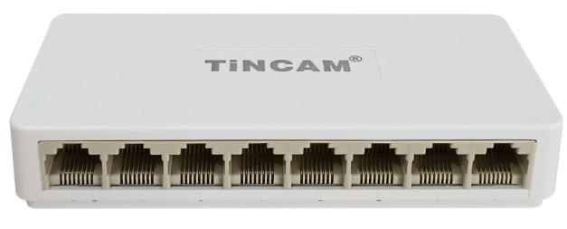

Product Description
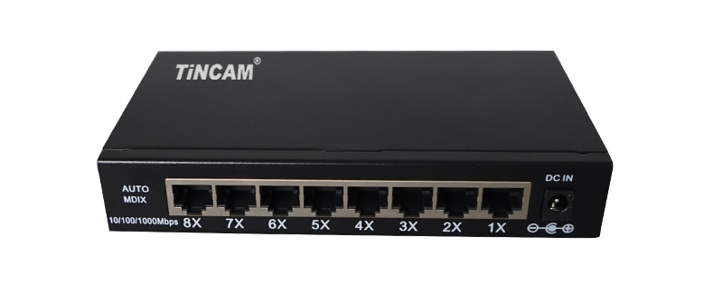

This a high performance,low-power 8-port 10/100Mbps Ethernet switch, it provides one full line-speed gigabit networking connection to your working group or server for your play and plug ,this flexible non-blocking frame make user not subject to the limit of bandwidth and media network .
This switch supports half-duplex flow control and full-duplex back pressure mode ,and each switch port support auto-adaptive function.It provides an economical、practical、high cost-effective 10/100M shared device for broadband LAN networking,providing a stable, high-throughput, wire-speed data transmission network for each end user connected to the LAN. Each port adopts store-and-forward mode to effectively isolate broadcast storm ,reduce error /wrong packets,and avoid network congestion and network conflict .The LED panel can detect the operation status of each port and whole system, and support IPv4 IGMP v1/v2/v3 and IPv6 ML Dv1/v2 detection.

Product Features

- Comply with IEEE802.3, IEEE802.3u and 802.3ab standard;

- 8*10/100Mbps auto-adaptive RJ45 port, support Auto-MDI/MDIX;
- Support 8K MAC address;Support EEPROM configuration; Support stacks;
- Support IPv4 IGMP v1/v2/v3 and IPv6 ML Dv1/v2 detection;
- Support IEEE 802.3x half-duplex flow control and full-duplex back pressure mode ;
- Non-blocking exchange frame, full wire-speed transmission and max throughput filter the data packet;
- Support MAC address, auto-adjust transmission mode and transmission rate ;
- Mini appearance dimension design;
- LED indicators, link and activity, provide the simple indication of operation status and troubleshooting;
- External power supply DC5V 2A ;
- Desktop metals case design;
- Products have passed CE and ROHS certification.
Ethernet Switch Series

2/2
Specification

Standard | IEEE 802.3 10Base-T Ethernet
Standard | IEEE 802.3u 100Base-TX Fast Ethernet
Standard | ANSI/IEEE802.3 auto-adjust, IEEE 802.3x flow control standard
Protocol | CSMA/CD
Filter and transmission rate | Ethernet 10Mbps (half -duplex) 20Mbps (full-duplex),10Mbps:14,880pps
Filter and transmission rate | Fast Ethernet 100Mbps(half-duplex),200Mbps (full-duplex),100Mbps : 148800pps
topology | Star
Network Media | 10Base-T: CAT3 UTP or higher (≤100m)
Network Media | 100Base-TX:CAT 5 UTP(≤100m)
Port No., | 8*10/100M RJ45 port
Cascade | All ports can be UP-LINK port
Transmission mode | store-and -forward
Temperature | Operation temperature : 0 ℃~40℃ (32℉~104℉)
Temperature | Storage temperature : -40℃~70℃ (-40℉~158℉)
humidity | Operation humidity :10%~90% ,non-condensing
humidity | Storage humidity :5%~95%,non-condensing
Backplane bandwidth | 1.6G
LED indicators | 1 power indicator ( red LED )
LED indicators | 8 data LED indicators (Link/Act: green LED)
Power supply | DC 5V/2A External power supply
Material (case) | Metal
Certification | CE FCC ROHS
Operation  system | Windows /MAC OS/Netware/Linux
Size | 140mm*80mm*27mm
Customized  service | OEM/ODM

