TBC-3524-1L2 is a high performance, cost effective modules, which is supporting up to 1.25Gbps, and transmission distance up to 20km on SM fiber. The transceiver consists of two sections: The transmitter section incorporates a laser driver and a 1310nm FP laser. The receiver section consists of a PIN photodiode integrated with a transimpedance preamplifier (TIA) and a Limitting Amplifier. The module is hot pluggable into the 20-pin connector. The high-speed electrical interface is base on low voltage logic, with nominal 100Ohms differential impedance and AC coupled in the module.

The optical output can be disabled by LVTTL logic high-level input of TX_DIS. Transmit Fault (Tx_Fault) is provided to indicate that the module transmitter has detected a fault condition related to laser operation or safety. Loss of signal (RX_LOS) output is provided to indicate the loss of an input optical signal of receiver. A serial EEPROM in the transceiver allows the user to access transceiver monitoring and configuration data via the 2-wire SFP Management Interface. This interface uses a single address, A0h, with a memory map divided into a lower and upper area. Basic digital diagnostic (DD) data is held in the lower area while specific data is held in a series of tables in the high memory area.

Specification
Absolute Maximum Ratings
Parameter | Symbol | Min. | Max. | Unit | Notes
Storage Temperature | T_{S} | -40 | +85 | ℃
Supply Voltage | V_{CC3} | 0 | 3.6 | V
Relative Humidity | RH | 5 | +85 | % | Note1
Rx Input Average Power | Pmax | - | +1 | dBm
Notes:
[1] Non-condensing state.

Recommended Operating Conditions

Parameter | Symbol | Min. | Typical | Max. | Unit
Operating Case Temperature | T_{C} | 0 | 25 | +70 | ℃
Power Supply Voltage | V_{CC3} | 3.13 | 3.3 | 3.47 | V
Total Supply Current | I_{CC3} | - | - | 300 | mA
Power Dissipation | P_{D} | - | - | 1.0 | W
Data Rate |  |  | 1.25 |  | Gbps

Transmitter Operating Characteristic-Optical, Electrical
Parameter | Symbol | Min. | Typical | Max. | Unit | Note
Centre Wavelength | λ_{C} | 1260 | 1310 | 1355 | nm
Spectral Width | Δλ |  |  | 4 | nm | FP (RMS)
Average Optical Power | Pavg | -9 | - | -3 | dBm
Laser Off Power | Poff | - | - | -40 | dBm
Extinction Ratio | ER | 8.2 | - | - | dB
Operating Data Rate |  | - | 1.25 | - | Gbps
Optical Eye Mask | Compliant with 802.3ah eye masks when filtered
Tx Input Diff. Voltage | VI | 500 | - | 2400 | mV
Tx Fault Output Voltage -- Low | VoL | -0.3 | - | 0.4 | V
Tx Fault Output Voltage -- High | VoH | 2.4 | - | Vcc+0.3 | V

Receiver Operating Characteristic-Optical, Electrical
Parameter | Symbol | Min. | Typ. | Max. | Unit | Note
Center Wavelength | λr | 1500 | 1550 | 1580 | nm
Receive Sensitivity In Average Power | Psen | - | - | -22 | dBm
Los Assert | LosA | -35 | - | - | dBm
Los Dessert | LosD | - | - | -23 | dBm
Los Hysteresis | LosH | 0.5 | - | -6 | dB
Overload | Pin | - | - | -3 | dBm
Rx Output Diff Voltage | Vo | 370 | - | 2000 | mV
Operating Data Rate | - | - | 1.25 | - | Gbps

Digital Diagnostic Functions
Parameter | Symbol | Min. | Max. | Unit | Note
Temperature monitor absolute error | DMI_Temp | -3 | 3 | ℃ | Over operating temp
Laser power monitor absolute error | DMI_TX | -3 | 3 | dB
RX power monitor absolute error | DMI_RX | -3 | 3 | dB
Supply voltage monitor absolute error | DMI_VCC | -3% | +-3% | V
Bias current monitor absolute error | DMI_Ibias | -10% | 10% | mA

Control and Status I/O Timing Characteristics
Parameter | Symbol | Min. | Max. | Unit | Note
TX Disable Assert Time | t_off | - | 100 | µs | Note1
TX Disable Negate Time | t_on | - | 2 | ms | Note2
Time to initialize including reset of TX_Fault | t_init | - | 300 | ms | Note3
TX Fault Assert Time | t_fault_on | - | 1 | ms | Note4
TX Fault Reset Time | t_reset | 10 | - | µs | Note5
LOS Assert Time | t_loss_on | - | 100 | µs | Note6
LOS Deassert Time | t_loss_off | - | 100 | µs | Note7

Notes:
[1] Time from rising edge of TX Disable to when the optical output falls below 10% of nominal
[2] Time from falling edge of TX Disable to when the modulated optical output rises above 90% of nominal
[3] From power on or negation of TX Fault using TX Disable
[4] Time from fault to TX fault on
[5] Time from TX fault to TX nominal
[6] Time from LOS state to RX LOS assert
[7] Time from non-LOS state to RX LOS deassert.

Pin-out Definition
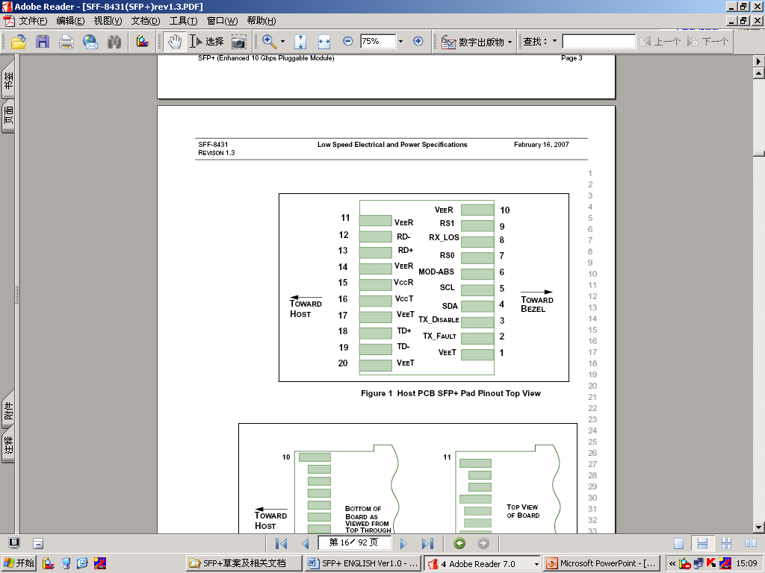

Figure1
Pin Assignment
Pin | Logic | Symbol | Name/Description | Note
1 |  | VeeT | Module Transmitter Ground
2 | LVTTL-O | TX_Fault | Module Transmitter Fault
3 | LVTTL-I | TX_Disable | Transmitter Disable; Turns off transmitter laser output
4 | LVTTL-I/O | SDA | 2-wire Serial Interface Data Line (Same as MOD-DEF2 as deﬁned in the INF-8074i)
5 | LVTTL-I/O | SCL | 2-wire Serial Interface Clock (Same as MOD-DEF1 as deﬁned in the INF-8074i)
6 |  | MOD_ABS | Module Absent, connected to VeeT or VeeR in the module
7 | LVTTL-I | RS0 | Not used
8 | LVTTL-O | RX_LOS | Receiver Loss of Signal Indication (In FC designated as RX_LOS, in SONET designated as LOS, and in Ethernet designated at Signal Detect)
9 | LVTTL-I | RS1 | Not used
10 |  | VeeR | Module Receiver Ground
11 |  | VeeR | Module Receiver Ground
12 | CML-O | RD- | Receiver Inverted Data Output
13 | CML-O | RD+ | Receiver Non-Inverted Data Output
14 |  | VeeR | Module Receiver Ground
15 |  | VccR | Module Receiver 3.3 V Supply
16 |  | VccT | Module Transmitter 3.3 V Supply
17 |  | VeeT | Module Transmitter Ground
18 | CML-I | TD+ | Transmitter Non-Inverted Data Input
19 | CML-I | TD- | Transmitter Inverted Data Input
20 |  | VeeT | Module Transmitter Ground

Block Diagram of Transceiver
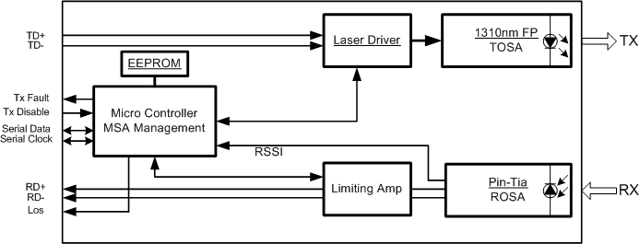
Figure2
Transmitter Section
The transmitter converts 1.25Gbit/s serial PECL or CML electrical data into serial optical data compliant with the 1000BASE-LX standard. An open collector compatible Transmit Disable (Tx_Dis) is provided. A logic “1,” or no connection on this pin will disable the laser from transmitting. A logic “0” on this pin provides normal operation. The transmitter has an internal automatic power control loop (APC) to ensure constant optical power output across supply voltage and temperature variations. An open collector compatible Transmit Fault (Tx_Fault) is provided. TX_Fault is a module output contact that when high, indicates that the module transmitter has detected a fault condition related to laser operation or safety. The TX_Fault output contact is an open drain/collector and shall be pulled up to the Vcc_Host in the host with a resistor in the range 4.7-10 kΩ. TX_Disable is a module input contact. When TX_Disable is asserted high or left open, the SFP module transmitter output shall be turned off. This contact shall be pulled up to VccT with a 4.7 kΩ to 10 kΩ resistor

Receiver Section
The receiver converts 1.25Gbit/s serial optical data into serial PECL/CML electrical data. An open collector compatible Loss of Signal is provided. Rx_LOS when high indicates an optical signal level below that specified in the relevant standard. The Rx_LOS contact is an open drain/collector output and shall be pulled up to Vcc_Host in the host with a resistor in the range 4.7-10 kΩ, or with an active termination. Power supply filtering is recommended for both the transmitter and receiver. The Rx_LOS signal is intended as a preliminary indication to the system in which the SFP is installed that the received signal strength is below the specified range. Such an indication typically points to non-installed cables, broken cables, or a disabled, failing or a powered off transmitter at the far end of the cable.

Recommended Interface Circuit
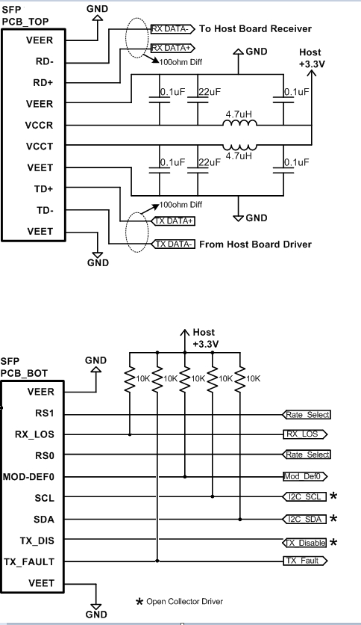
Figure3

Dimensions
Uint:mm
LC Receptacle
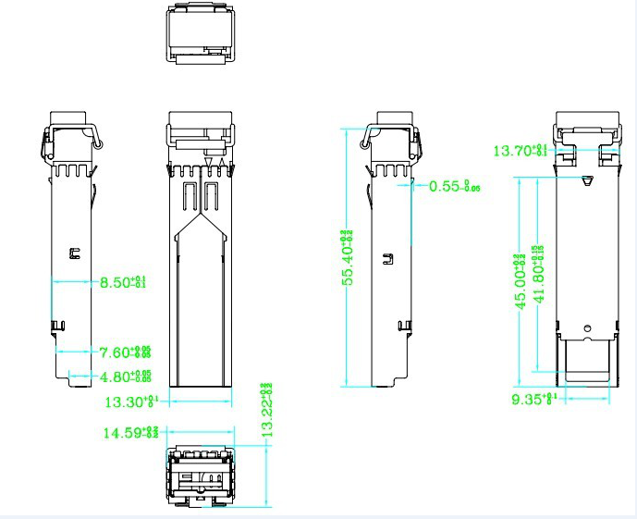
Figure 4

SC Receptacle

Figure5

Digital Diagnostic Memory Map

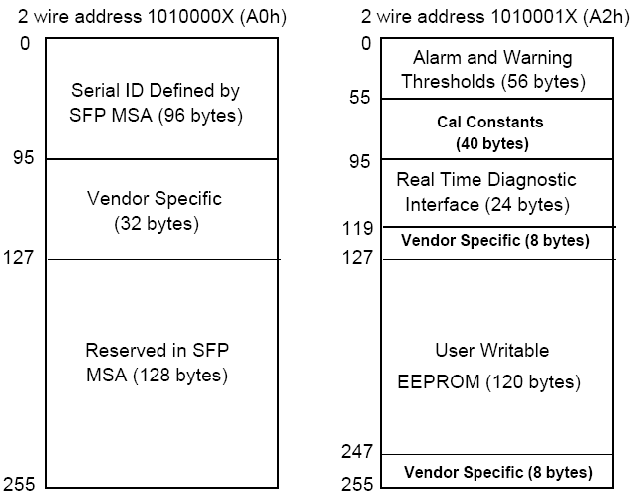
Figure 6

